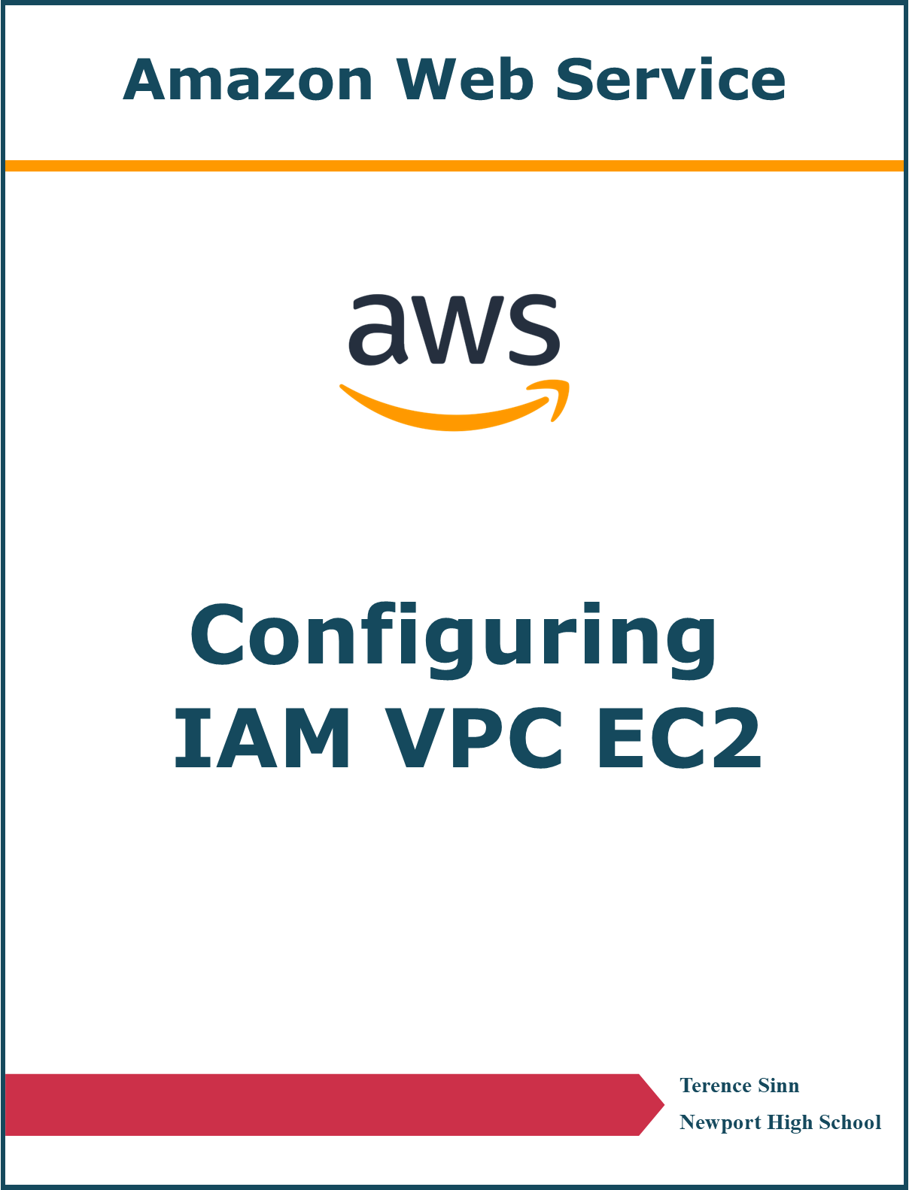

**Purpose**

With fundamental networking concepts such as redundancy, fault tolerance, scalability, quality of service, and security, the movement to cloud based networking architectures has expanded greatly. A cloud based network offers the redundancy of a core network provided by a much larger company such as Amazon. Fault tolerance is improved because web servers hosted on the virtual cloud can correct hardware failure by switching the virtual machine onto another physical machine. Scalability is greatly improved because cloud based networks do not require the acquisition of physical capital to run, resulting in a pay as you use policy. This allows networks to expand and shrink quickly without great economic losses or any waits when acquiring the hardware. These three significant advantages are responsible for the major shift towards cloud networking such as Amazon Web Services. This lab looks to explore basic operations of Amazon Web Services such as setting up user access to configuration, setting up a virtual cloud, and starting a web server on a virtual machine.

**Lab Summary**

Set up access permissions to the Amazon Web Services console using IAM. There are three predefined users and three predefined user groups to be used. Users are added to their respective user groups and their permissions are tested. Next, a virtual private cloud is set up with VPC with two public and two private subnets. Security groups are configured to allow web access to the VPC. Lastly, an EC2 virtual machine instance is created to host a web server. The volume of storage and power of the virtual machine are modified. Management and monitoring options of this virtual machine are explored.

**Part 1: Identity & Access Management (IAM)**

**Creating Users:**

1. On the menu on the left, select Users under Access Management to reach the Users dashboard.

2. Click add users to enter the user setup wizard.

3. Give the user a name and a password. Then click next to the permissions setup.

4. The permission page is optional and can add the user to groups which define the permissions they have. User permissions can be added after user creation. Click next to tags.

5. The tag page is optional and can be used to organize information about a specific user. Click next to review.

6. After review, click Create User.

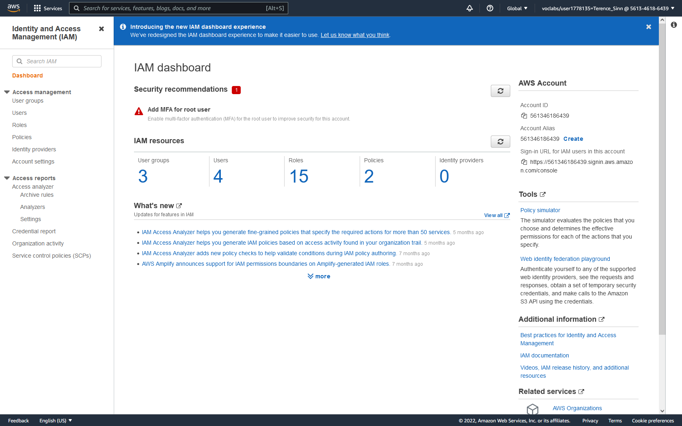

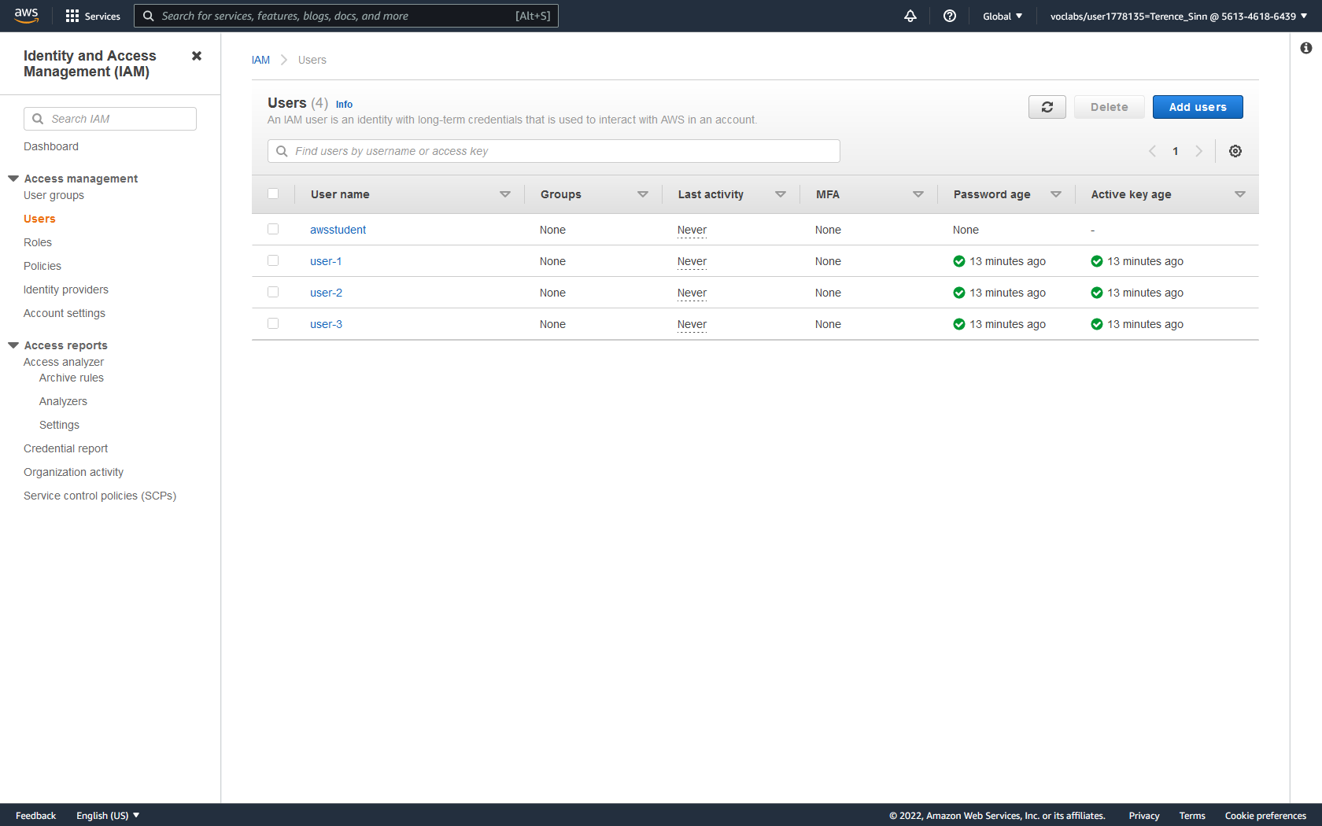

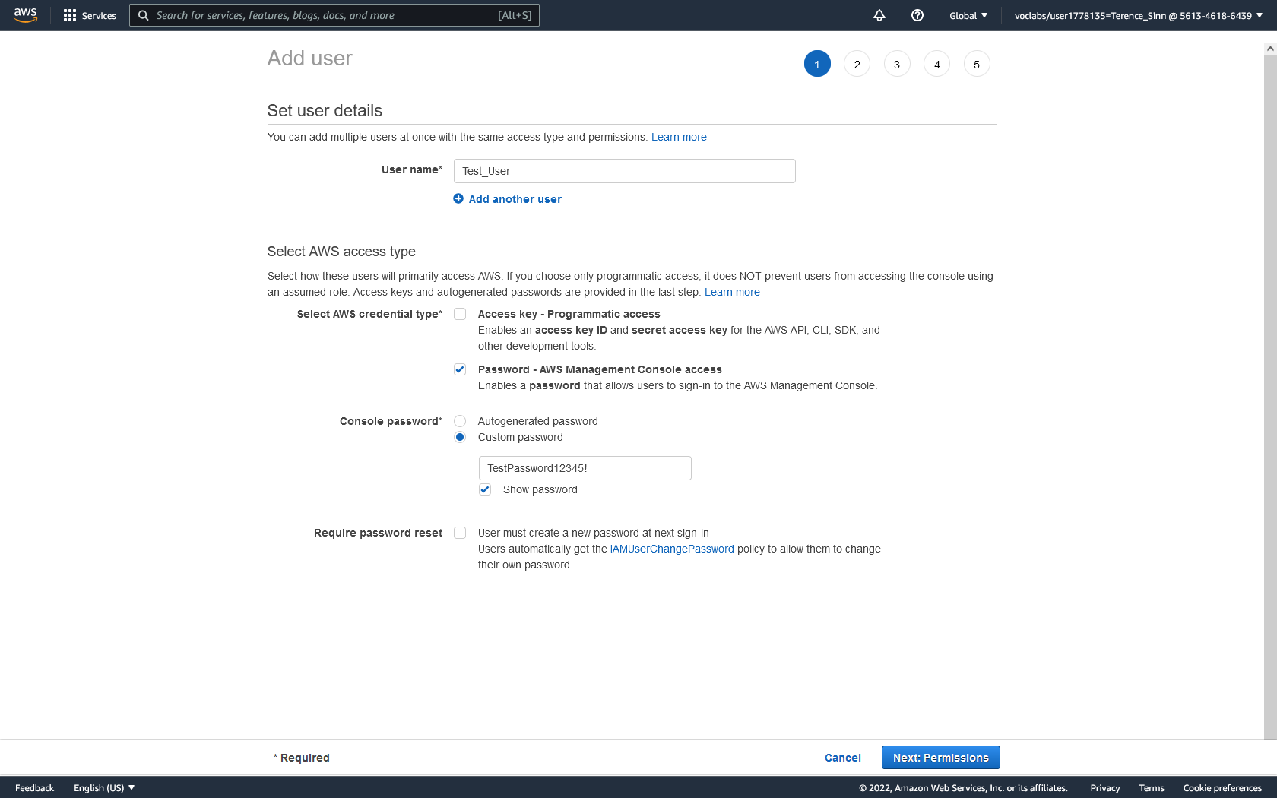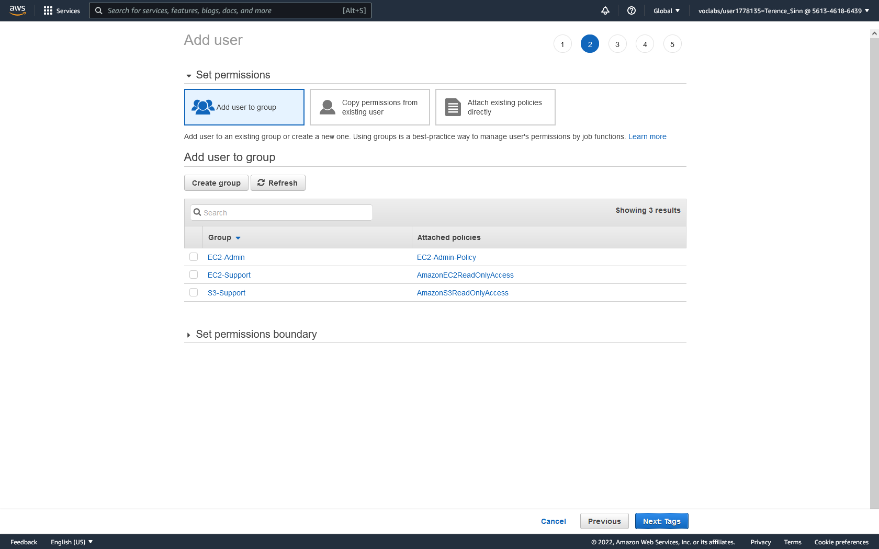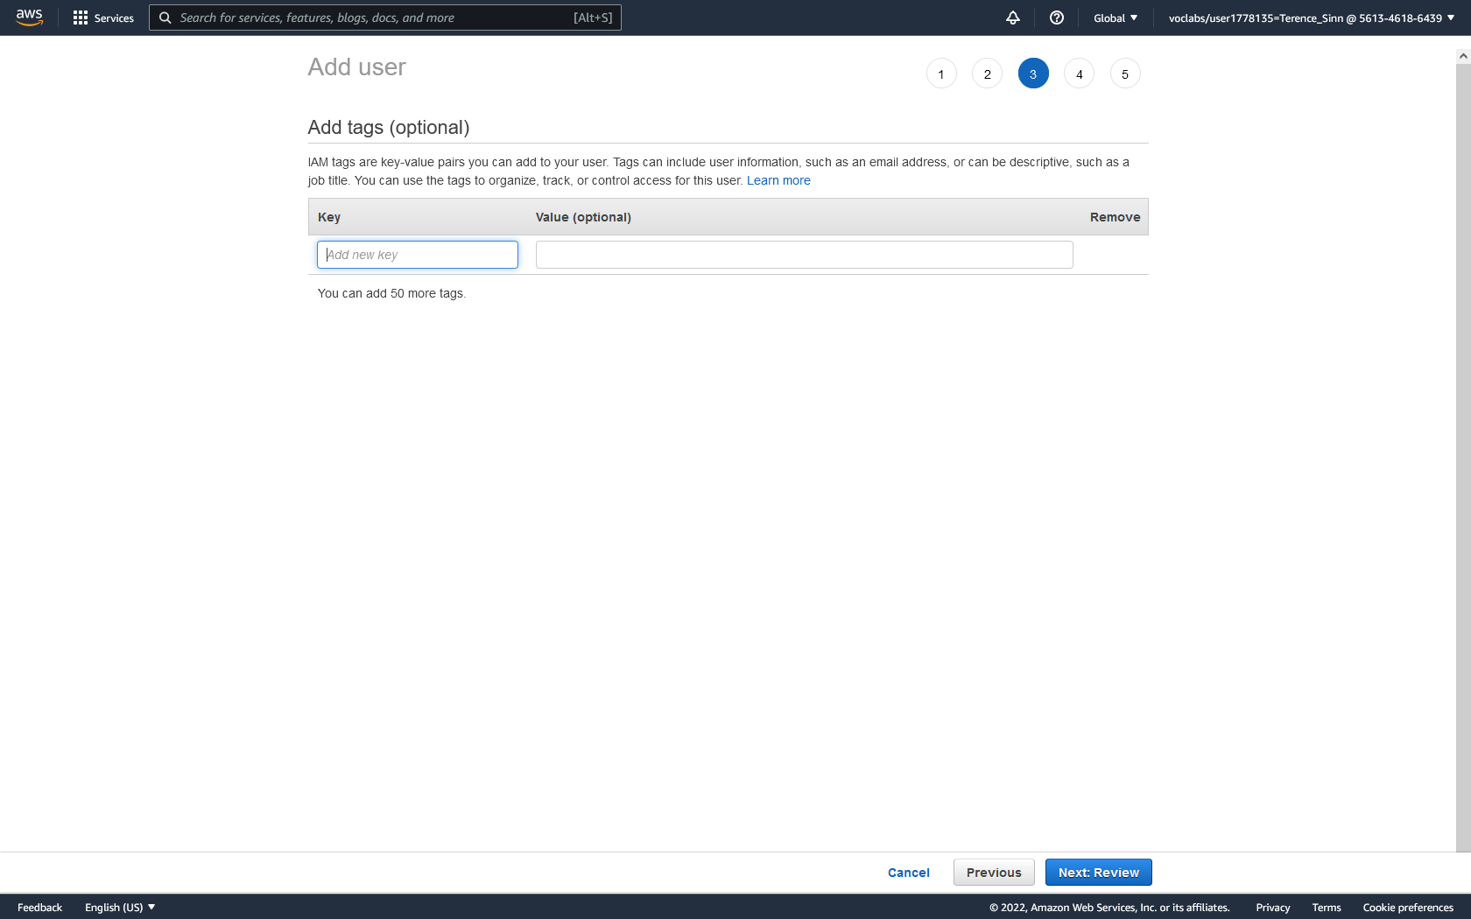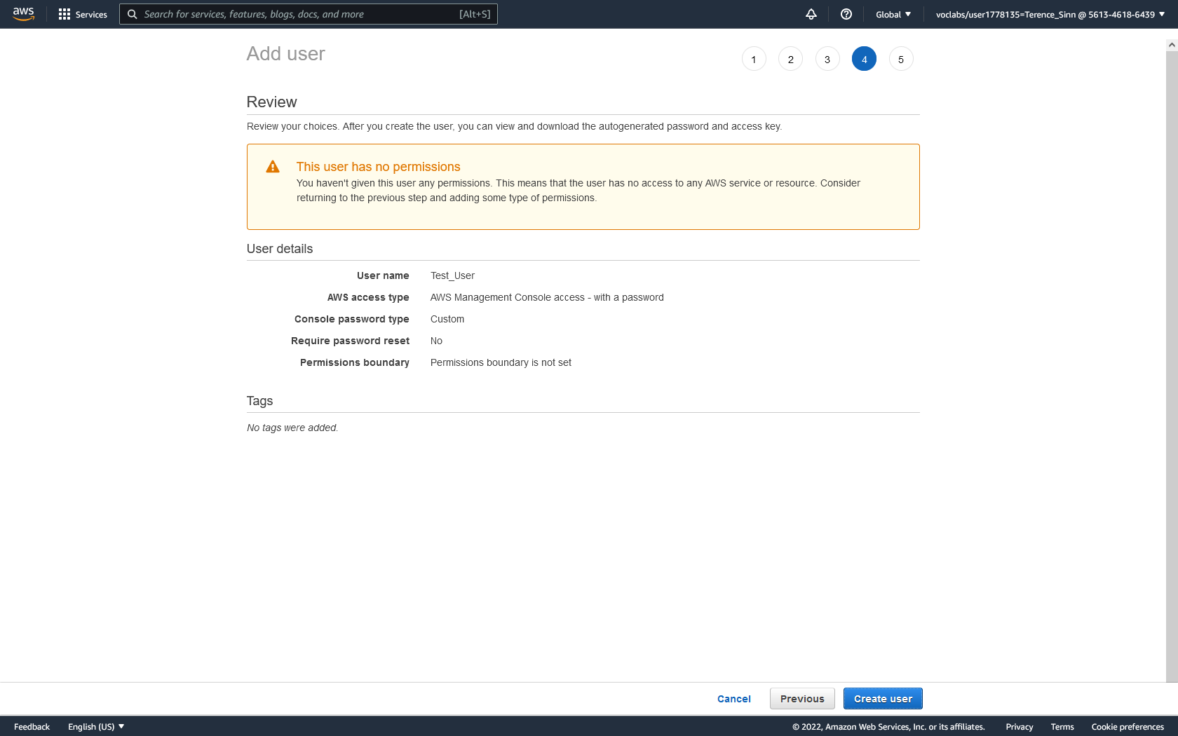

**Creating User Groups:**

1. On the left menu, select User groups under Access management to reach the User groups dashboard.  
2. Click Create group.

3. Give the User group a name and optionally add users into this group. Likewise, you can optionally add permissions to this User group that defines what users added to this group are capable of accessing on this AWS account.

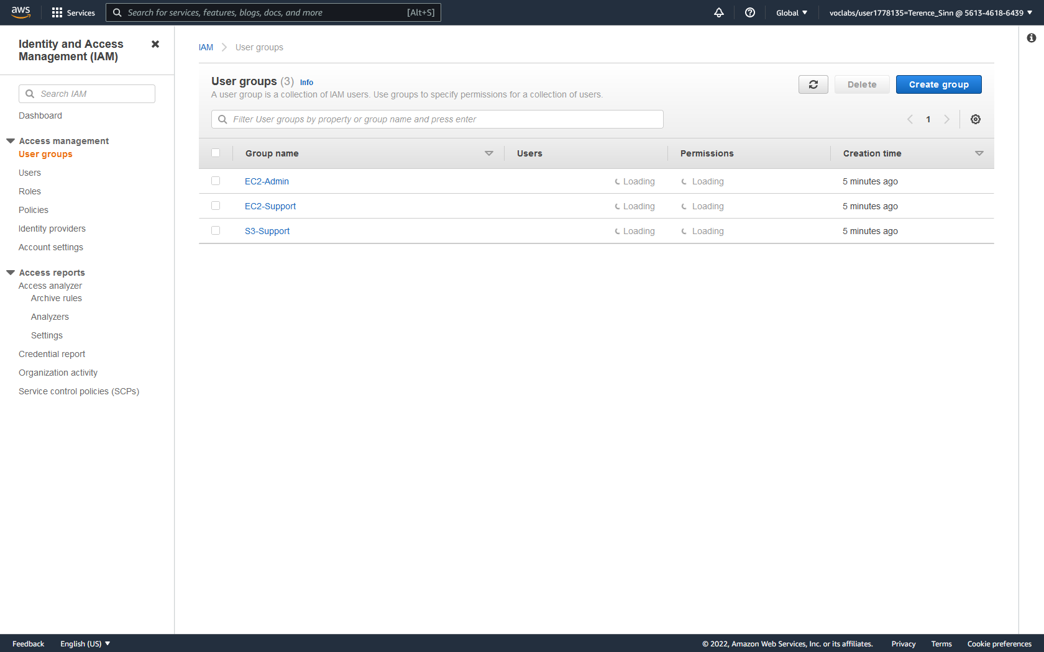

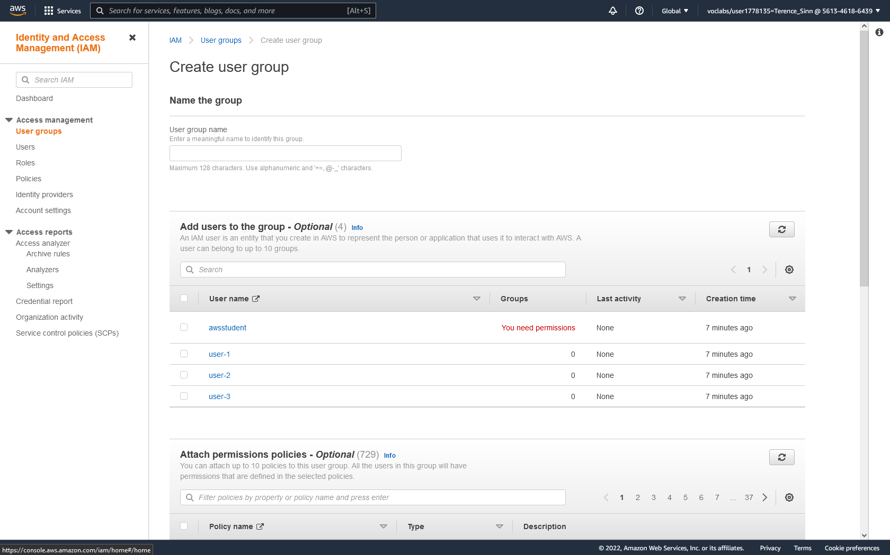

**Adding Users to User Groups:**

1. From the User dashboard, click into any user to view further details. For this lab, click into user-1

2. From the user-1 details page, select the Groups tab.

3. Add user-1 to the predefined EC2-Admin group.

**OR**

1. From the User groups dashboard, click into any group. For this lab, click into the predefined EC2-Admin group.

2. Under the Users tab, click add users.

3. Add user-1 to this group.

4. Using either of the two previous methods, add user-2 into the EC2-Support group and user-3 to the S3-Support group.



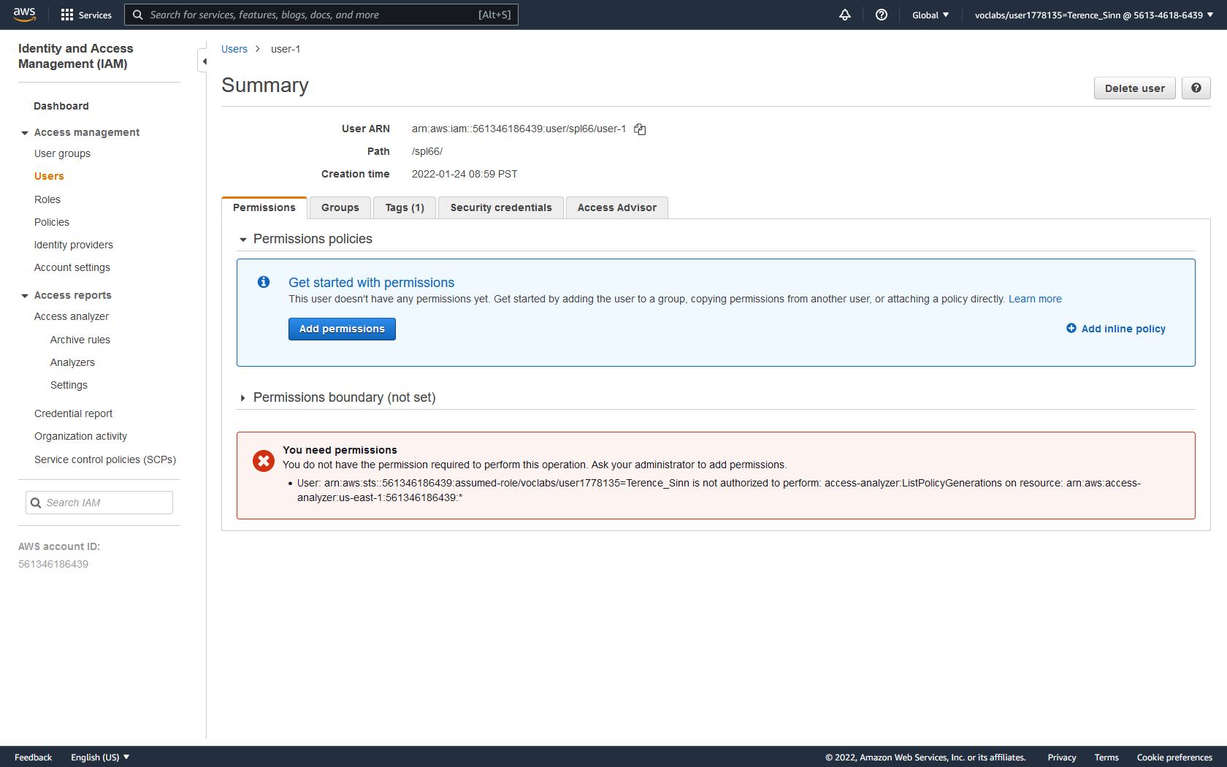

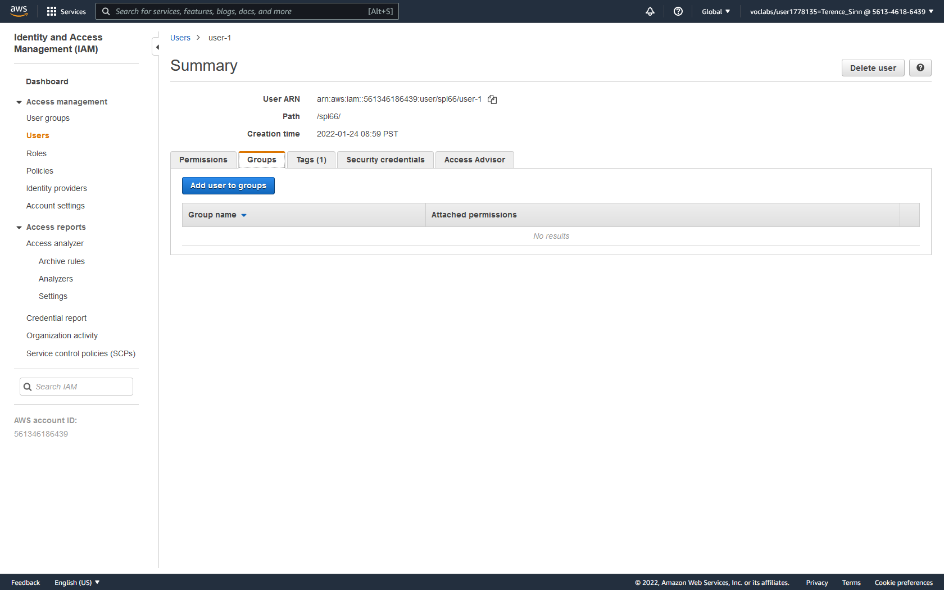

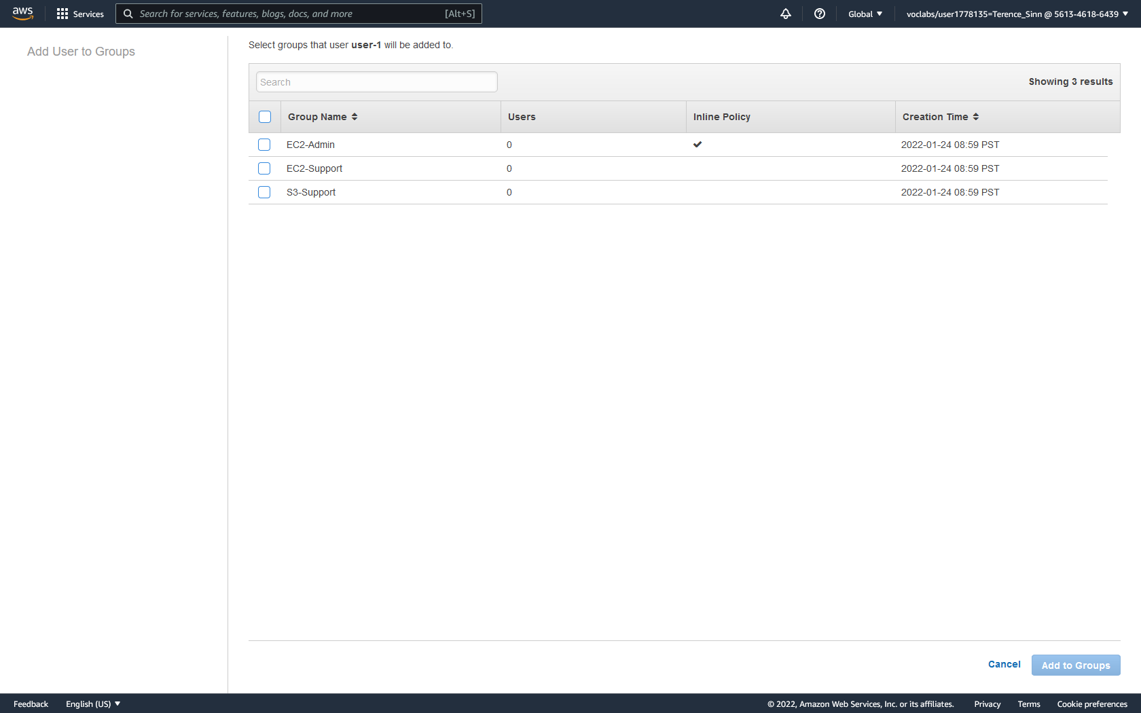

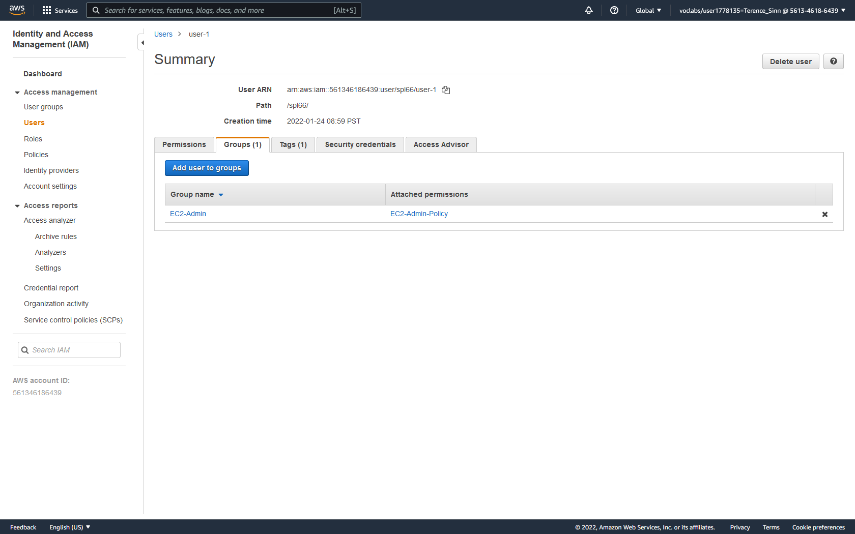

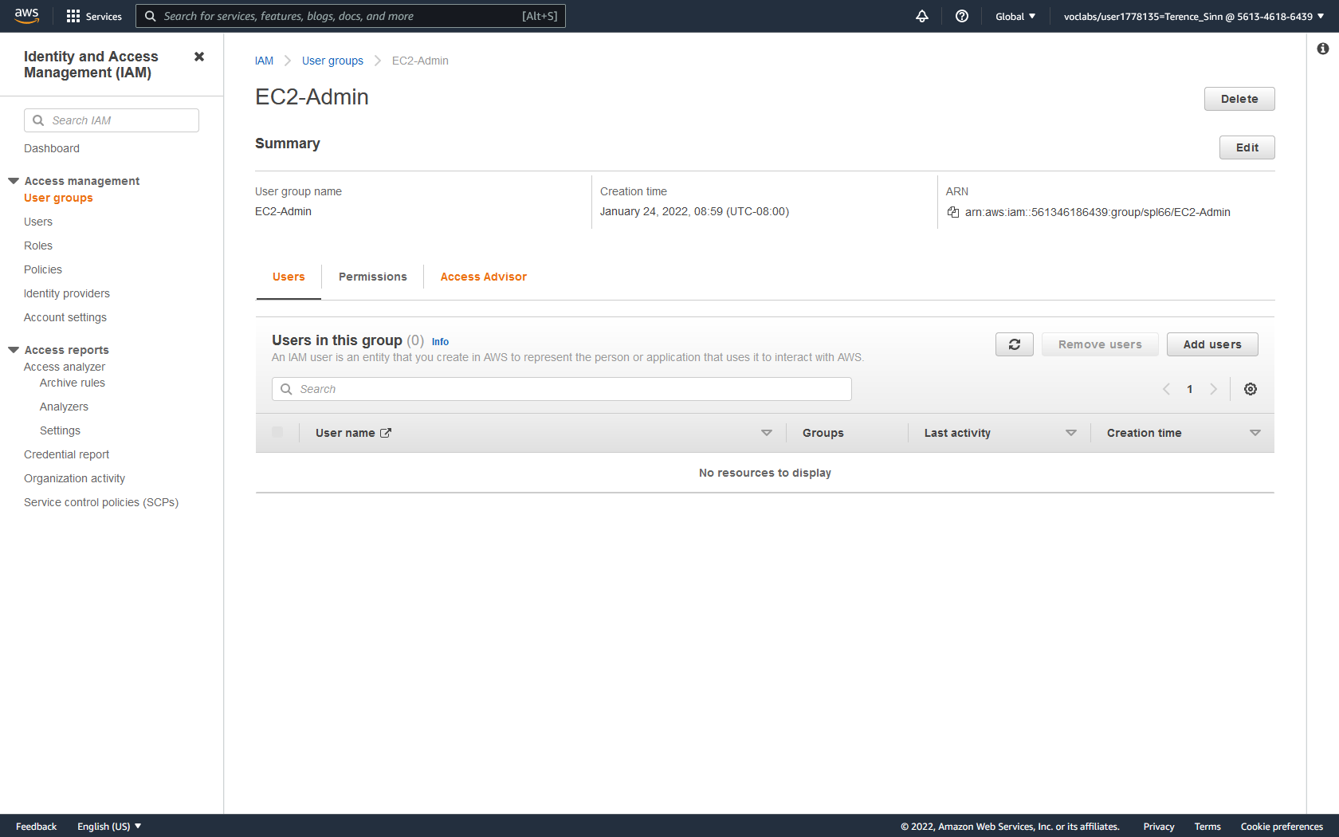

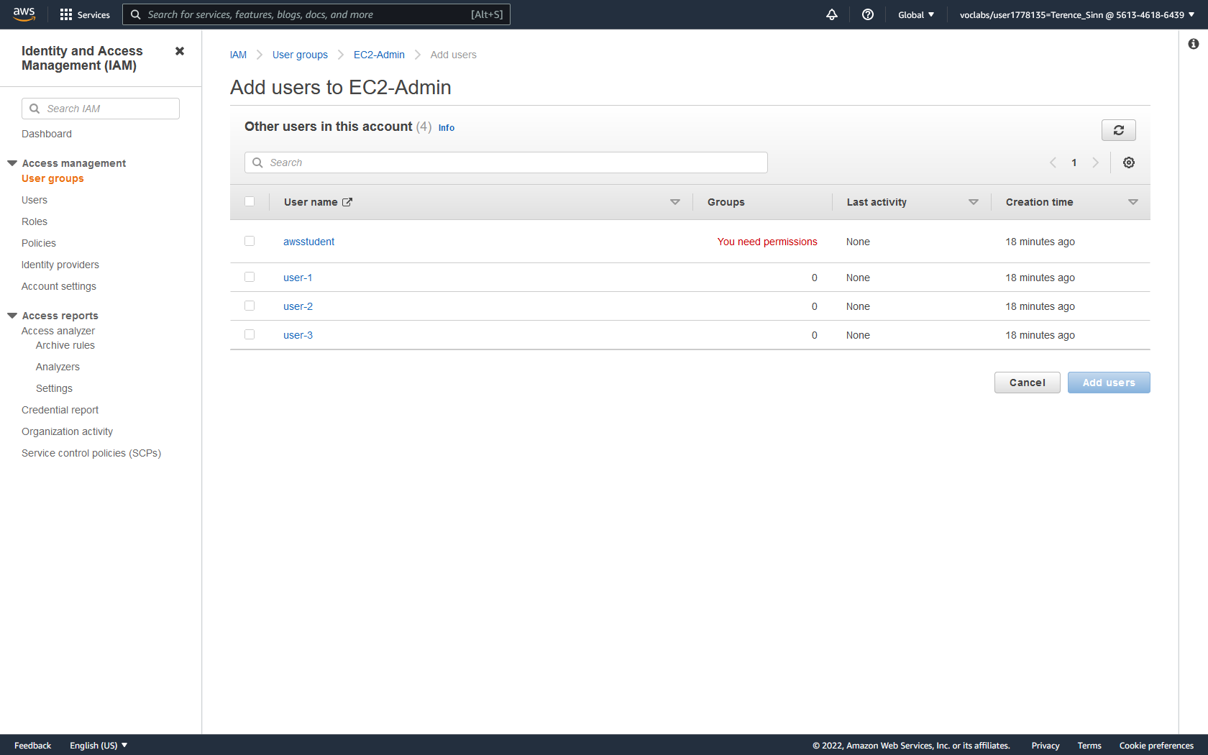

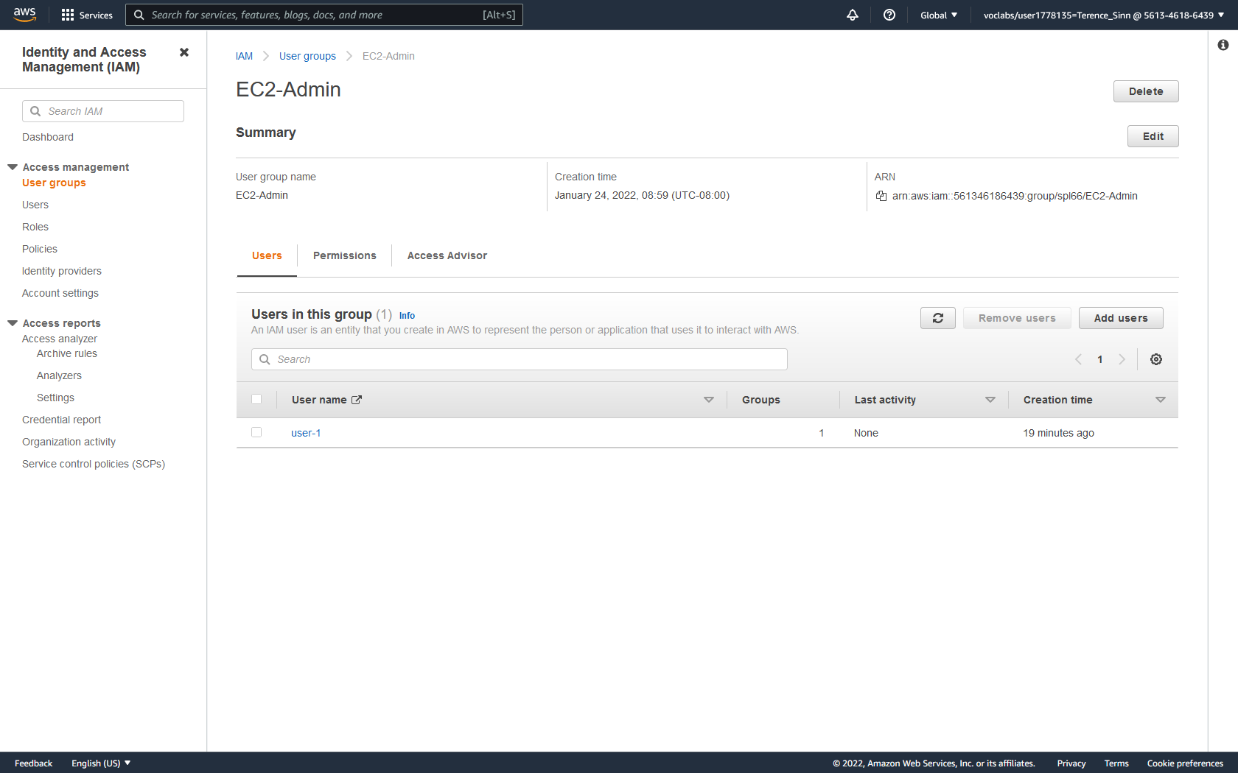

**Verifying Access:**

1. Under the IAM dashboard, copy the IAM login link on the right side of the screen.

2. Logout of the current admin account.

3. Sign-in to user-1’s account using username user-1 and password Lab-Password1

4. From the AWS console, click into the EC2 service.

5. Click into the instances from the left menu to get to the instances dashboard.

6. Stop either the lab host or bastion host by selecting the host, clicking the instance state dropdown menu, and then stop instance.

7. Wait until the lab host is stopped.

8. Sign out of user-1 and login to user-2 using username user-2 and password Lab-Password2.

9. Repeat steps 4-6 to try to start the host that you have previously stopped. You should receive a permission error as user-2 is added to the EC2-Support group which only has the permissions to view the EC-2 configurations.

10. Sign out of user-2 and login to user-3 using username user-3 and password Lab-Password3.

11. Try to access the instances dashboard. You should receive a permission error as user-3 is added to the S3-Support group, which doesn’t even have access to view the EC2 configurations.

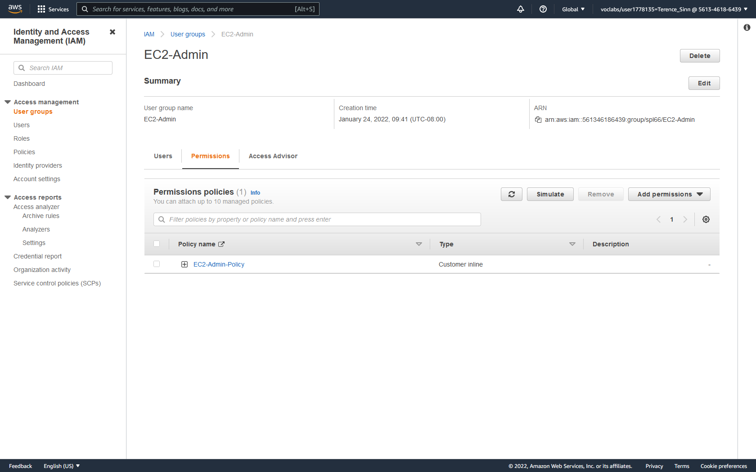

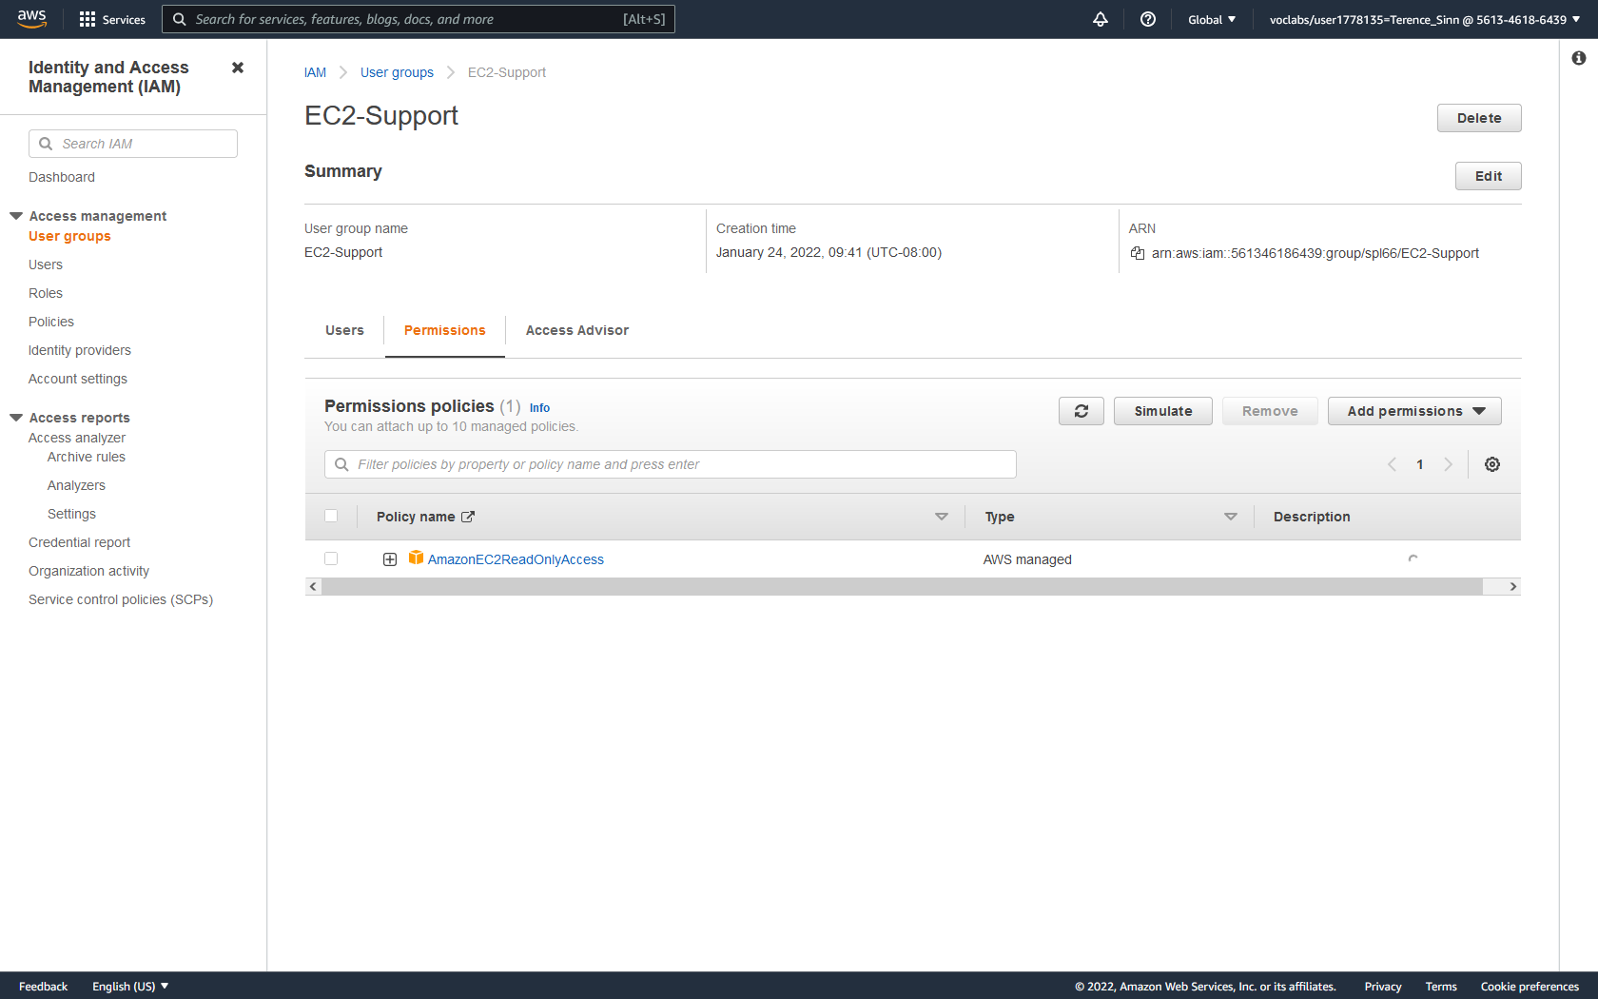

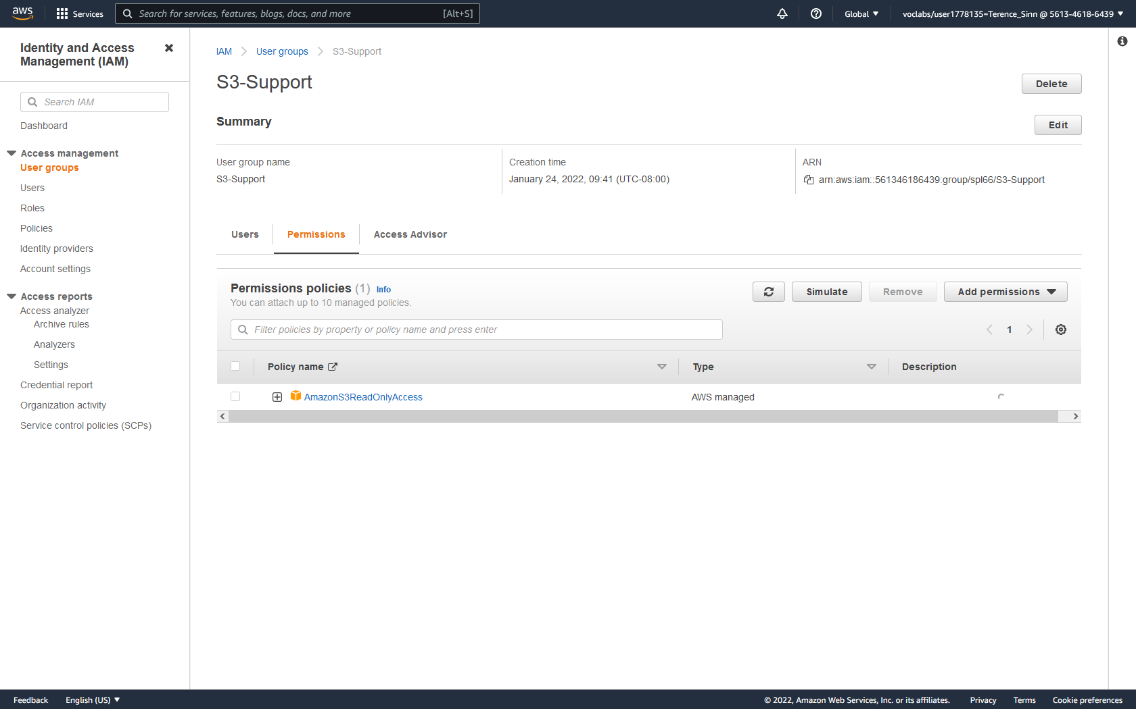



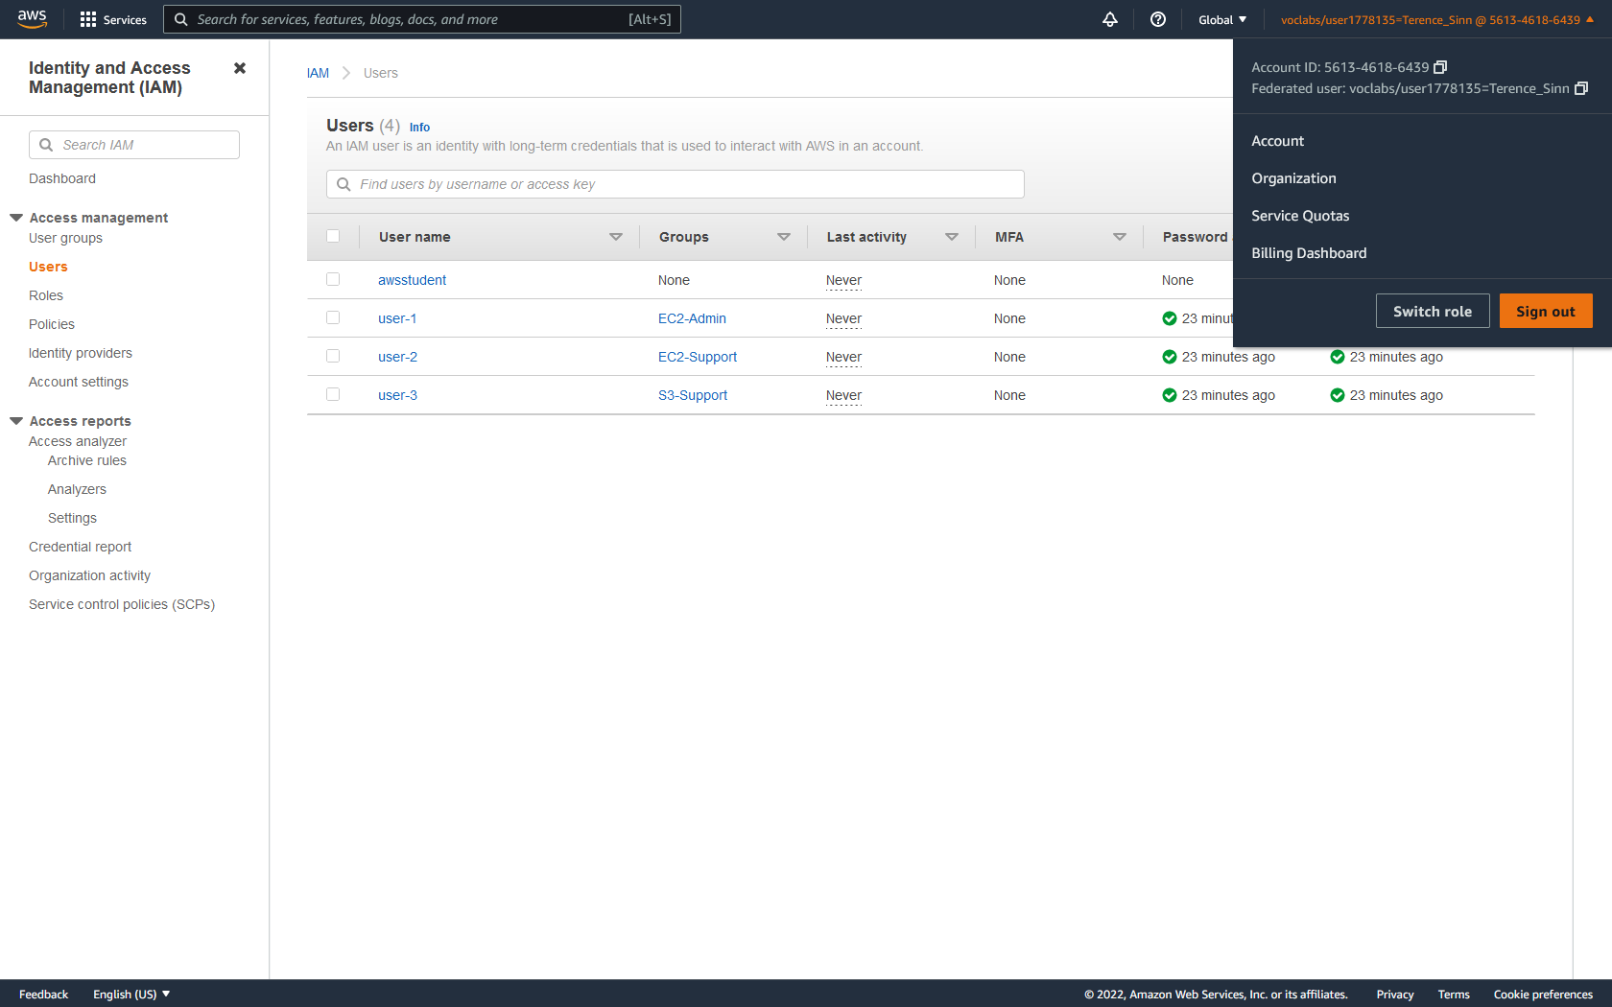

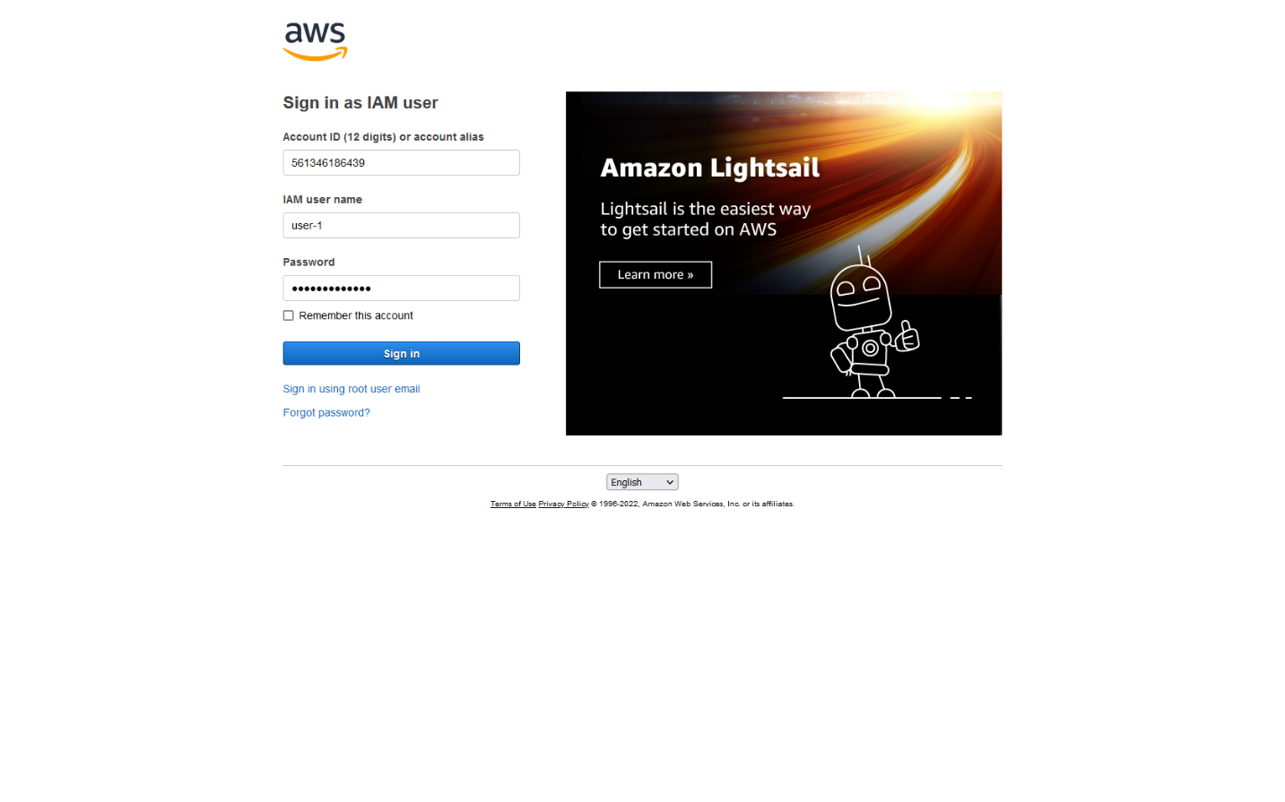

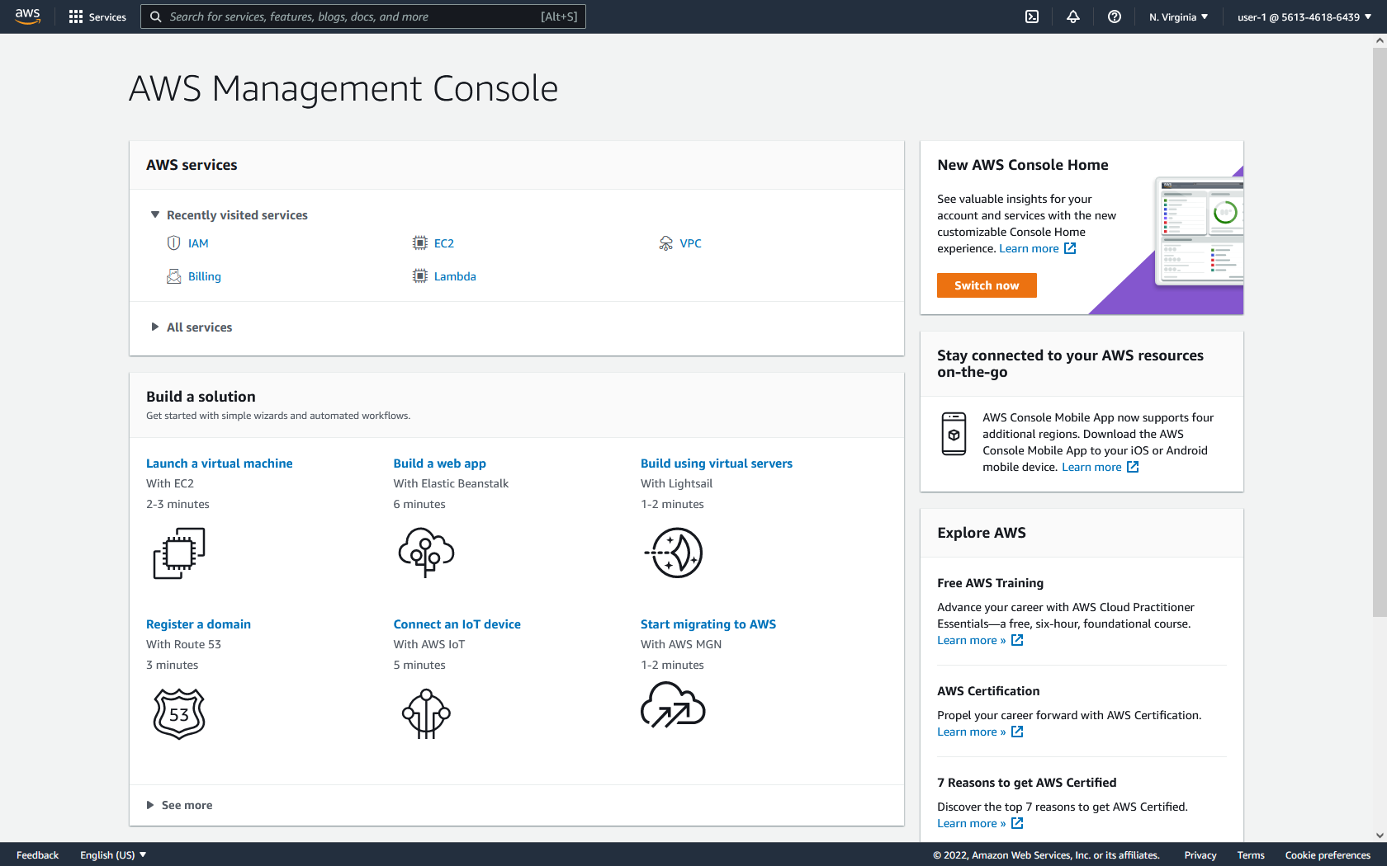

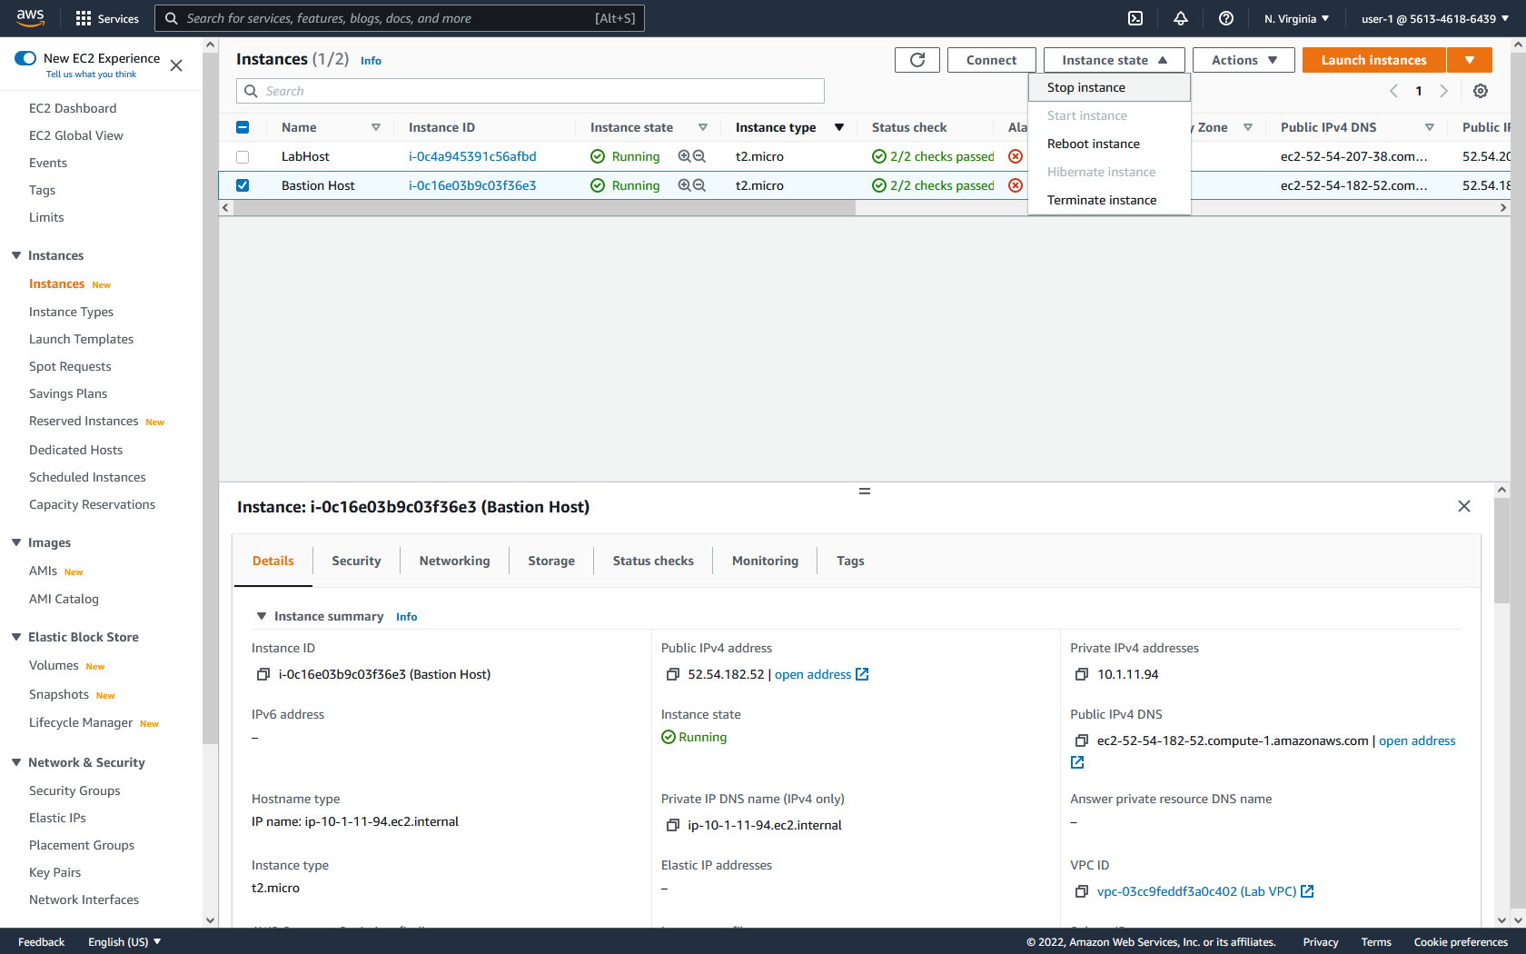

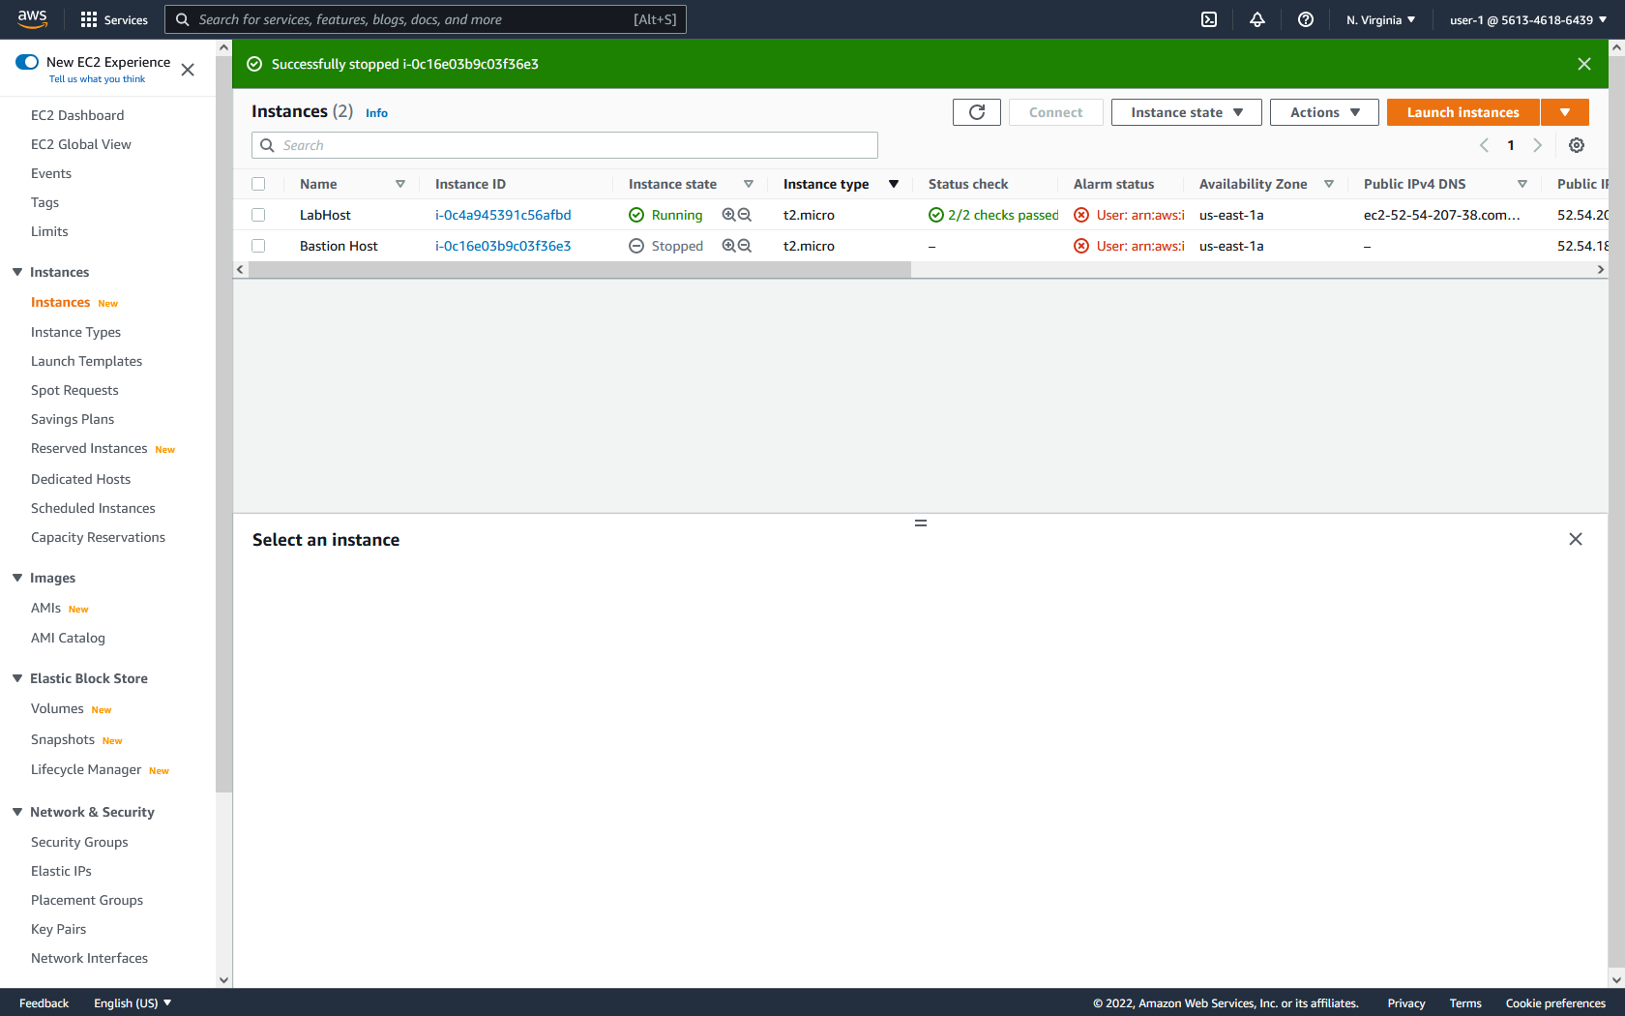

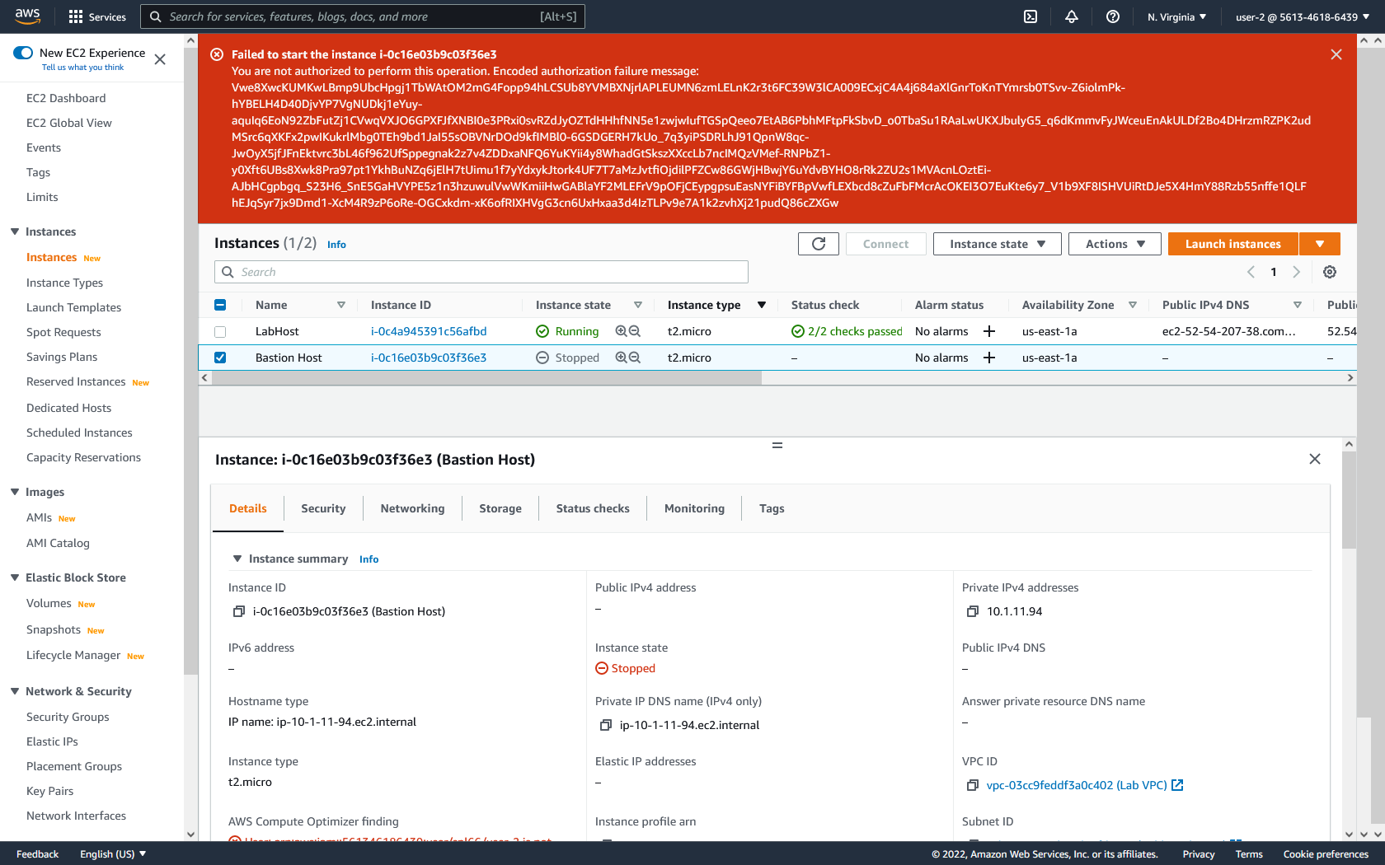

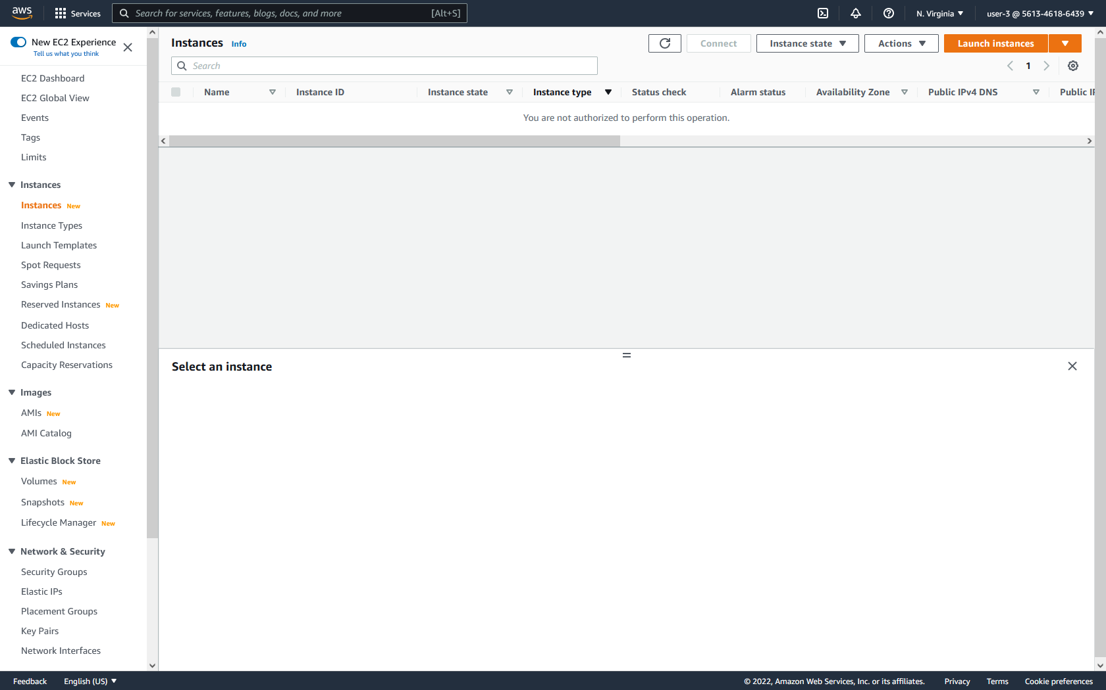

**Part 2: VPC**

**Create VPC:**

1. On the VPC dashboard, click launch VPC wizard.

2. On the left, choose the option to create a VPC with public and private subnets. Then click select.

3. Configure a name for the VPC, public, and private subnets. For this lab configure:

VPC Name: Lab VPC

Public Subnet IP Address: 10.0.0.0/24

Public Availability Zone: us-east-1a

Public Subnet Name: Public Subnet 1

Private Subnet IP Address: 10.0.1.0/24

Private Availability Zone: us-east-1a

Private Subnet Name: Public Subnet 2

4. Configure elastic IP allocation by clicking in the box and selecting the provided information. Then click Create VPC.

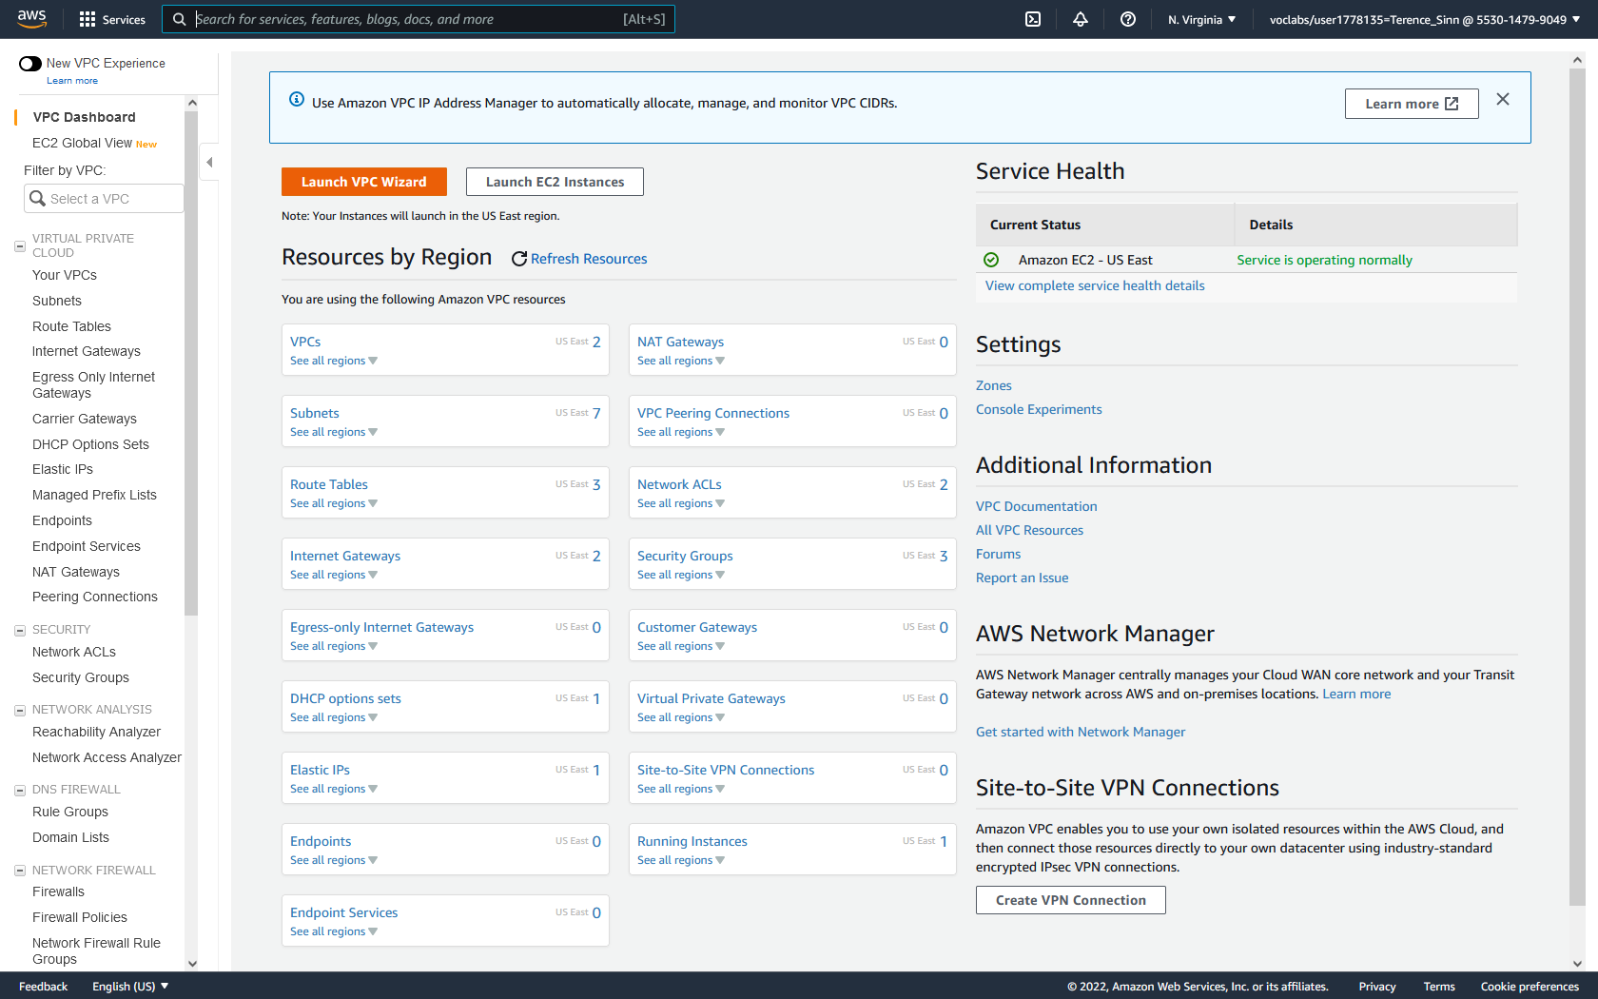

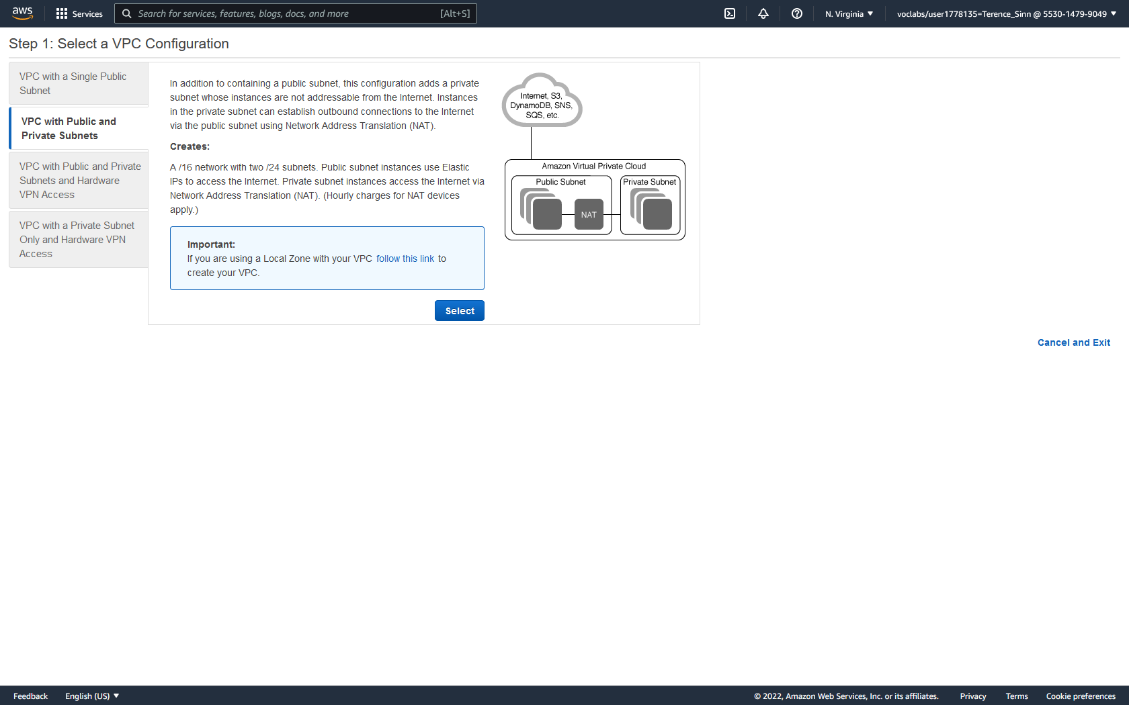

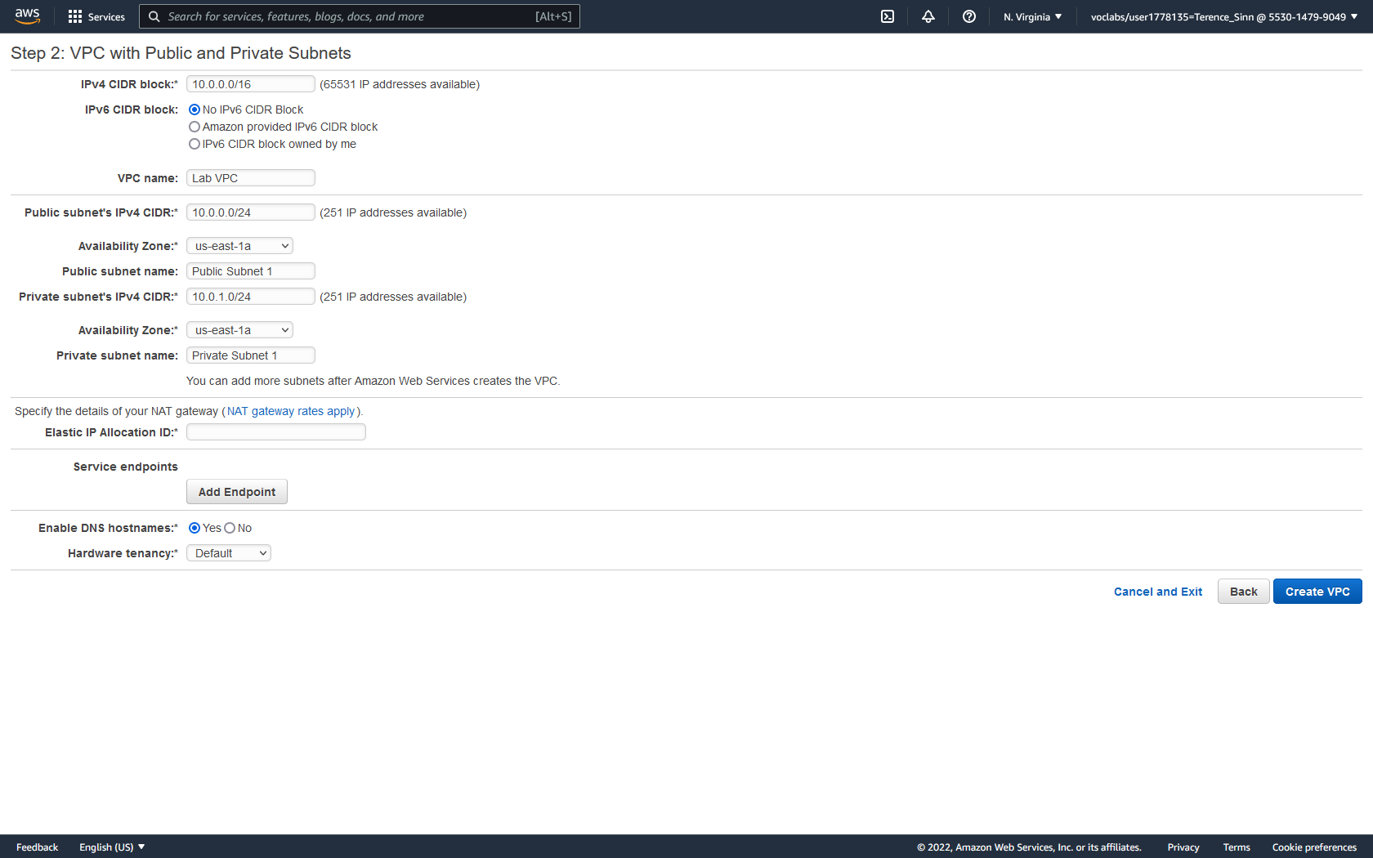

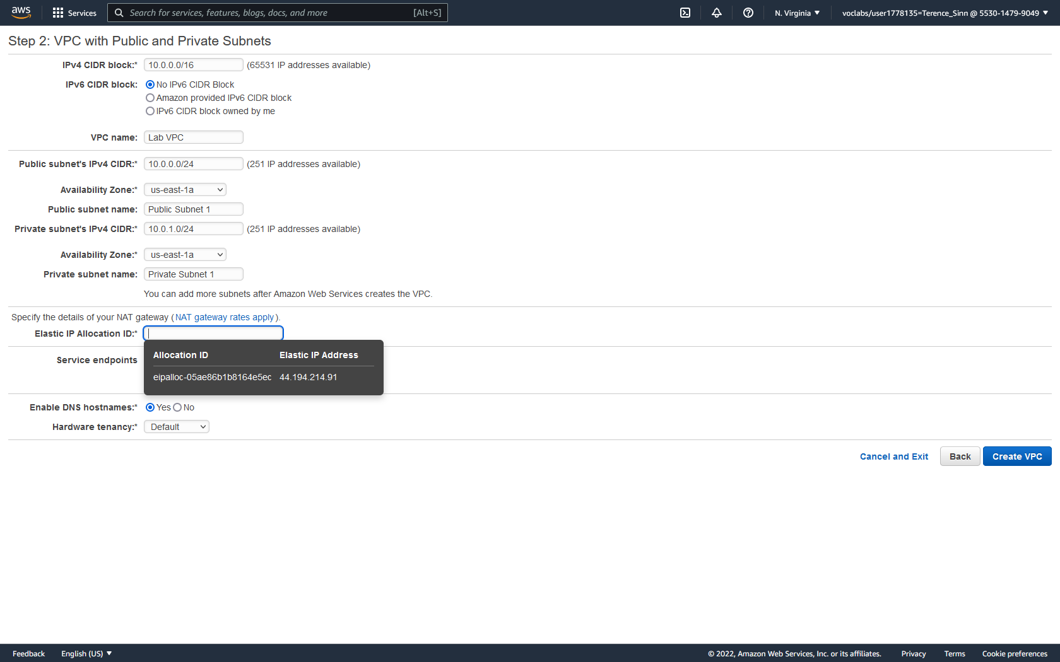

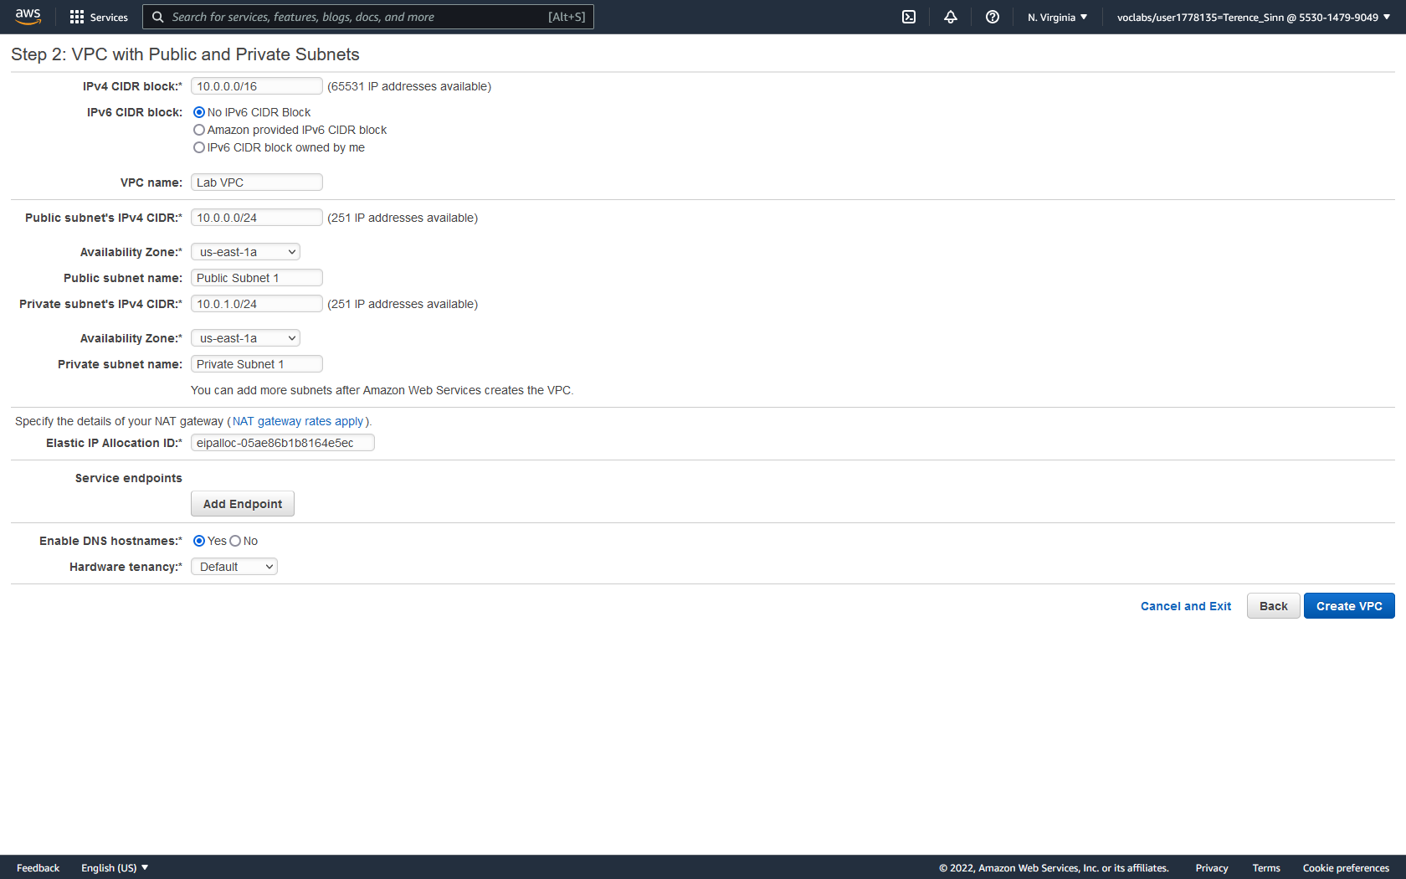

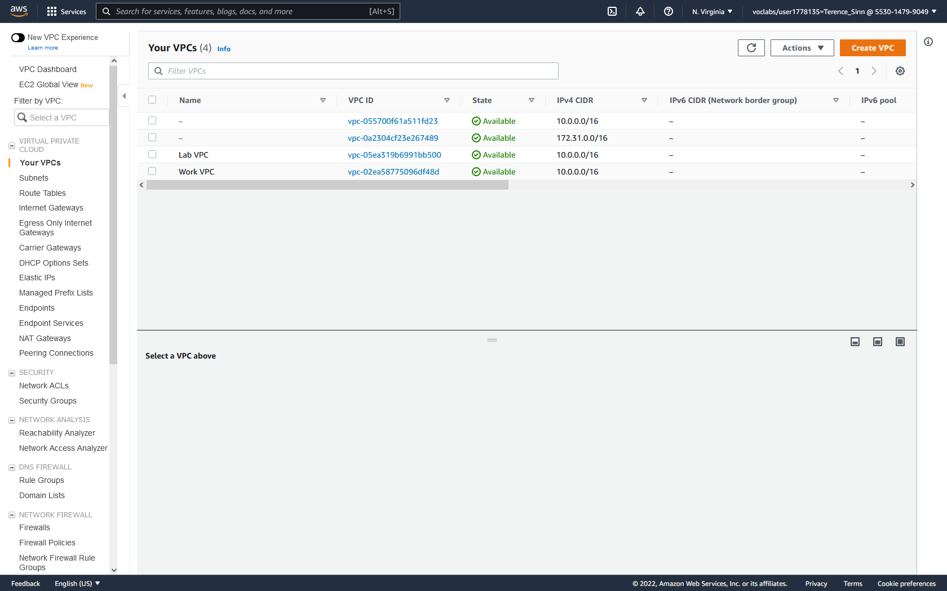

**Create Subnets:**

1. On the left menu, click subnets to reach the subnets dashboard.

2. Click Create subnet. Configure the new subnet to use:

VPC ID: Lab VPC

Subnet Name: Public Subnet 2

Availability Zone: us-east-1b

IPv4 CIDR Block: 10.0.2.0/24

Tags: Key – Name Value – Public Subnet 2

3. Create another subnet and configure using the following settings:

VPC ID: Lab VPC

Subnet Name: Private Subnet 2

Availability Zone: us-east-1b

IPv4 CIDR Block: 10.0.3.0/24

Tags: Key – Name Value – Private Subnet 2

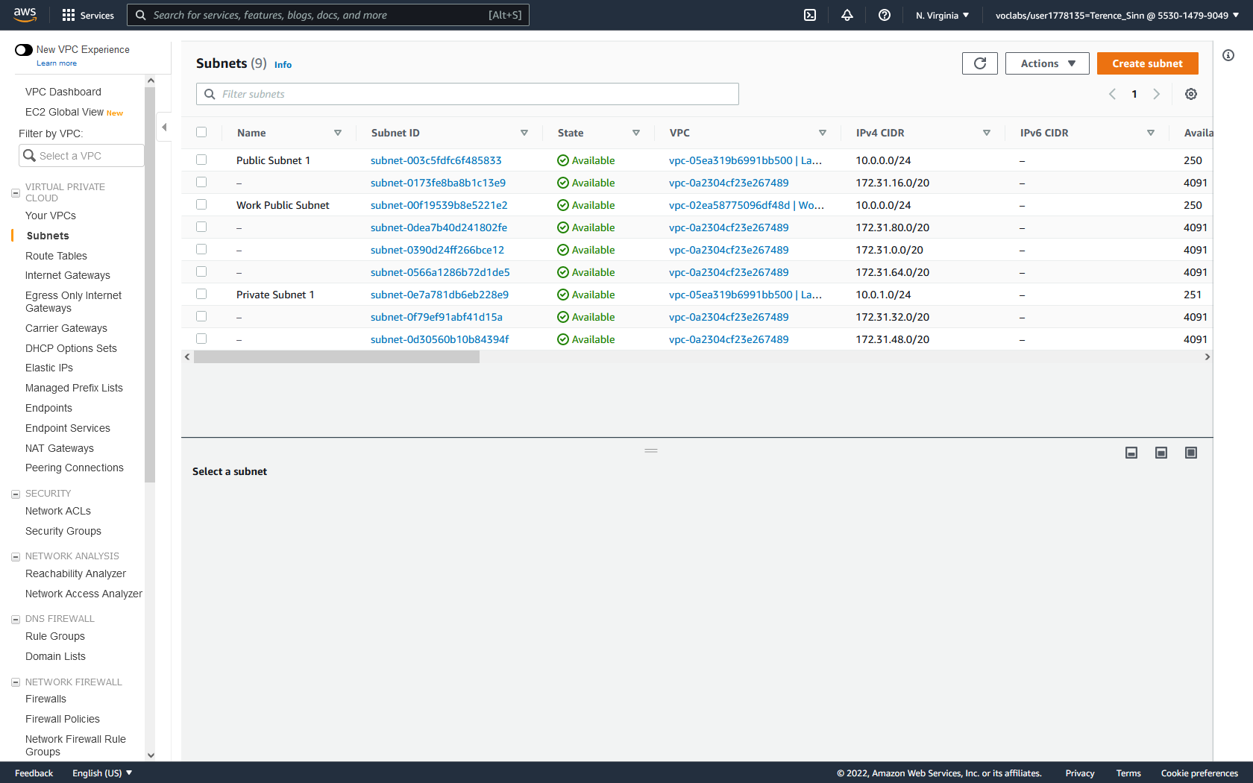

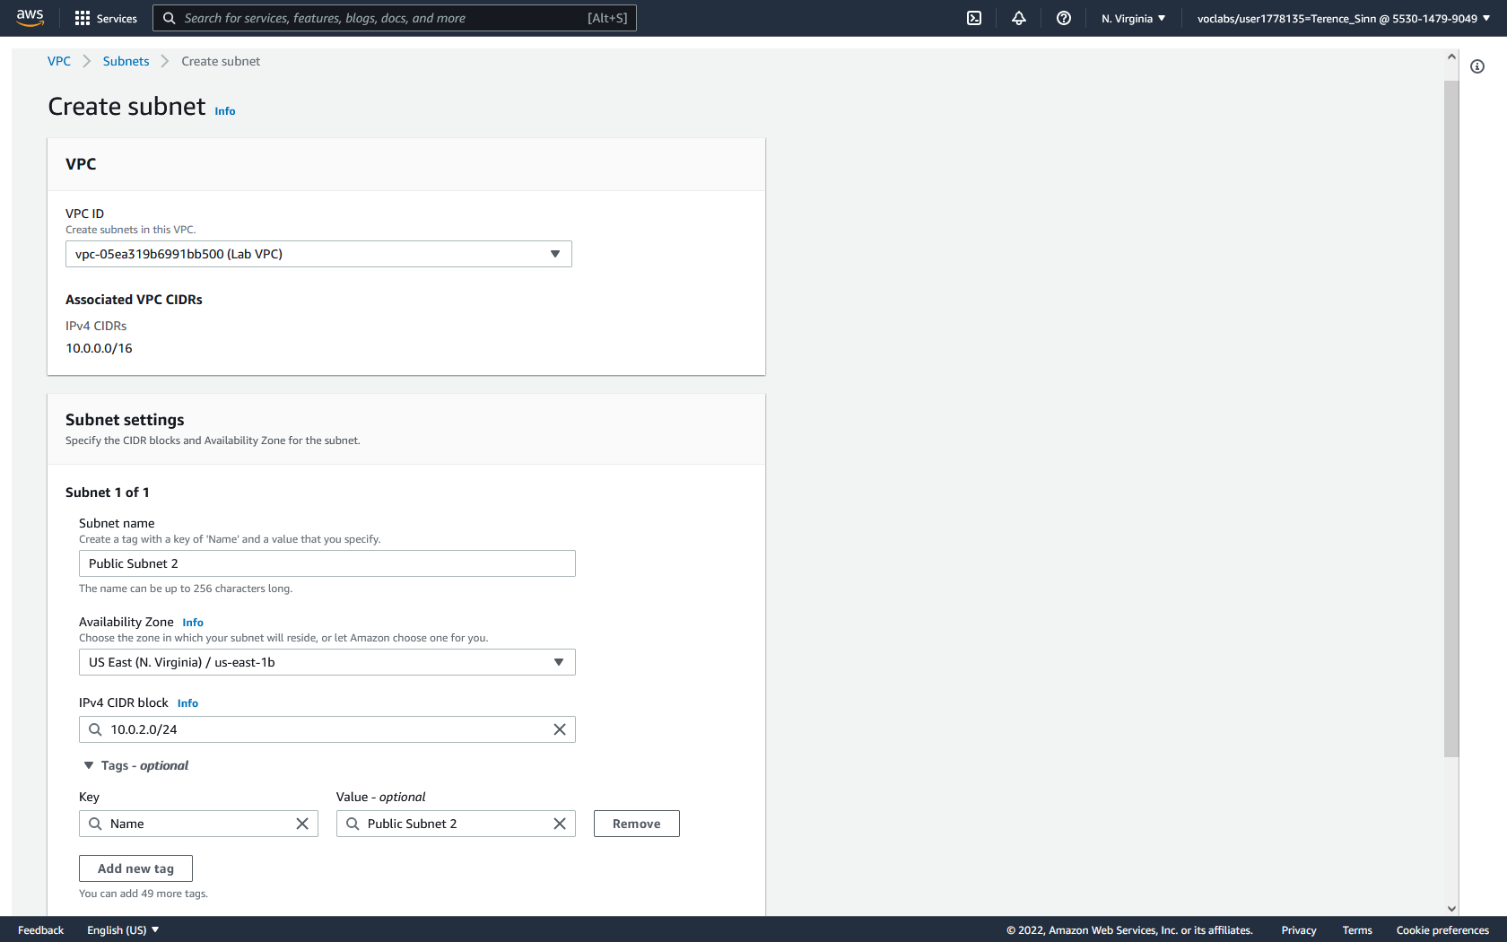

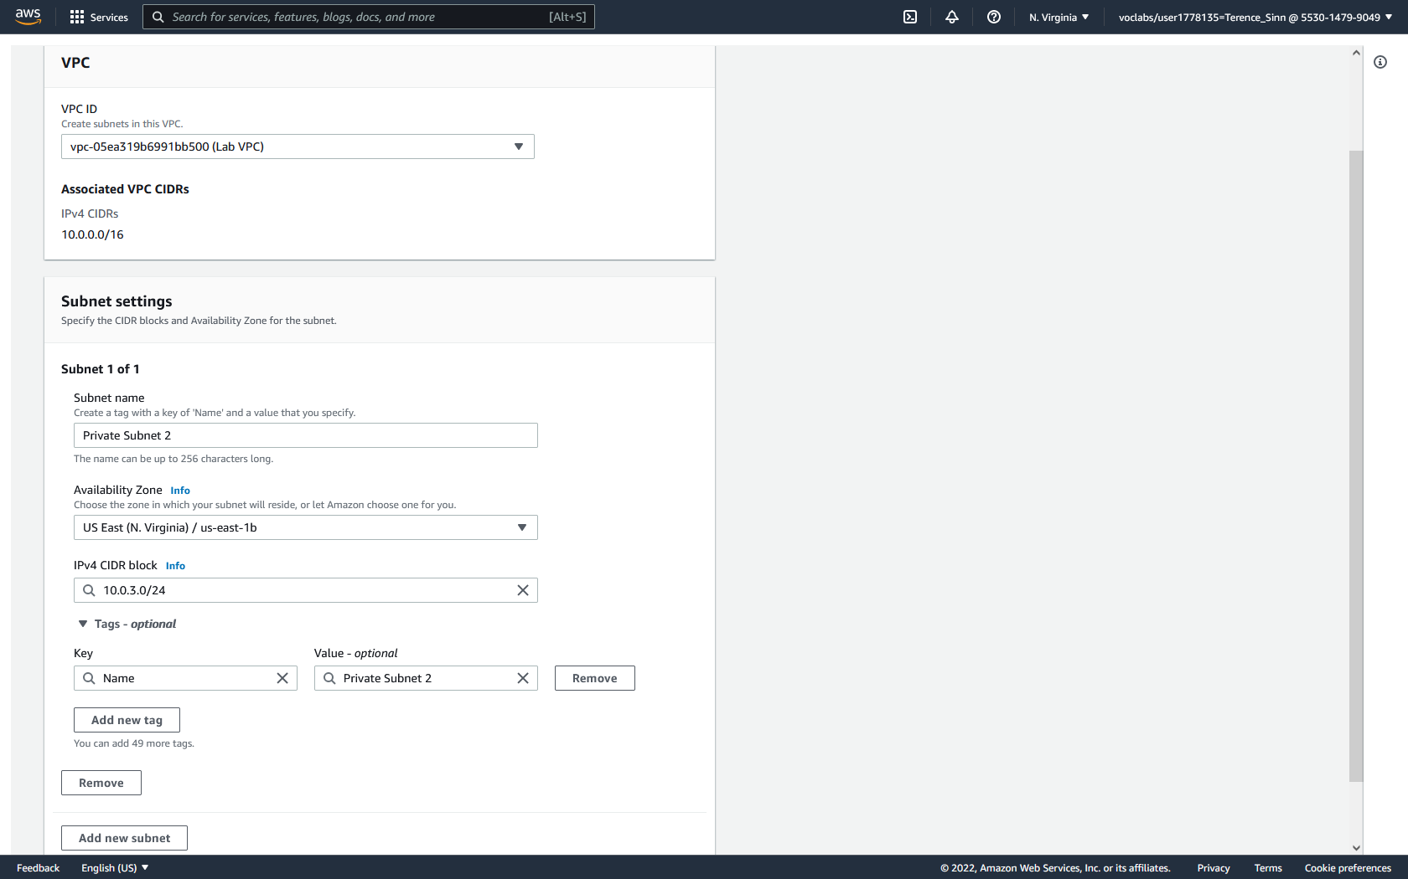

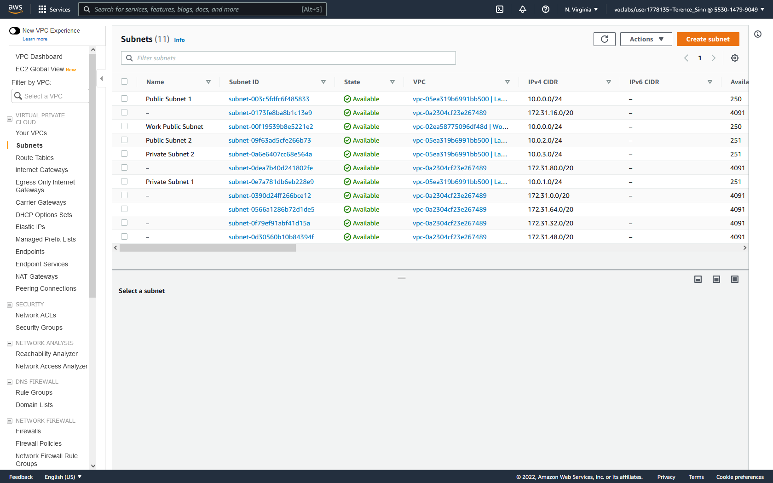

**Subnet Associations:**

1. On the left menu, click route tables to reach the route tables dashboard.

2. Rename the route table associated with Lab VPC and with Main=Yes as Private Route Table. Rename the route table associated with Lab VPC and with Main=NO as public Route Table.

3. Click into the Private Route table. Note how there is a generic 0.0.0.0/0 route that forwards information to a nat destination. This is because in a private network, traffic is directed to the nat gateway before being moved to a public network.

4. Click into subnet associations and edit subnet associations. Add both Private Subnet 1 and Private Subnet 2 to the Private Route table.  
5. Go back to the route tables dashboard and click into the Public Route table. Note how there is a generic 0.0.0.0/0 route to an igw destination. This is because in a public network, generic traffic is forwarded to the internet through an internet gateway router.

6. Click into subnet associations and edit subnet associations. Add both Public Subnet 1 and Public Subnet 2 to the Public Route Table.

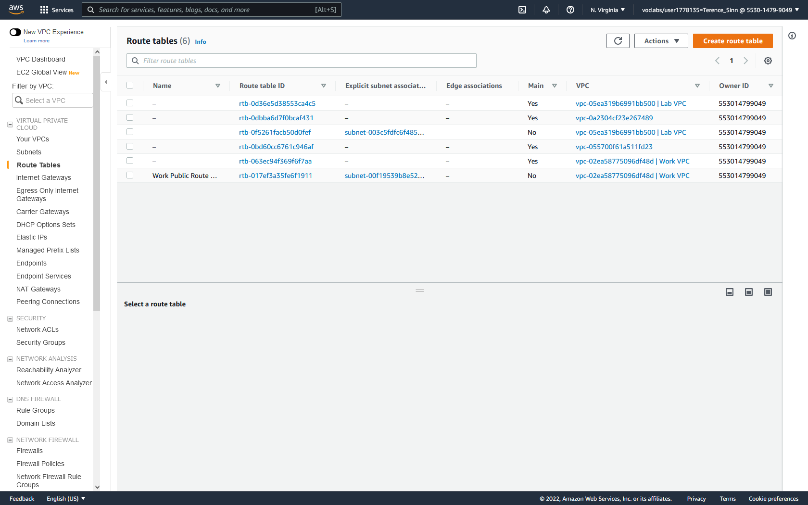

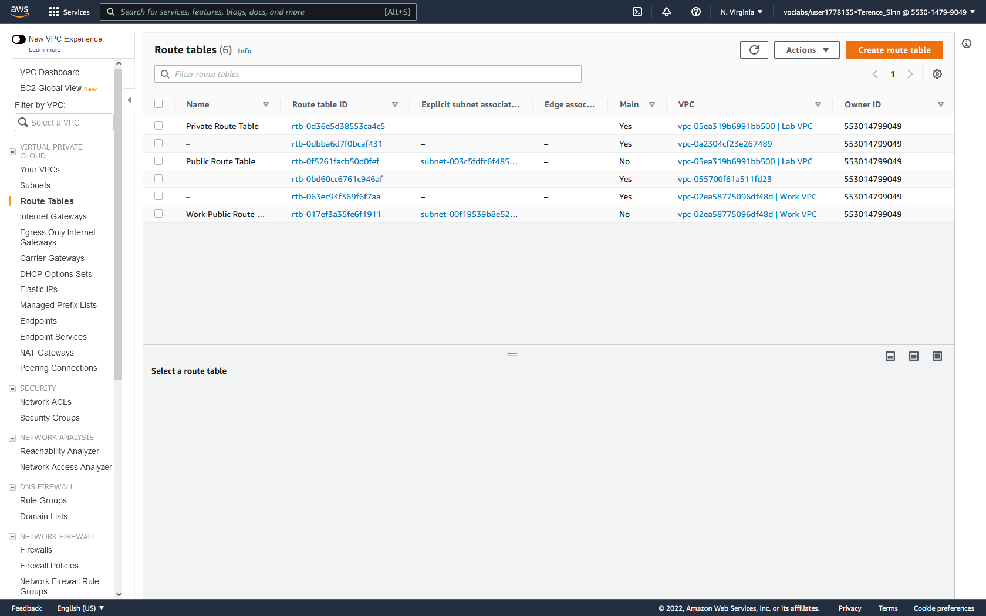

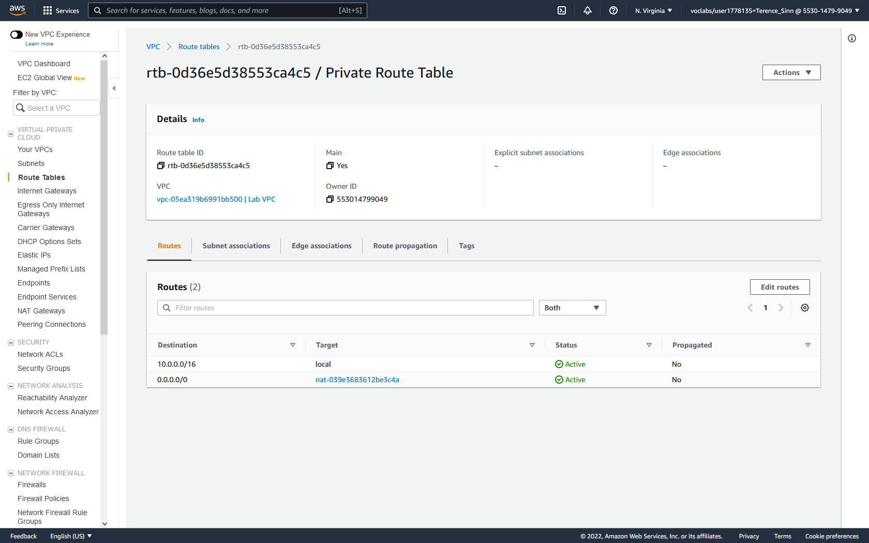

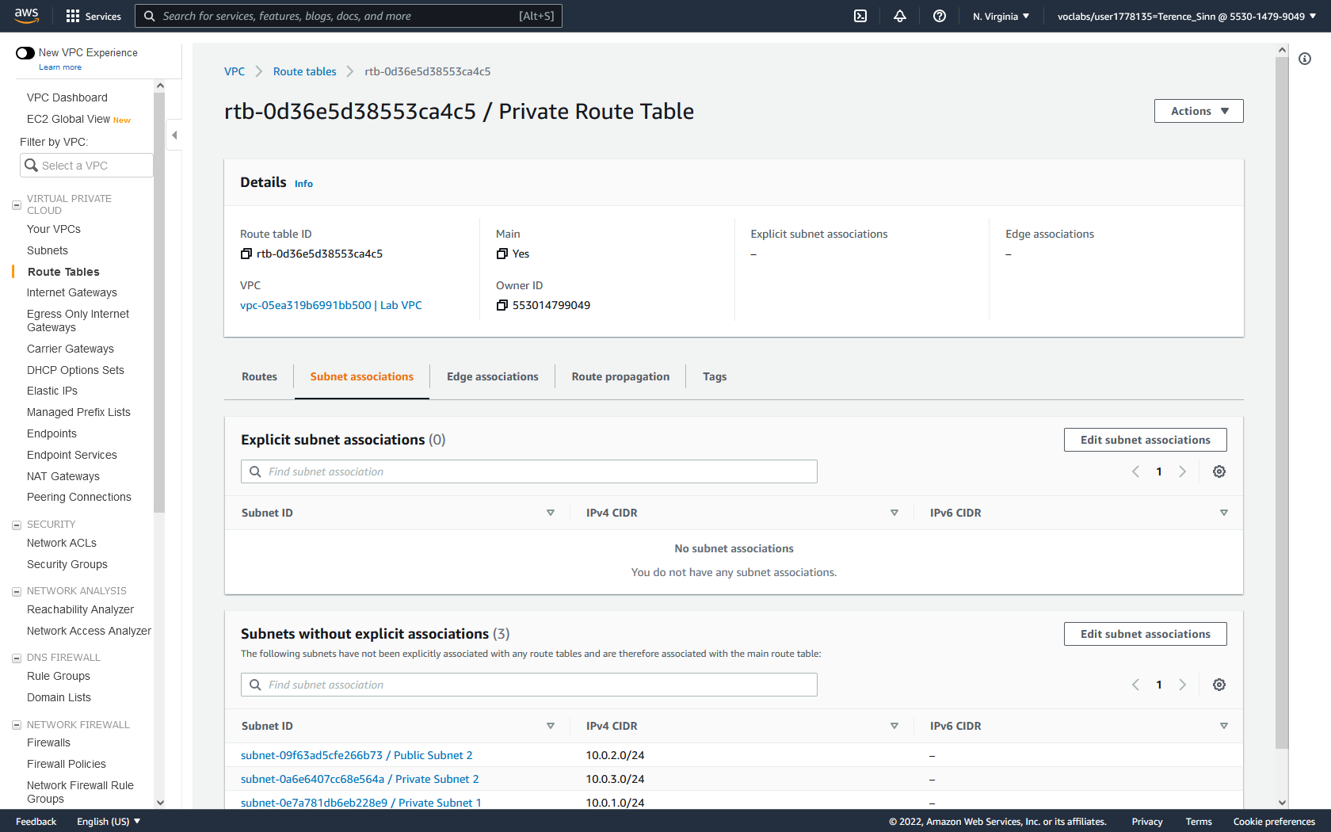

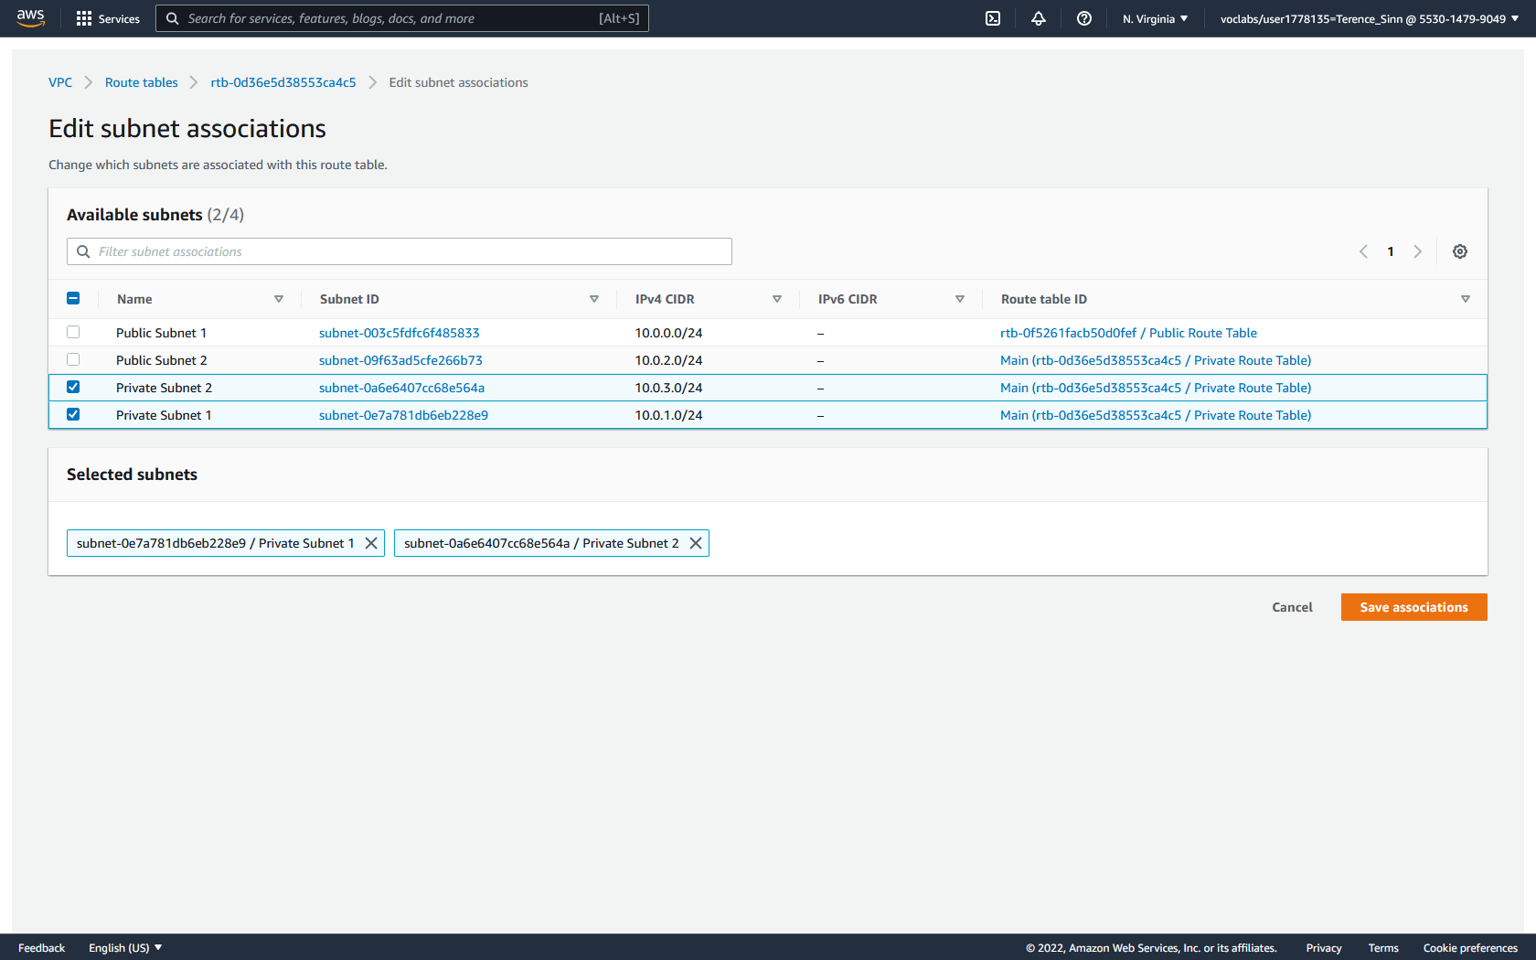

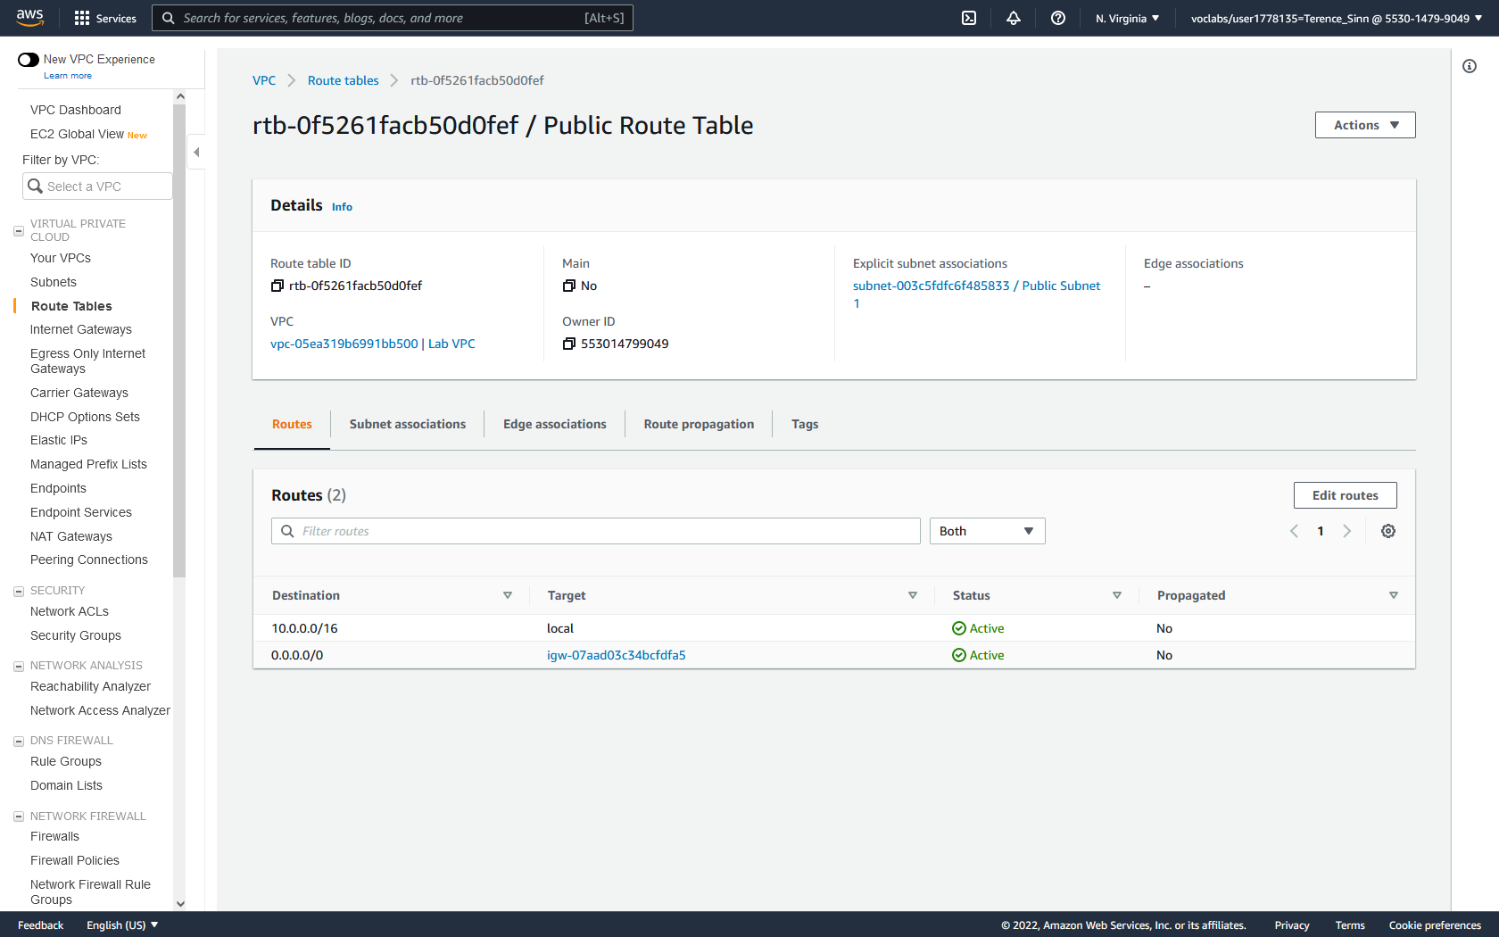

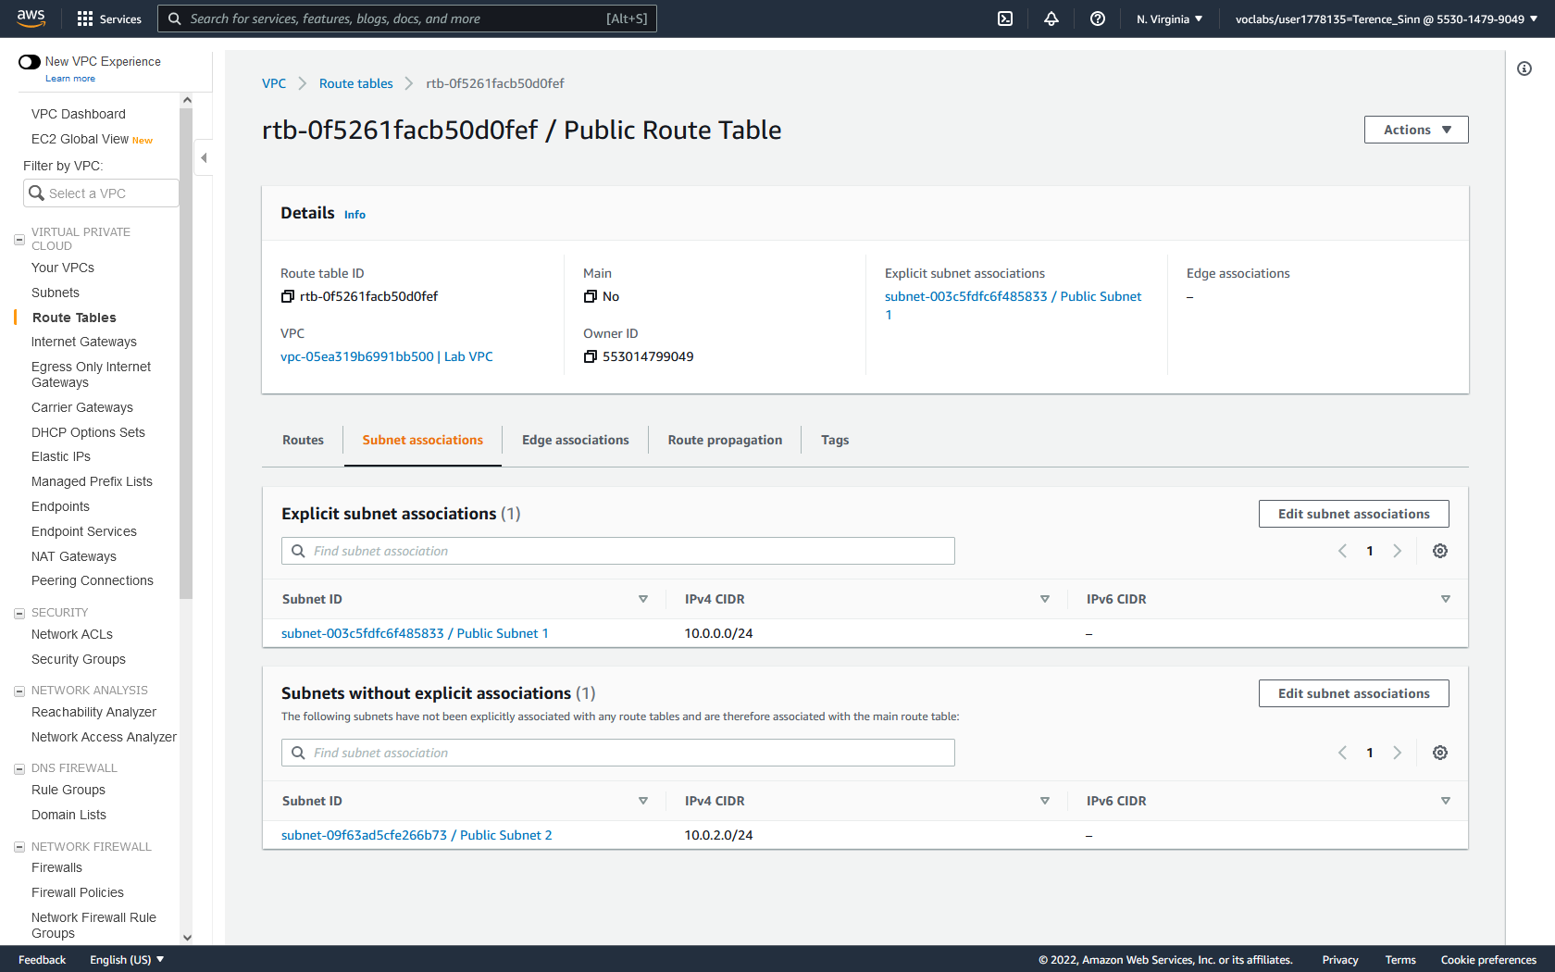

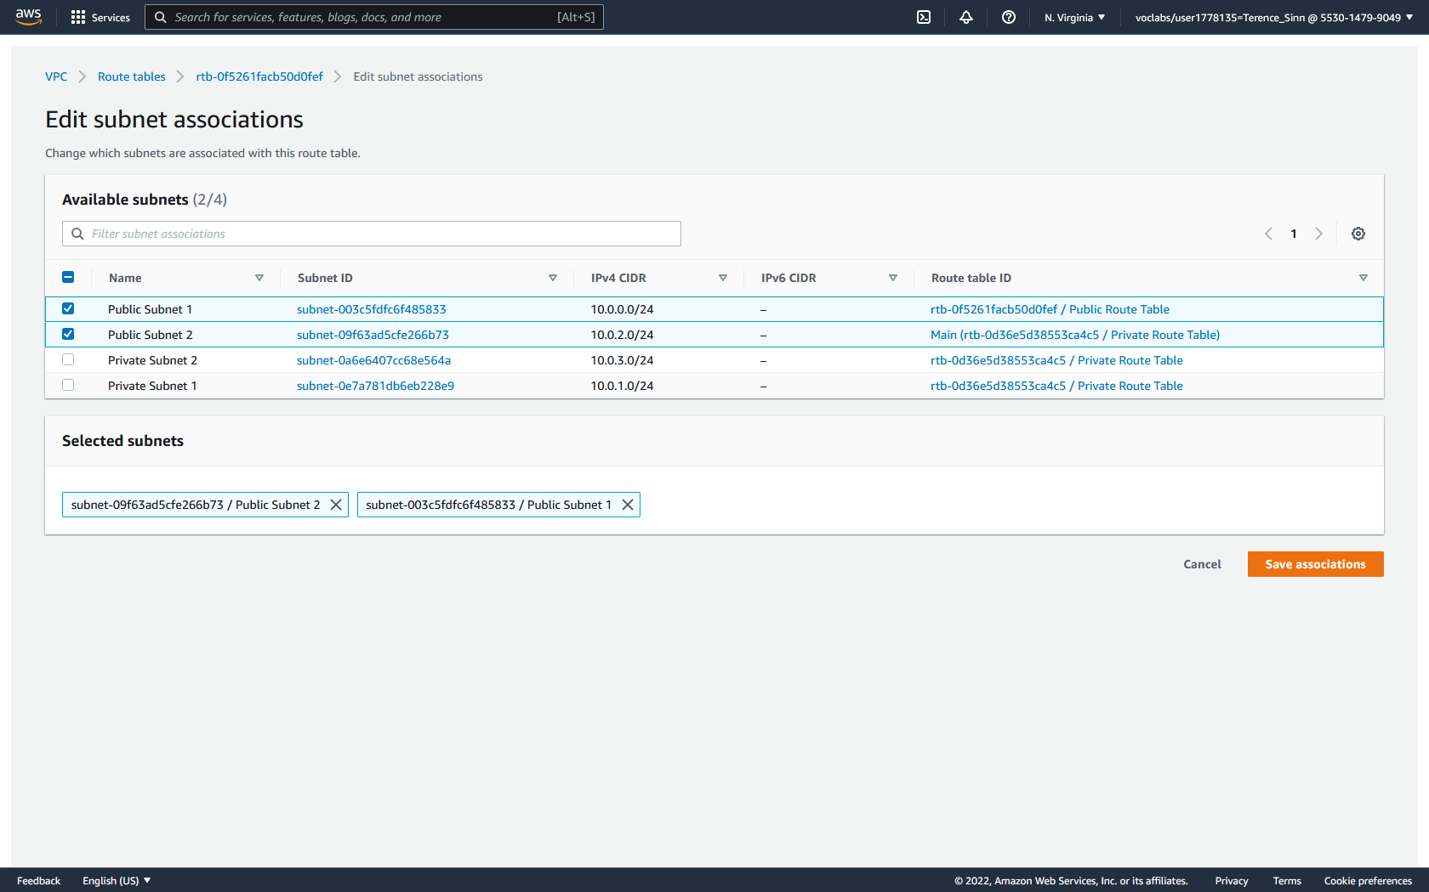

**Create Security Group:**

1. On the left menu, click Security Groups to reach the Security Groups dashboard.

2. Click Create security group.

3. Here, inbound and outbound access control entries are entered. Configure the security group with:

Name: Web Security Group

Description: Enable HTTP Access

Inbound Rule: HTTP from Anywhere-IPv4

Outbound Rule: All traffic from Anywhere-IPv4

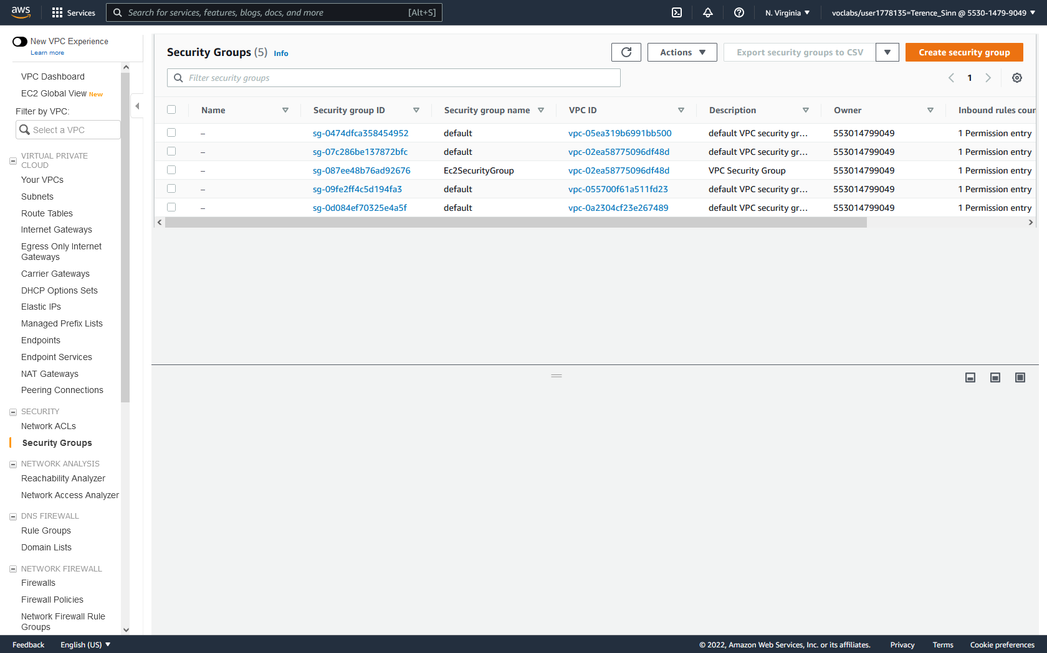

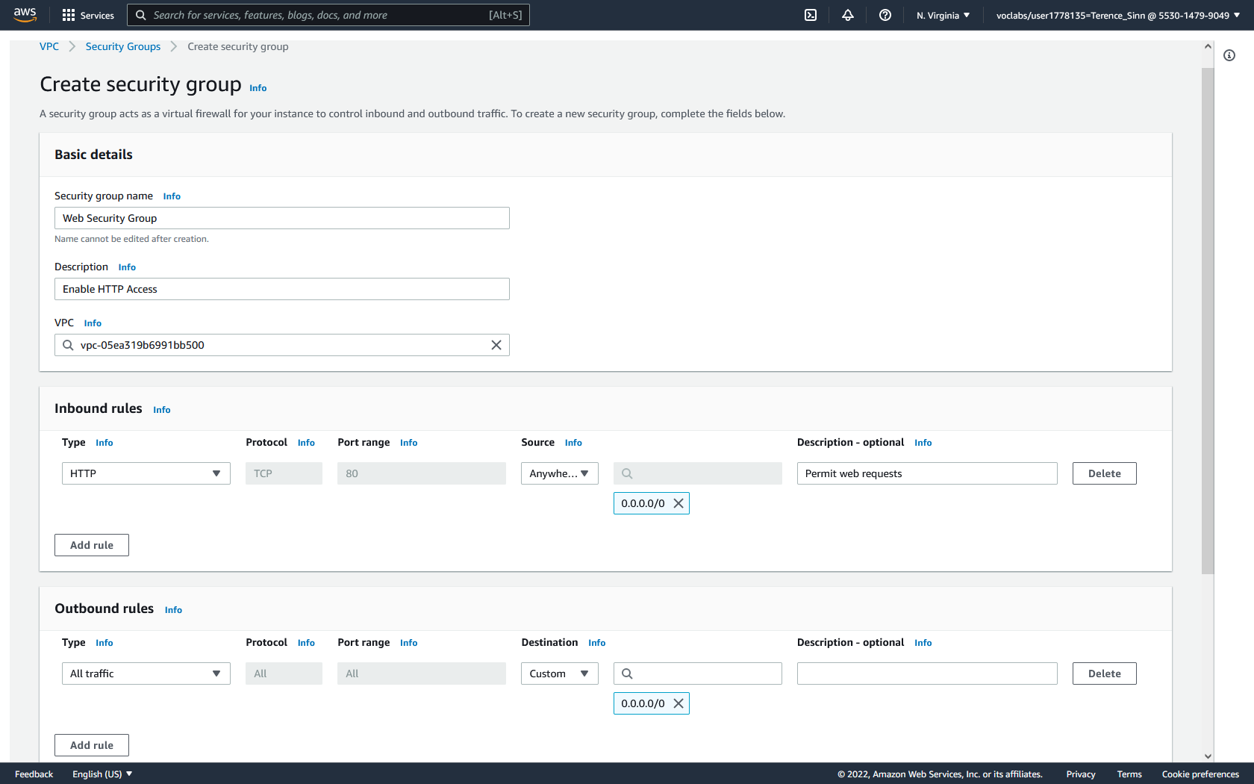

**Part 3: EC2**

**Create EC2 Instance:**

1. In the EC2 instances dashboard, click Launch Instances.

2. Next, the operating system of the virtual machine is chosen. For this lab, choose the Amazon Linux 2 AMI Kernel 5.10. Then click onto Instance Type.

3. Here, the computing hardware for the virtual machine is chosen. For this lab, choose the t2.micro option and click next onto instance details.

4. Configure the instance to use the Lab VPC and enable termination protection. Under user data, paste in the following script to automate the installation of the web server.

#!/bin/bash

yum -y install httpd

systemctl enable httpd

systemctl start httpd

echo '<html><h1>Hello From Your Web Server!</h1></html>' > /var/www/html/index.html

Click next onto storage.

5. Amount of storage is configured in this step. For this lab, the default 8 GiB will be used.

6. Next, optionally add tags. For this lab, create the tag / key pair of Name / Web Server.

7. Click to security groups and configure the security group with the name Web Server security group and give it the description of Security group for my web server. Remove the existing SSH rule to disable remote management of this server.

8. Click review and launch. When prompted to choose a key pair, choose the option to proceed with no key pair and acknowledge. Key pairs are used for remote management and logging into the virtual machine. For this lab, this is not needed so we can proceed without it.

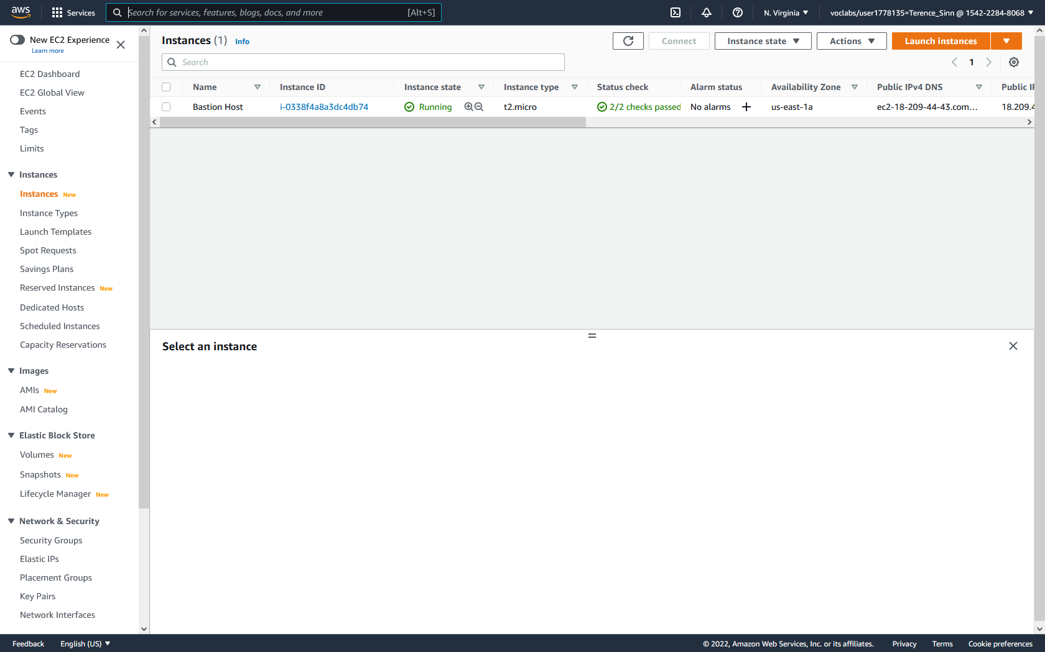

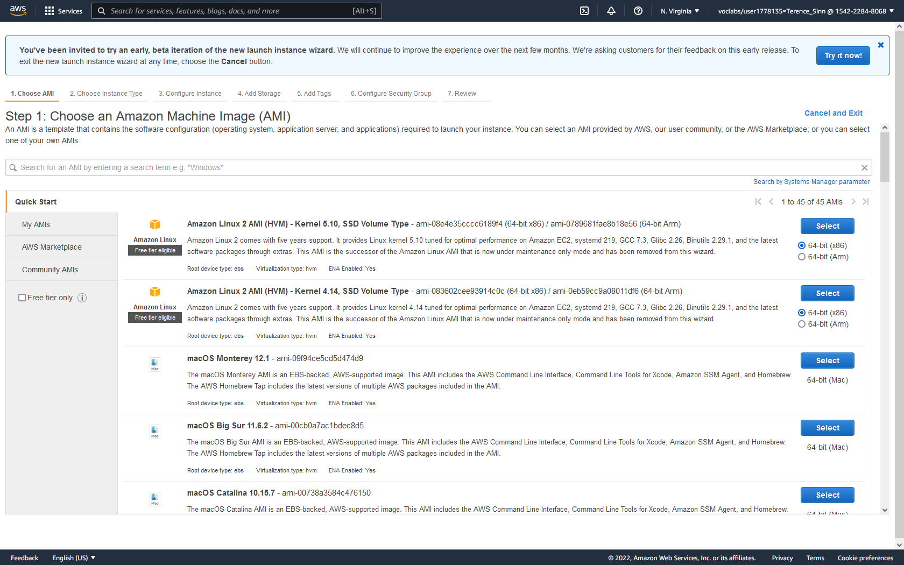

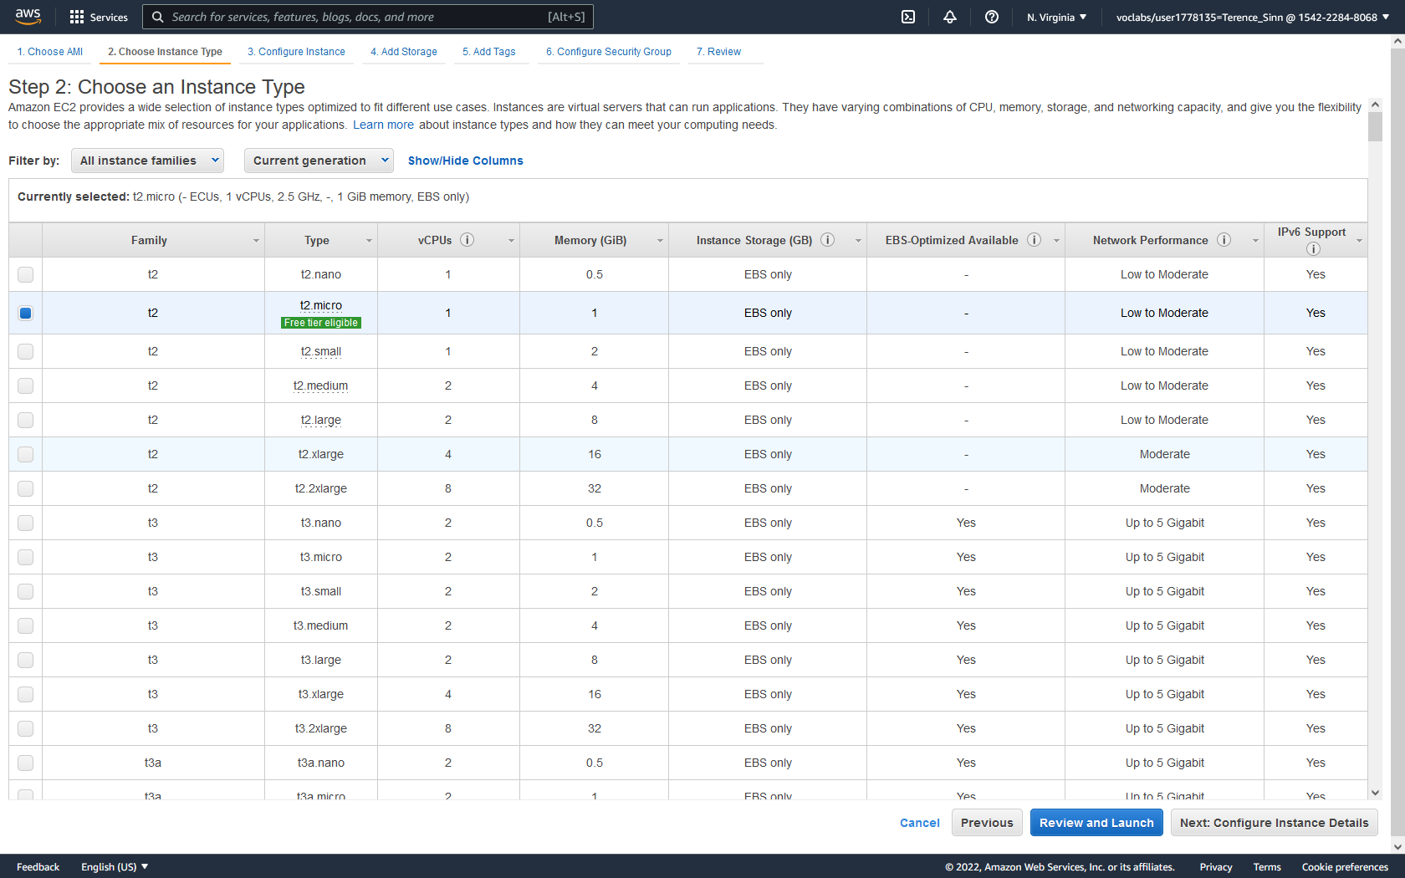

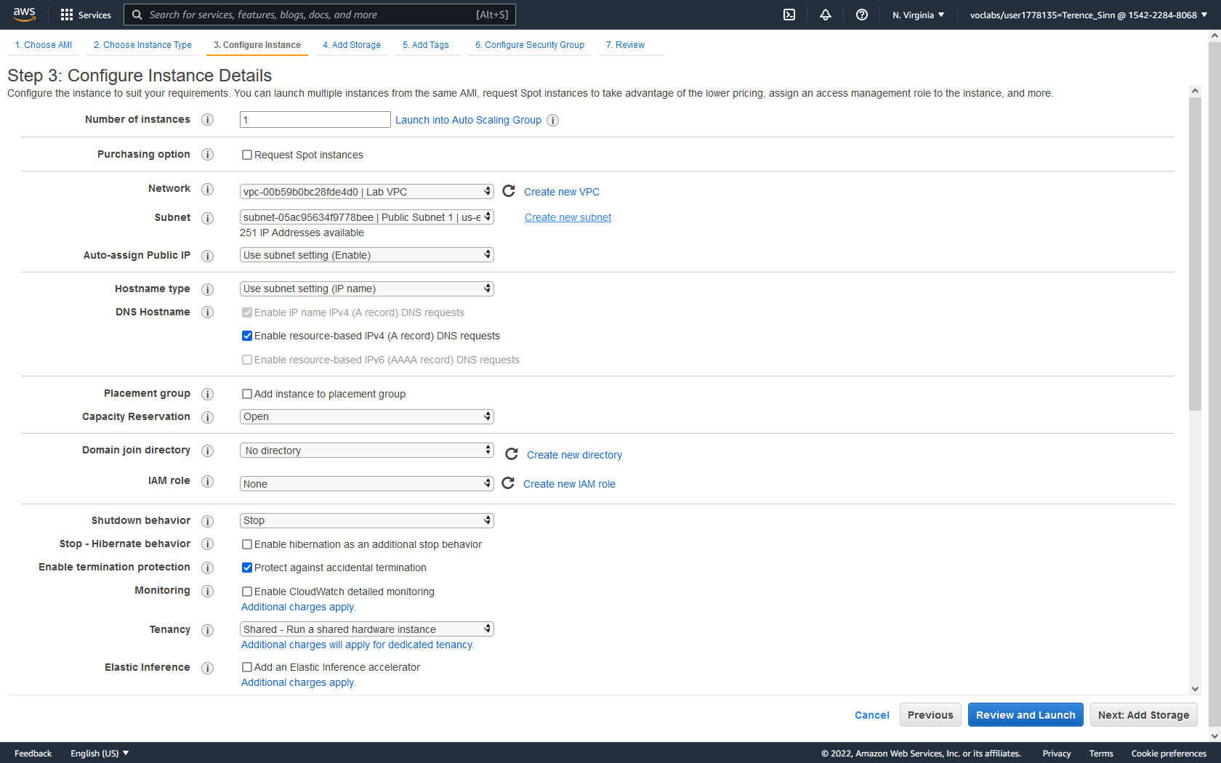

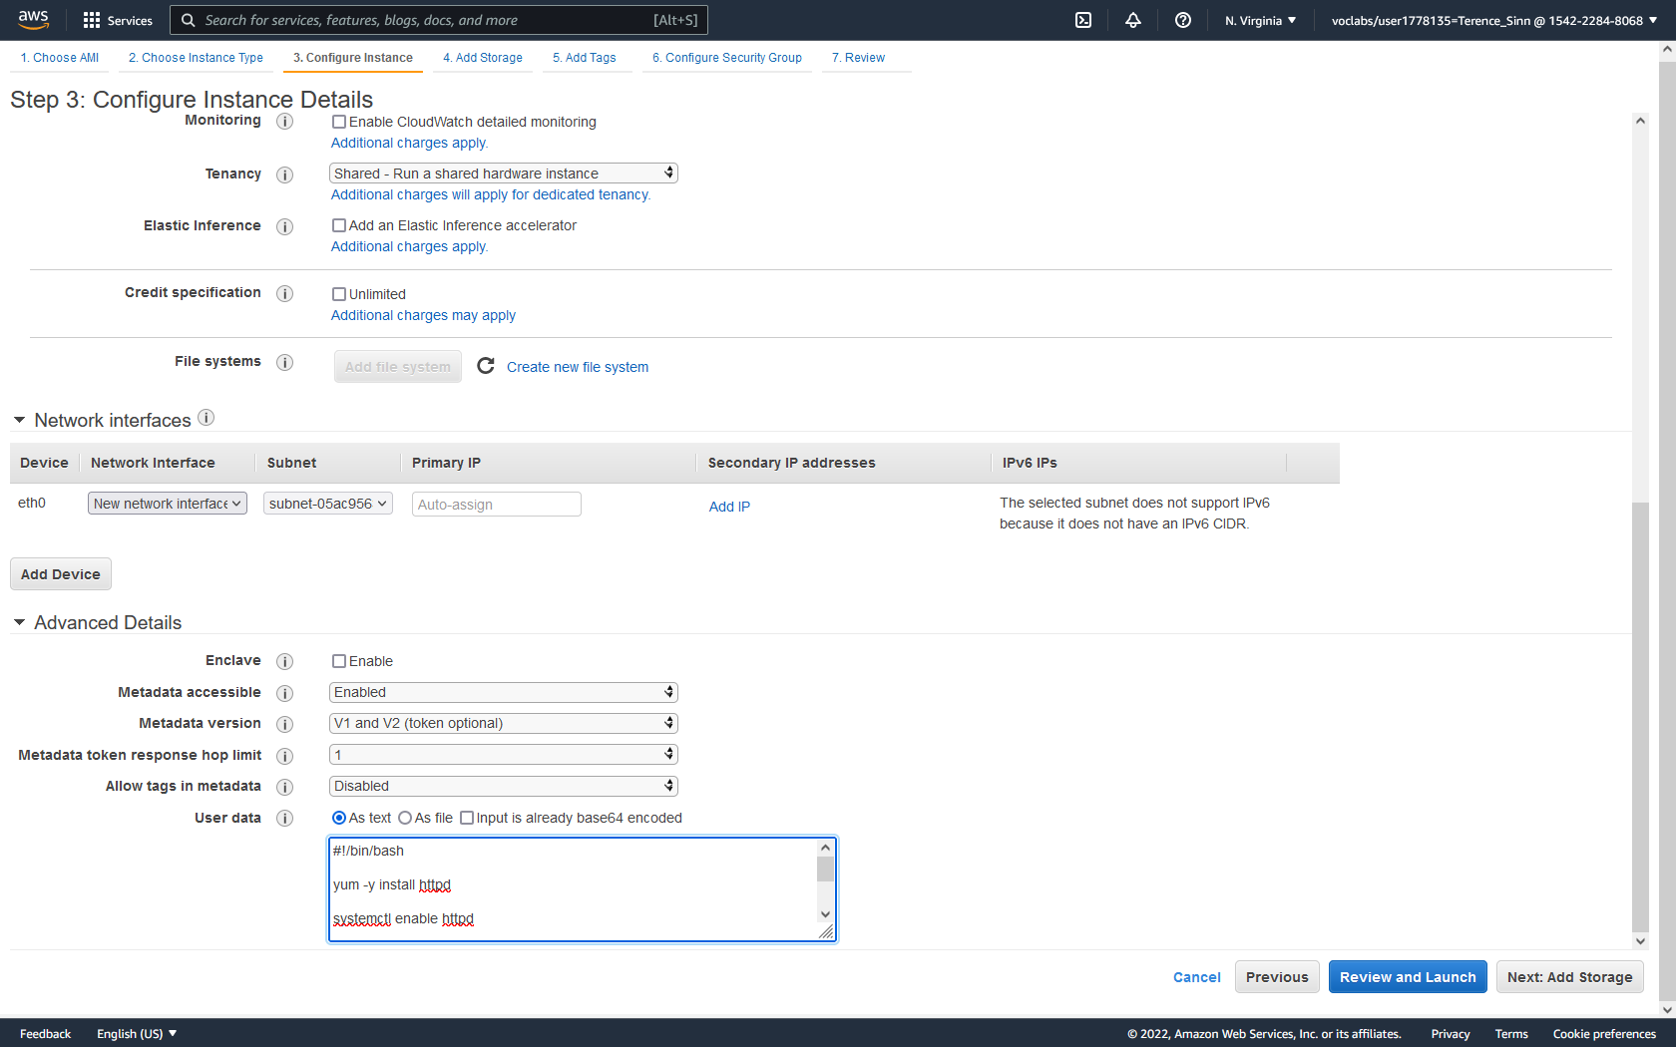

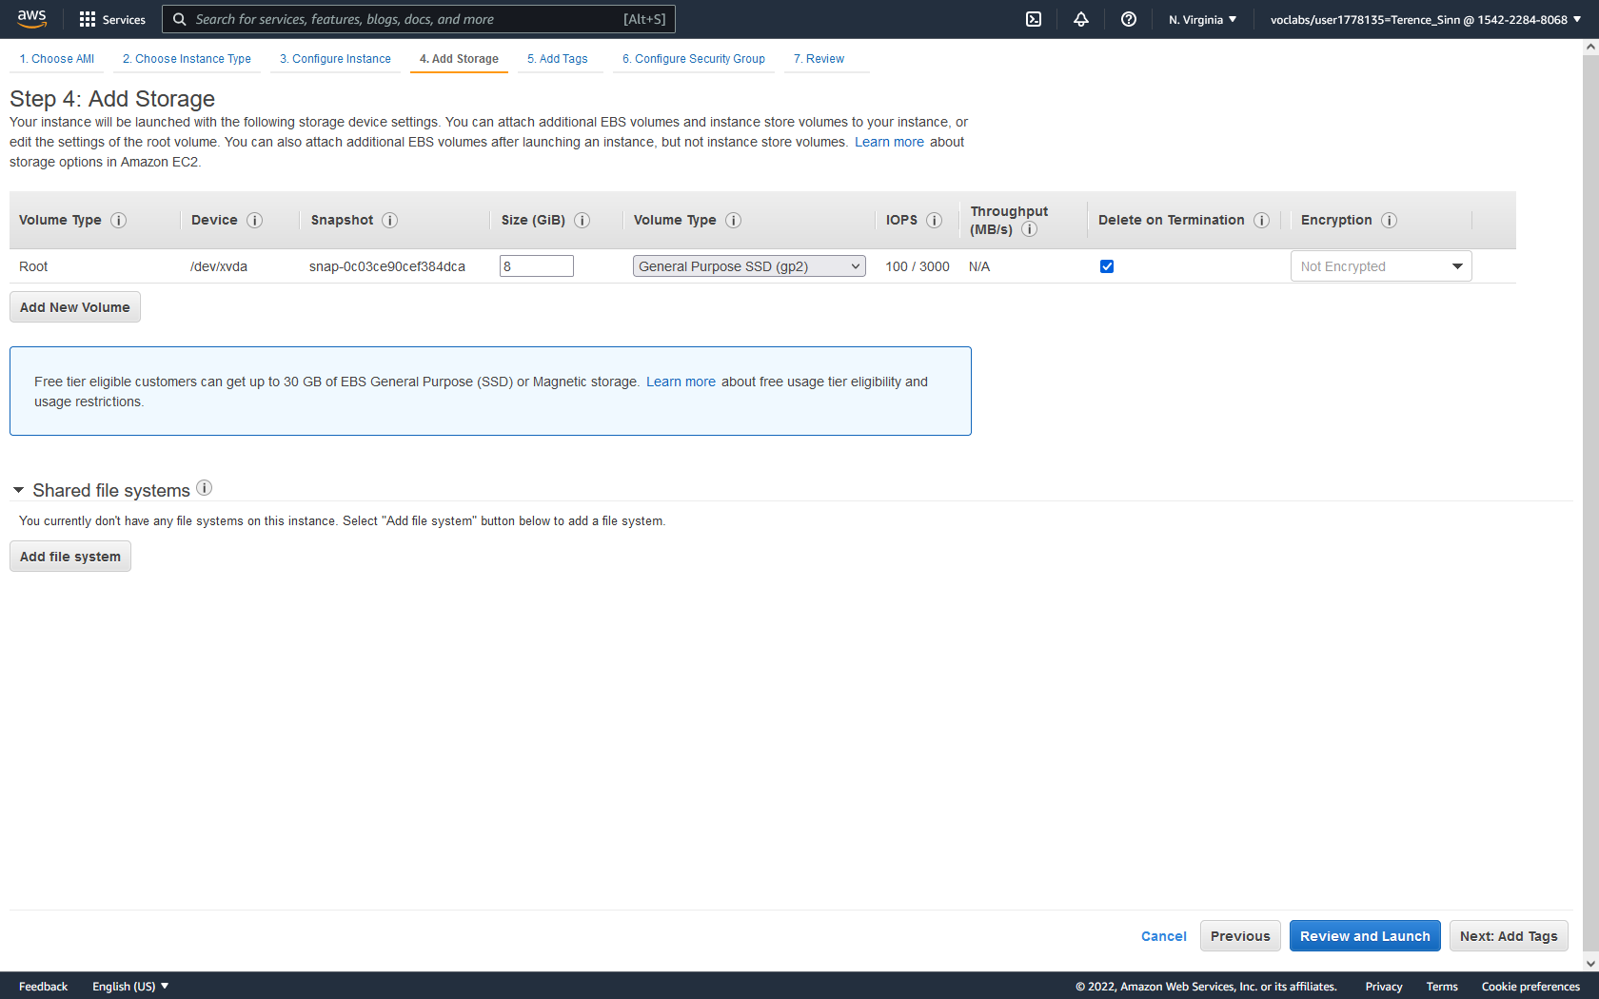

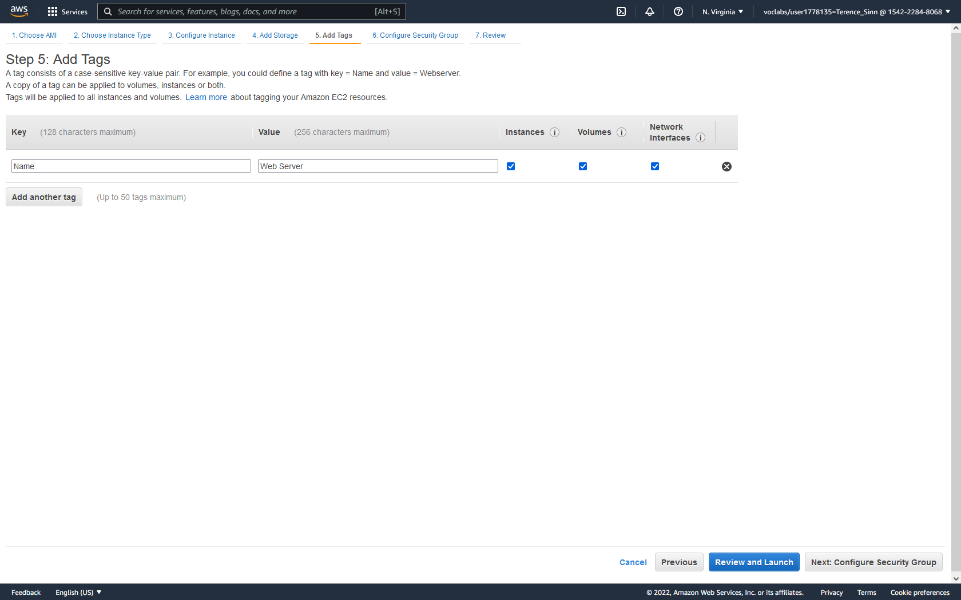

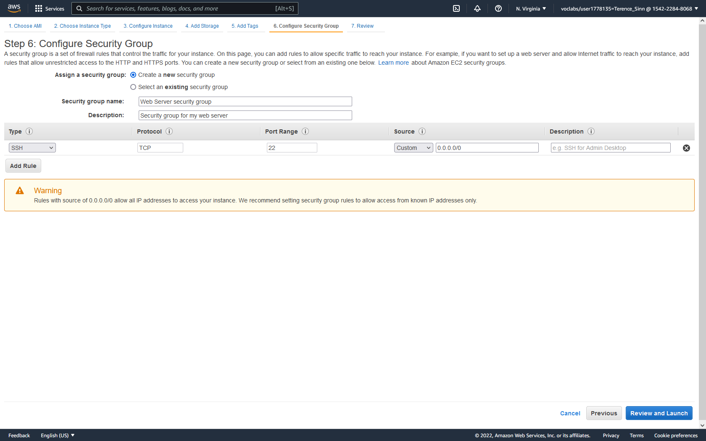

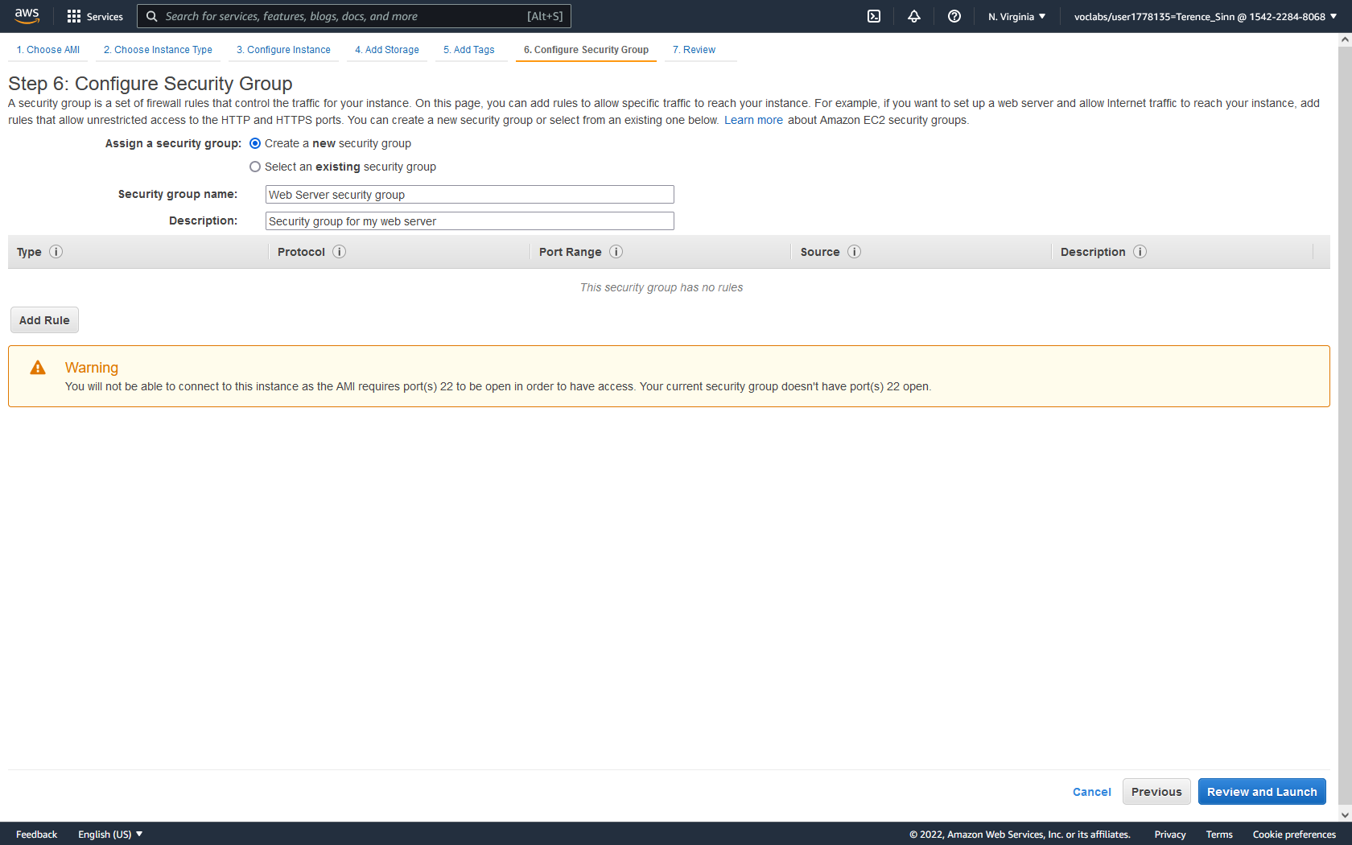

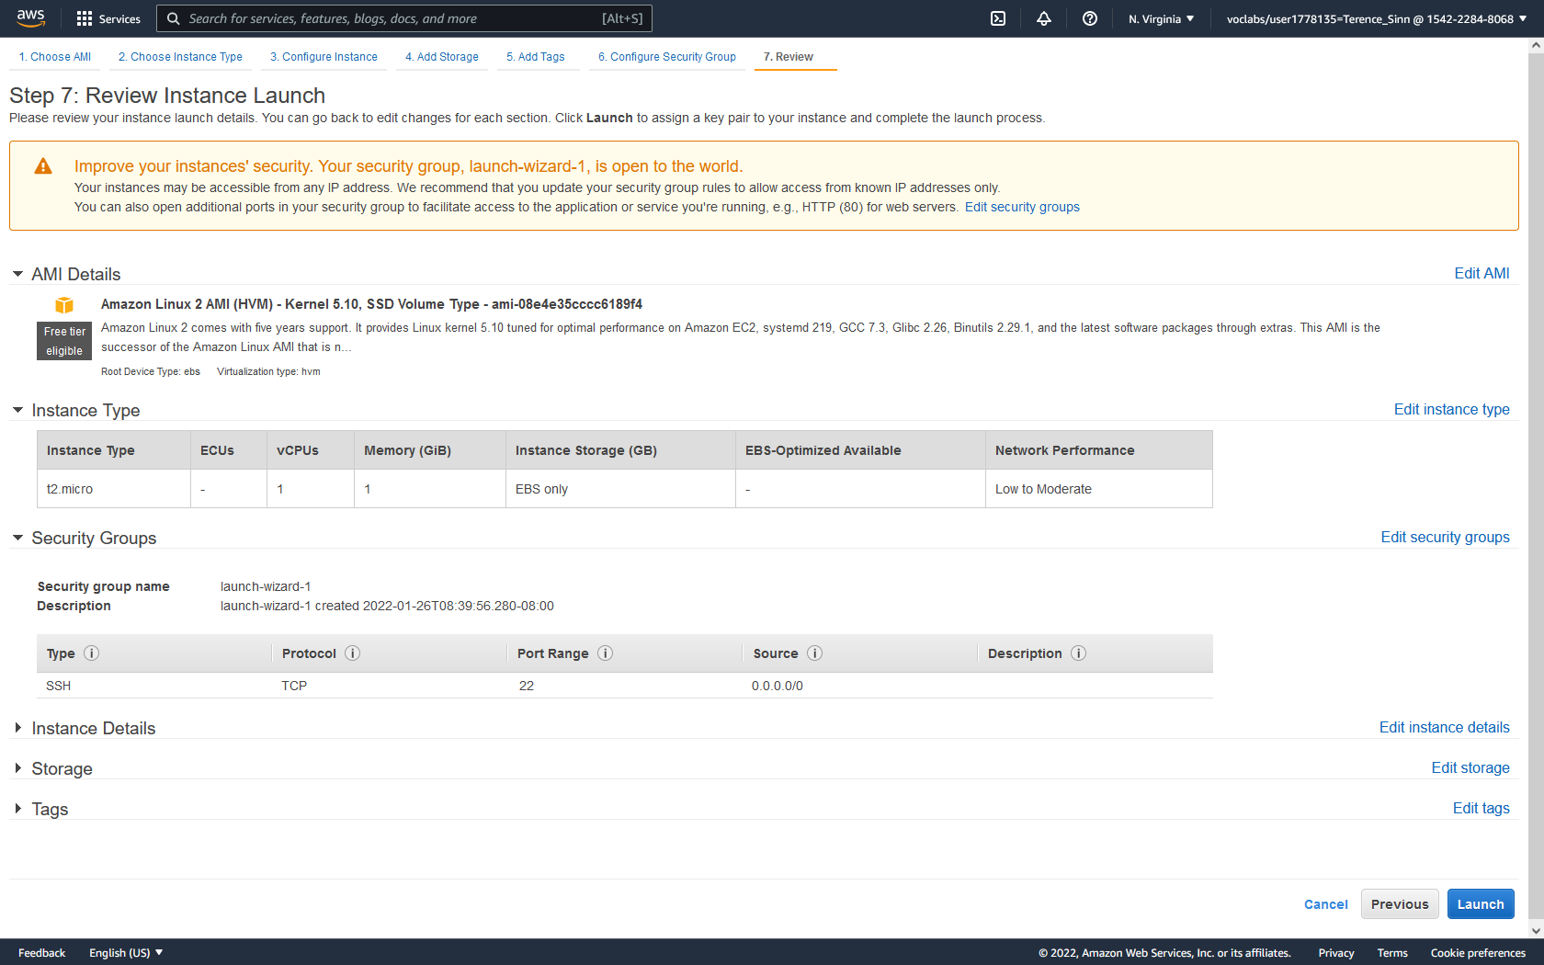

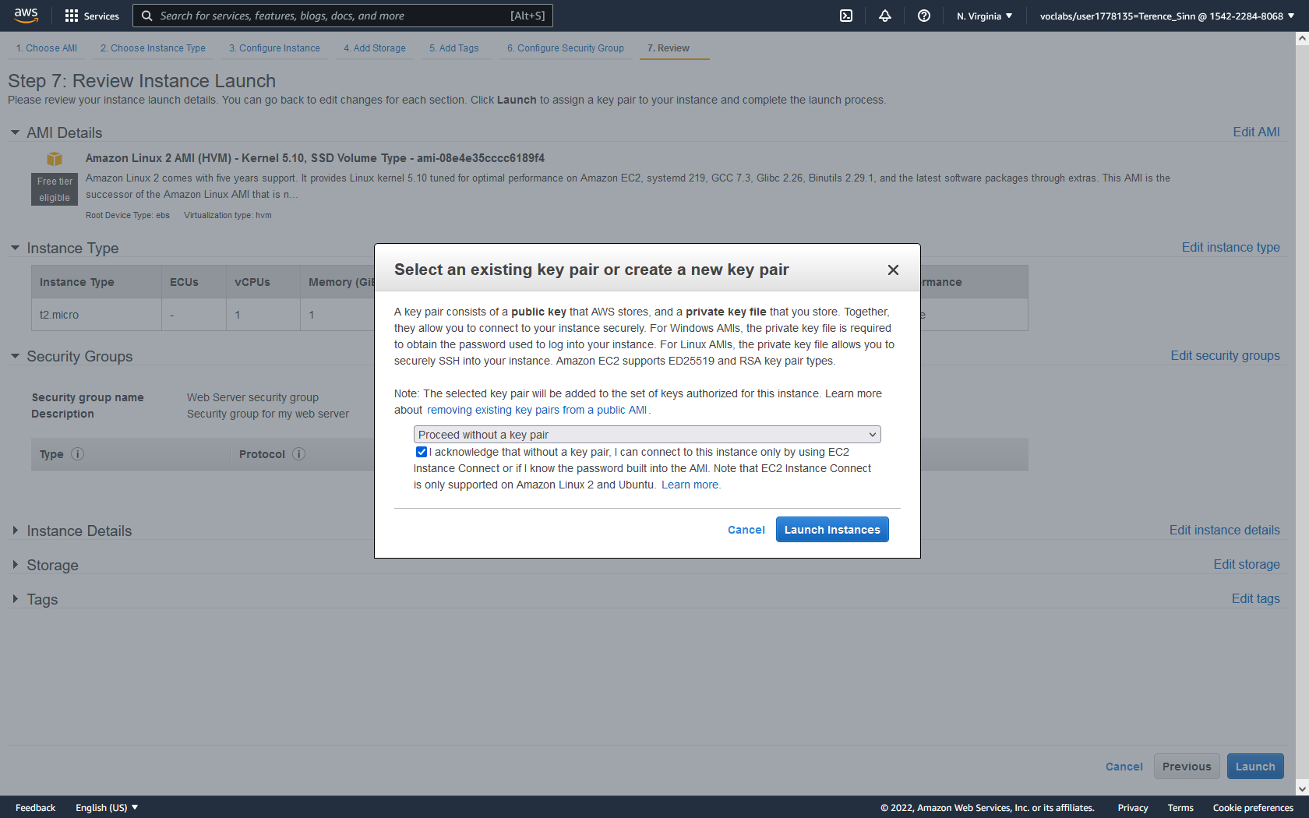

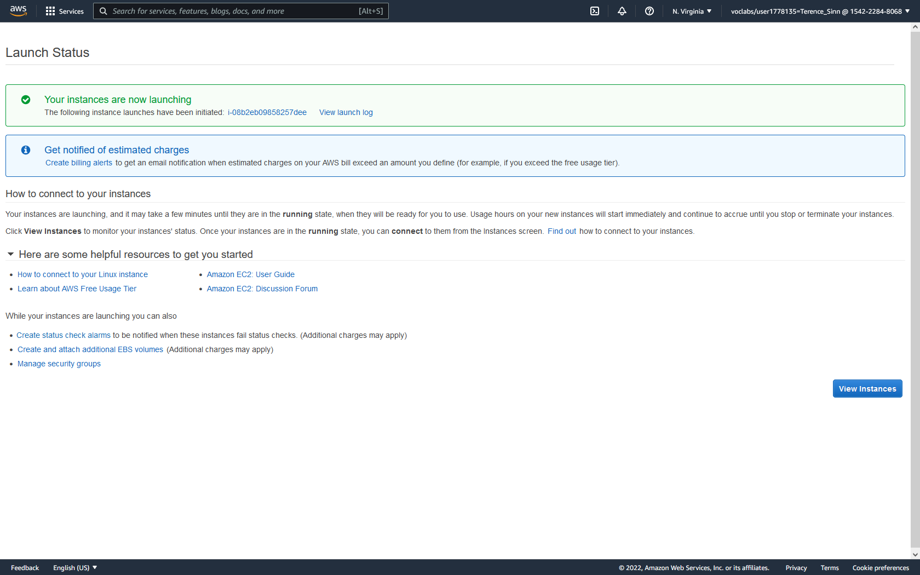

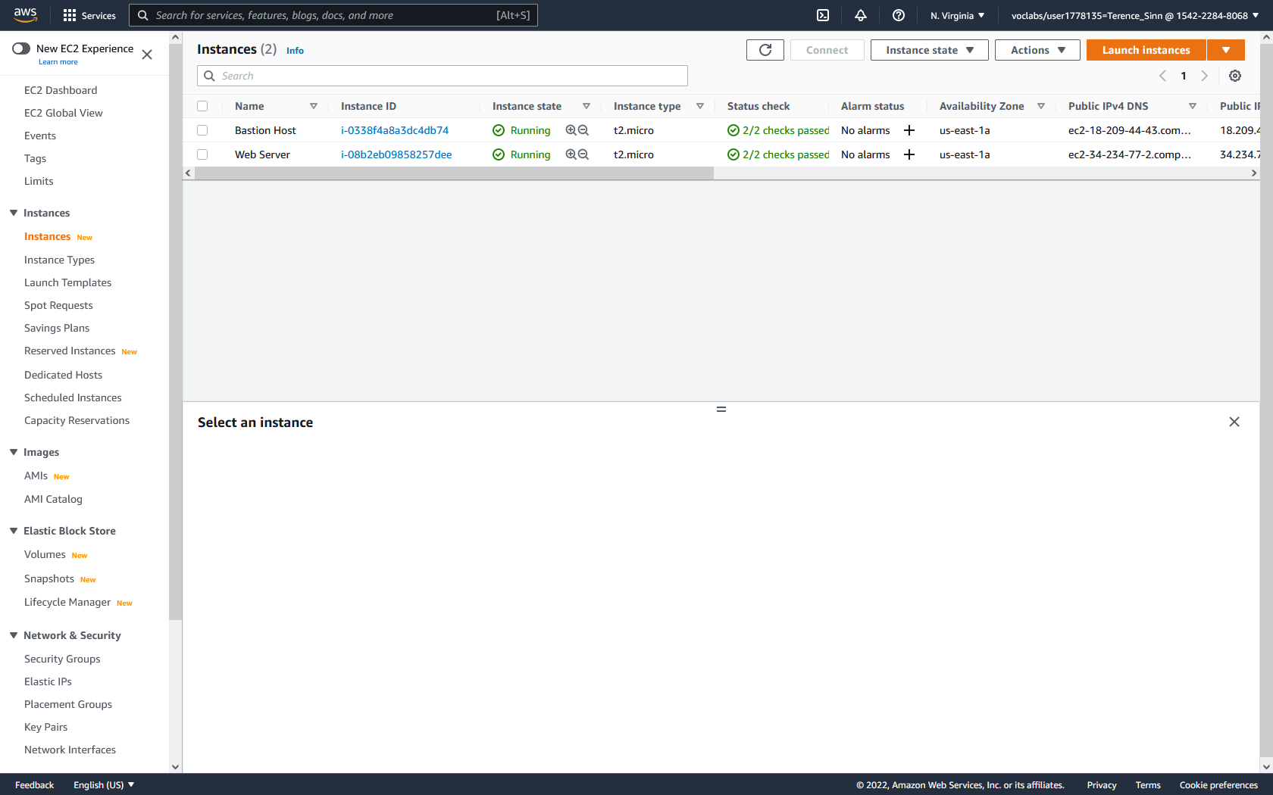

**Accessing the web server:**

1. Click into the web server to view its details. Notice the public IPv4 addresses and public IPv4 DNS address. Copy either address and try to access it. This request should time out. This failure is because we haven’t enabled the capability to reach the web server using http.

2. Go to security groups on the left menu. Click into the web server security group and notice how there are no inbound rules.

3. Click edit inbound rules and add rule. Setup the rule to encompass http traffic from anywhere-ipv4. Save the rules.

4. Repeat step 1 to try to access the web server. This should display a web server that says “Hello From Your Web Server!”

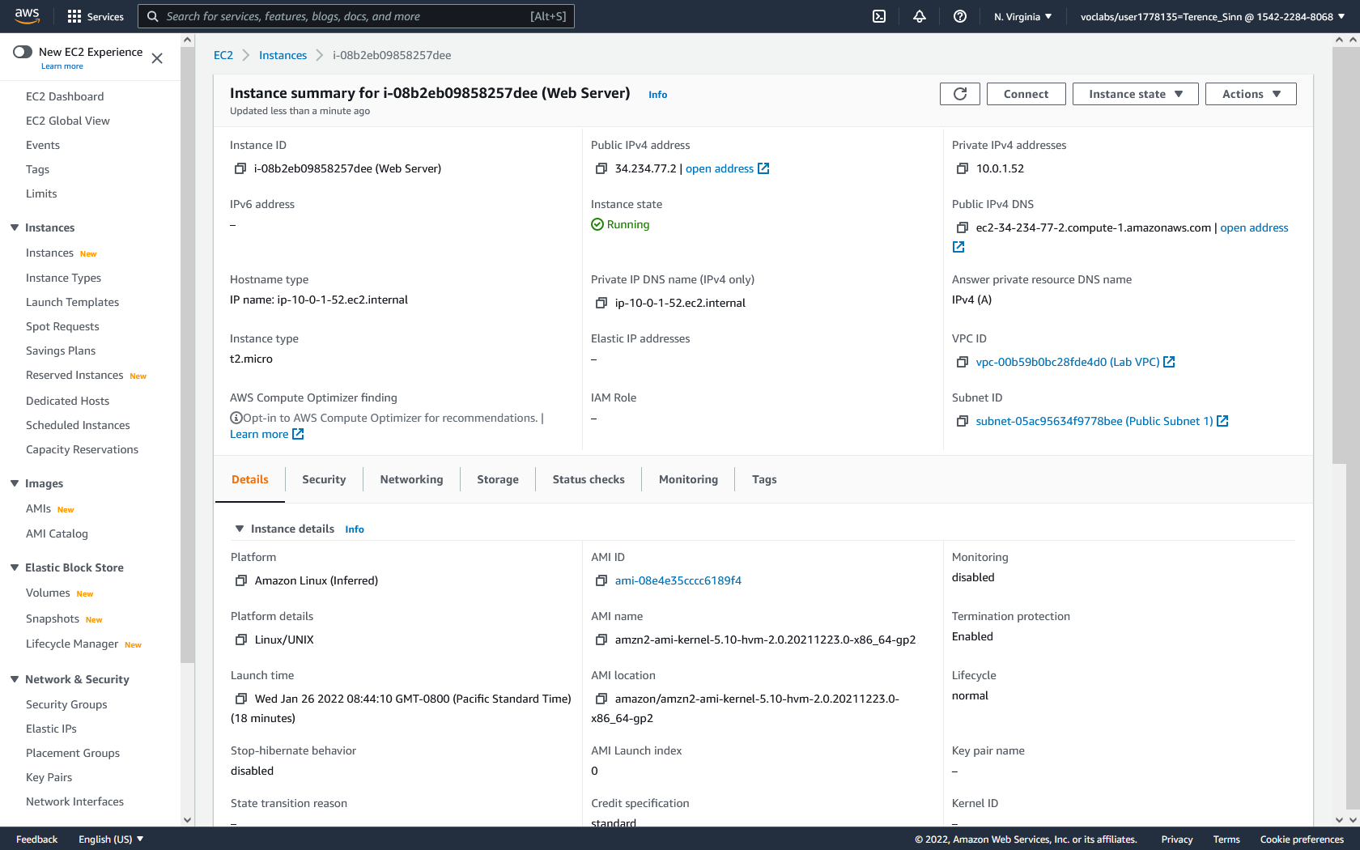

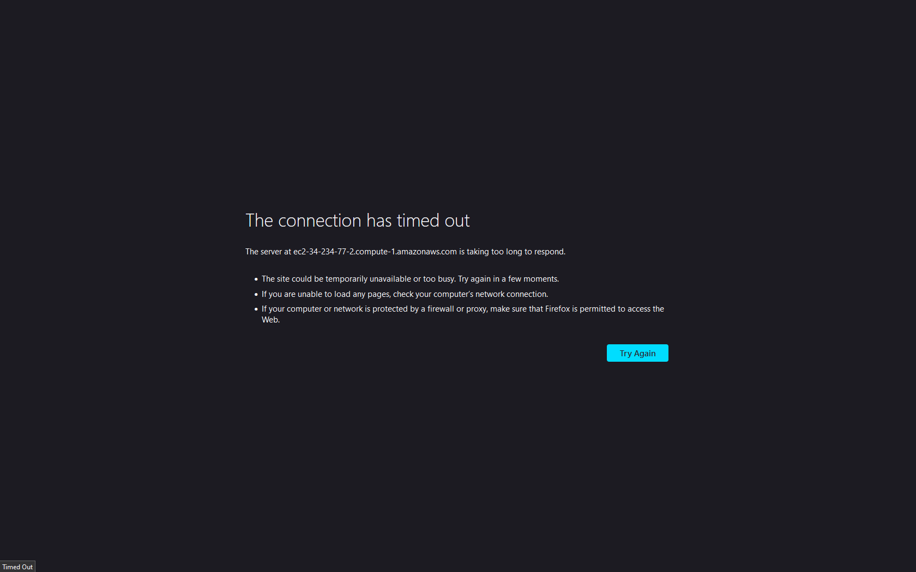

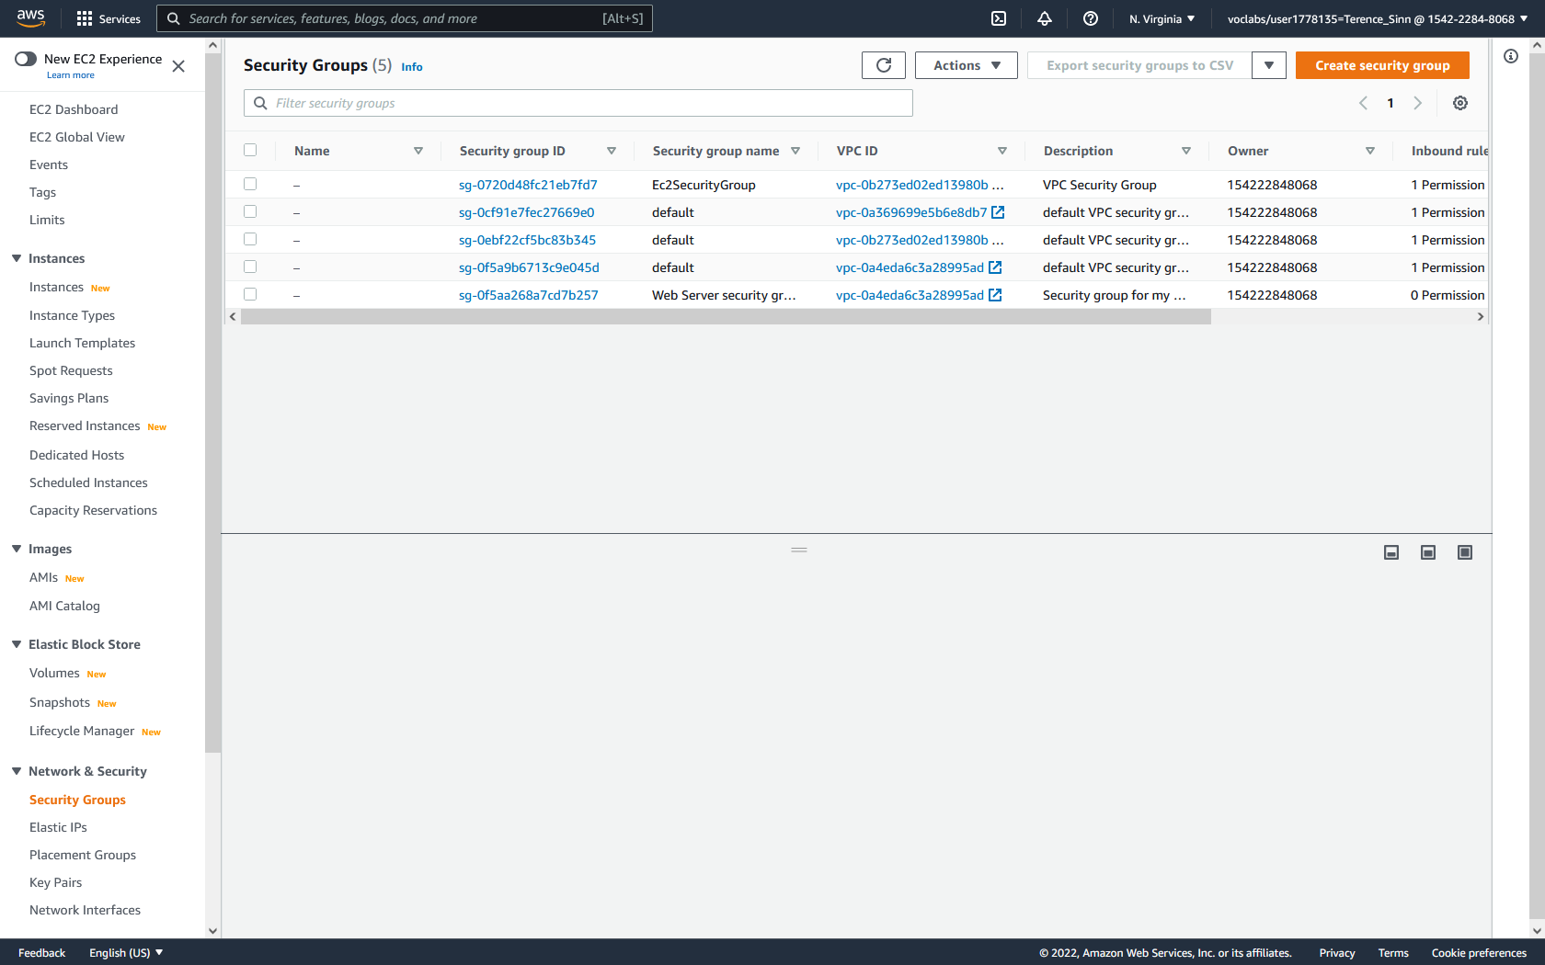

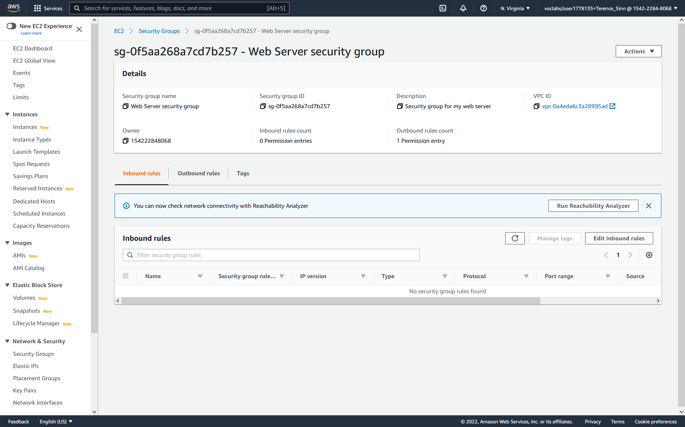

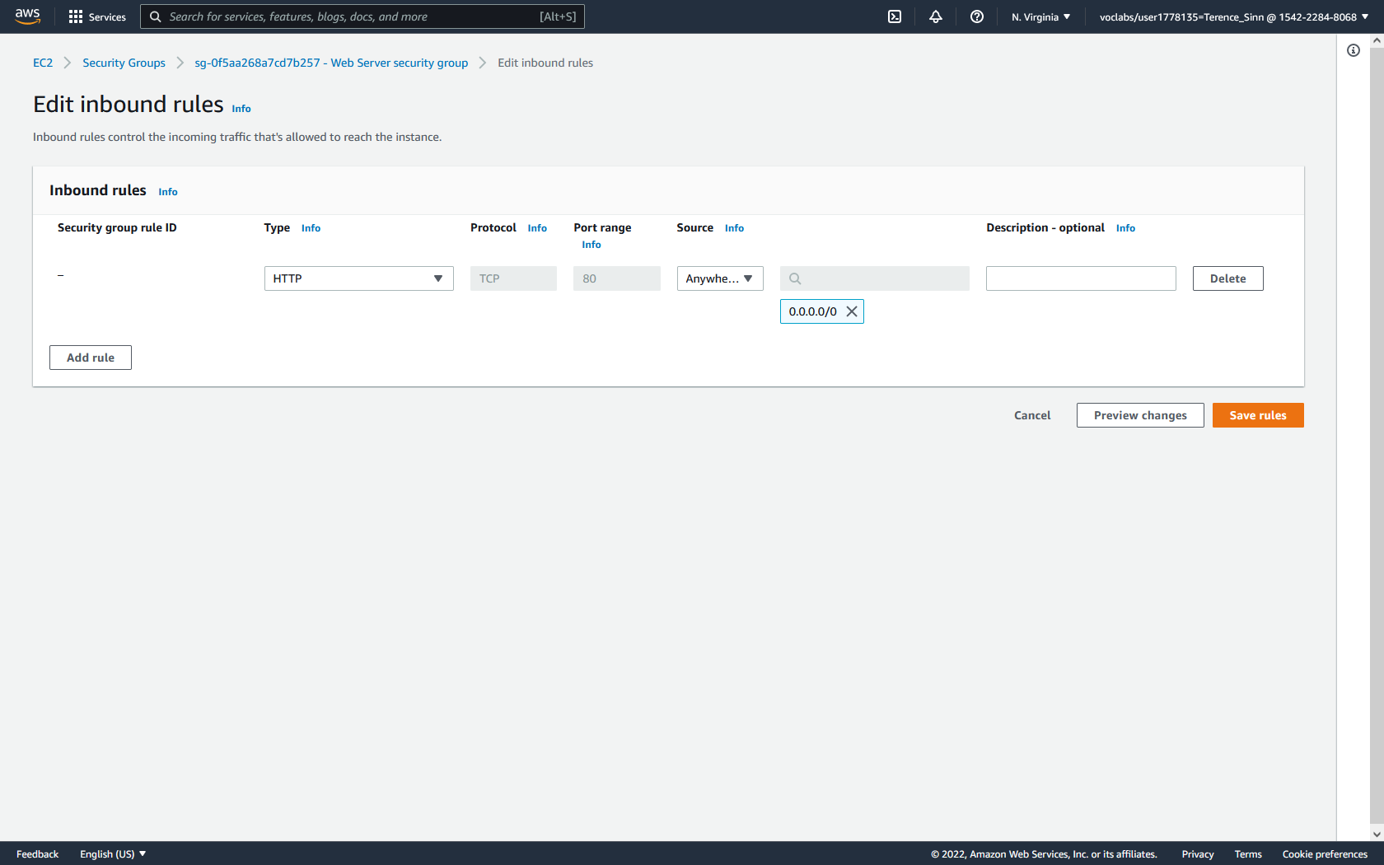

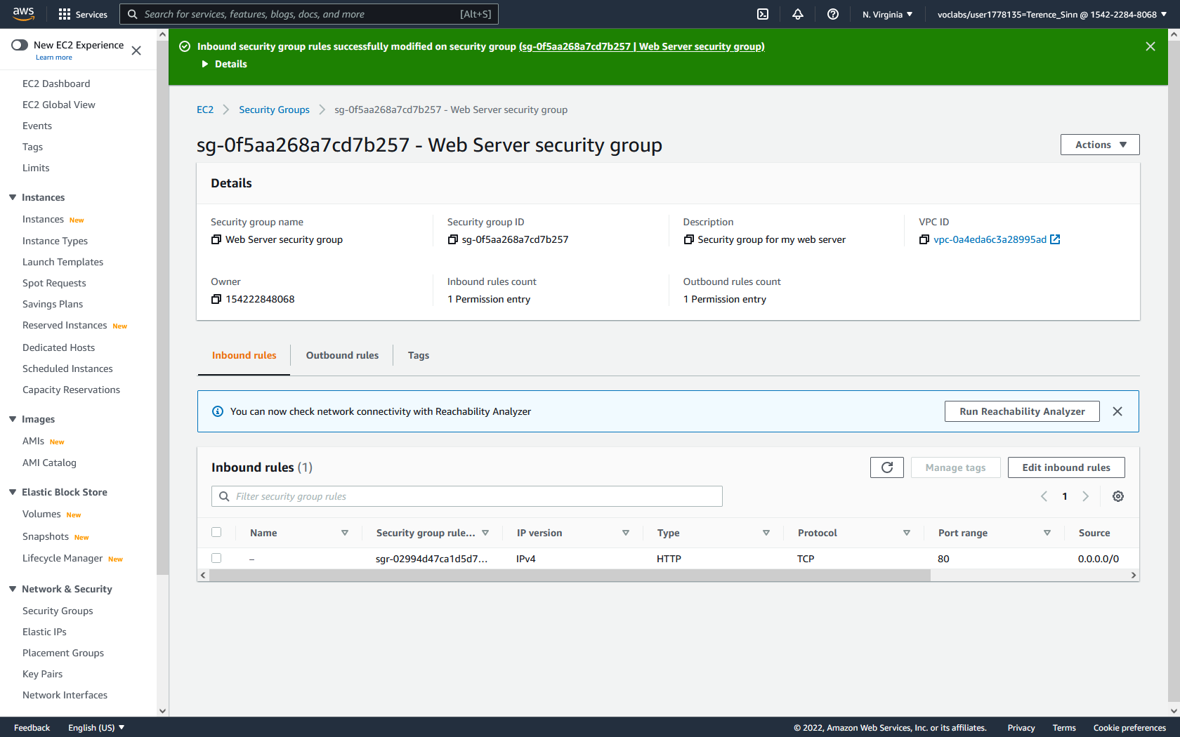



**Monitoring your virtual machine:**

1. In the instances dashboard, click into the web server. Then click into the status checks tab. This will show you whether the virtual machine is reachable.

2. Click into the monitoring tab. From here, you can examine the system performance and load.

3. In the top right, click actions, monitor and troubleshoot, and get system log. This will show you the console of the virtual machine. From here, you should see many line detailing the installation process of the web server.

4. In the top right, click actions, monitor and troubleshoot, and get instance screenshot. This will show you what the console would look like if you were directly connected and configuring the virtual machine.

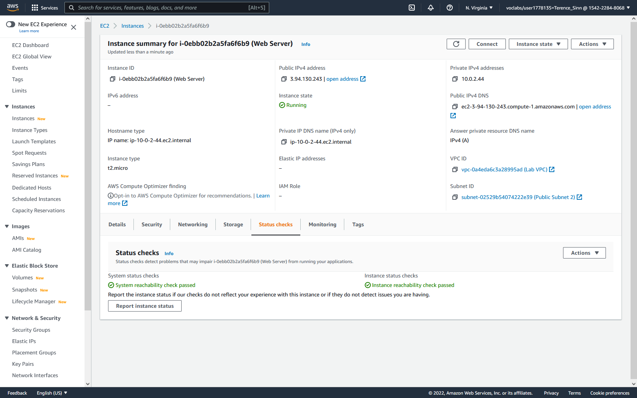

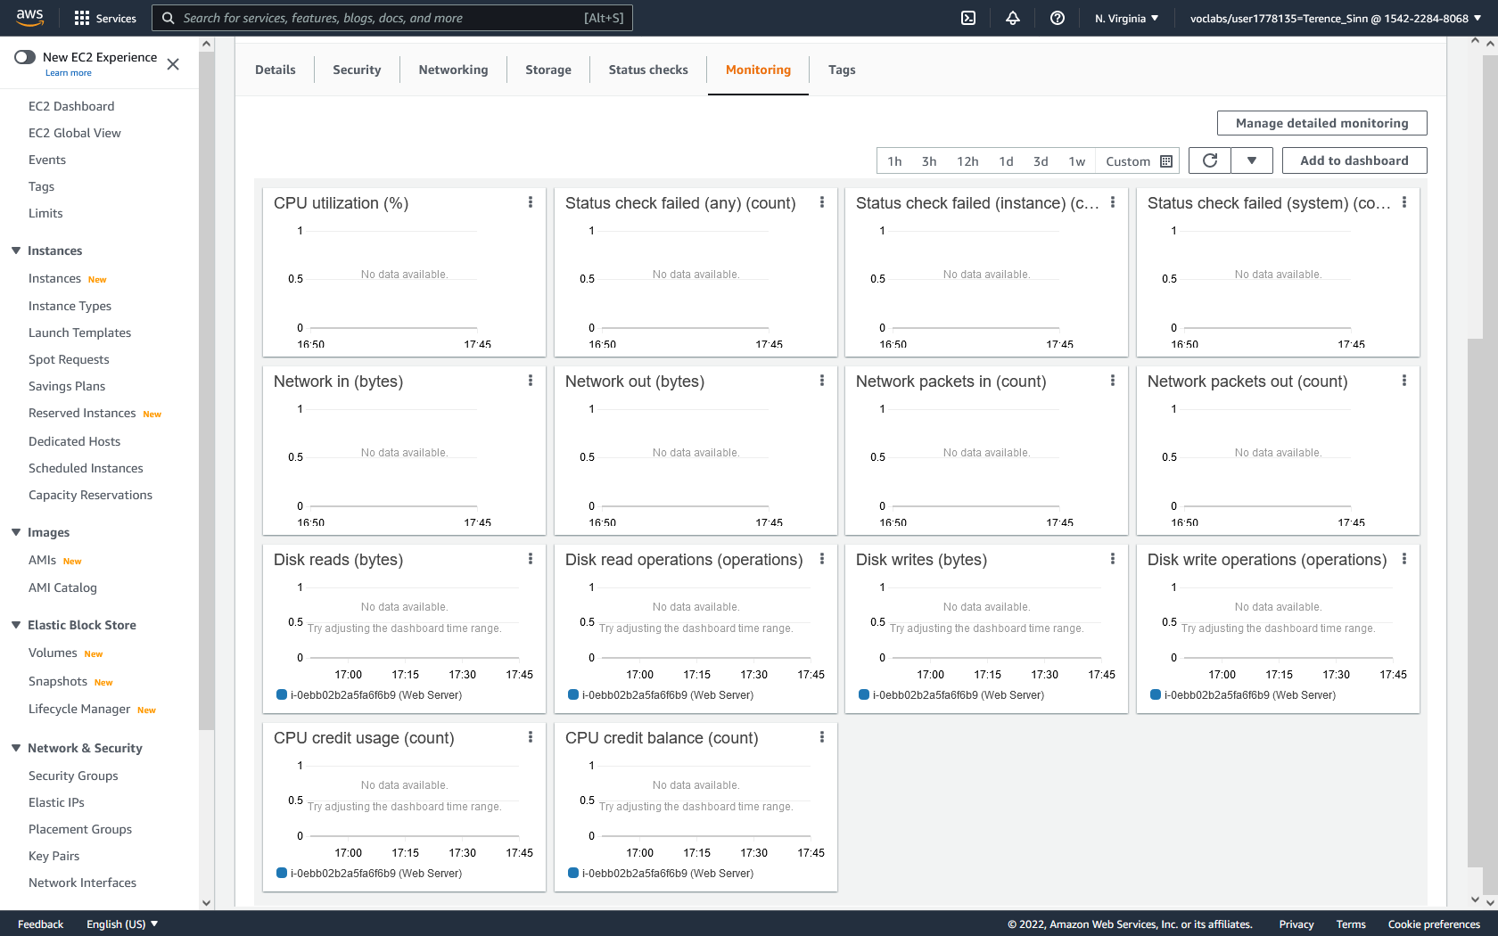

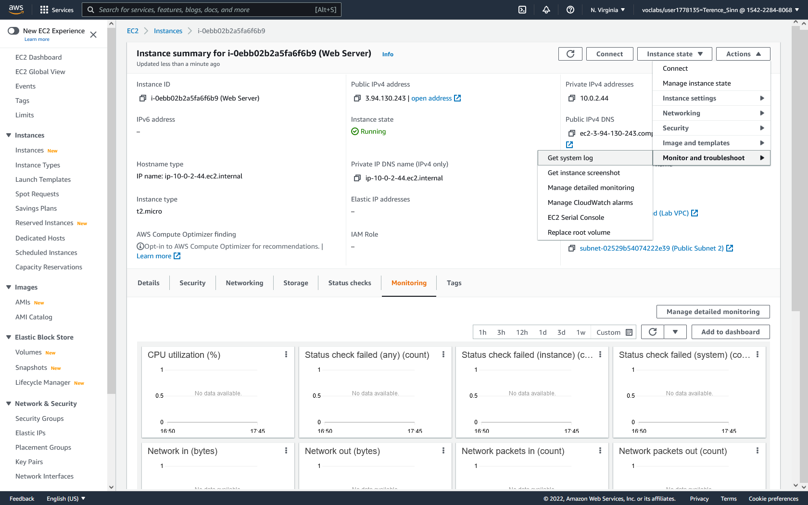

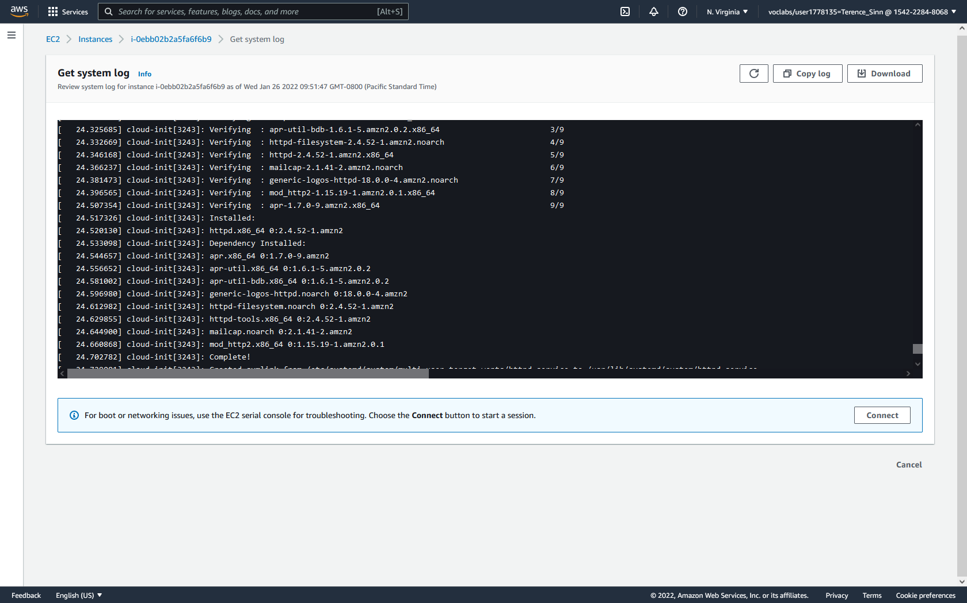

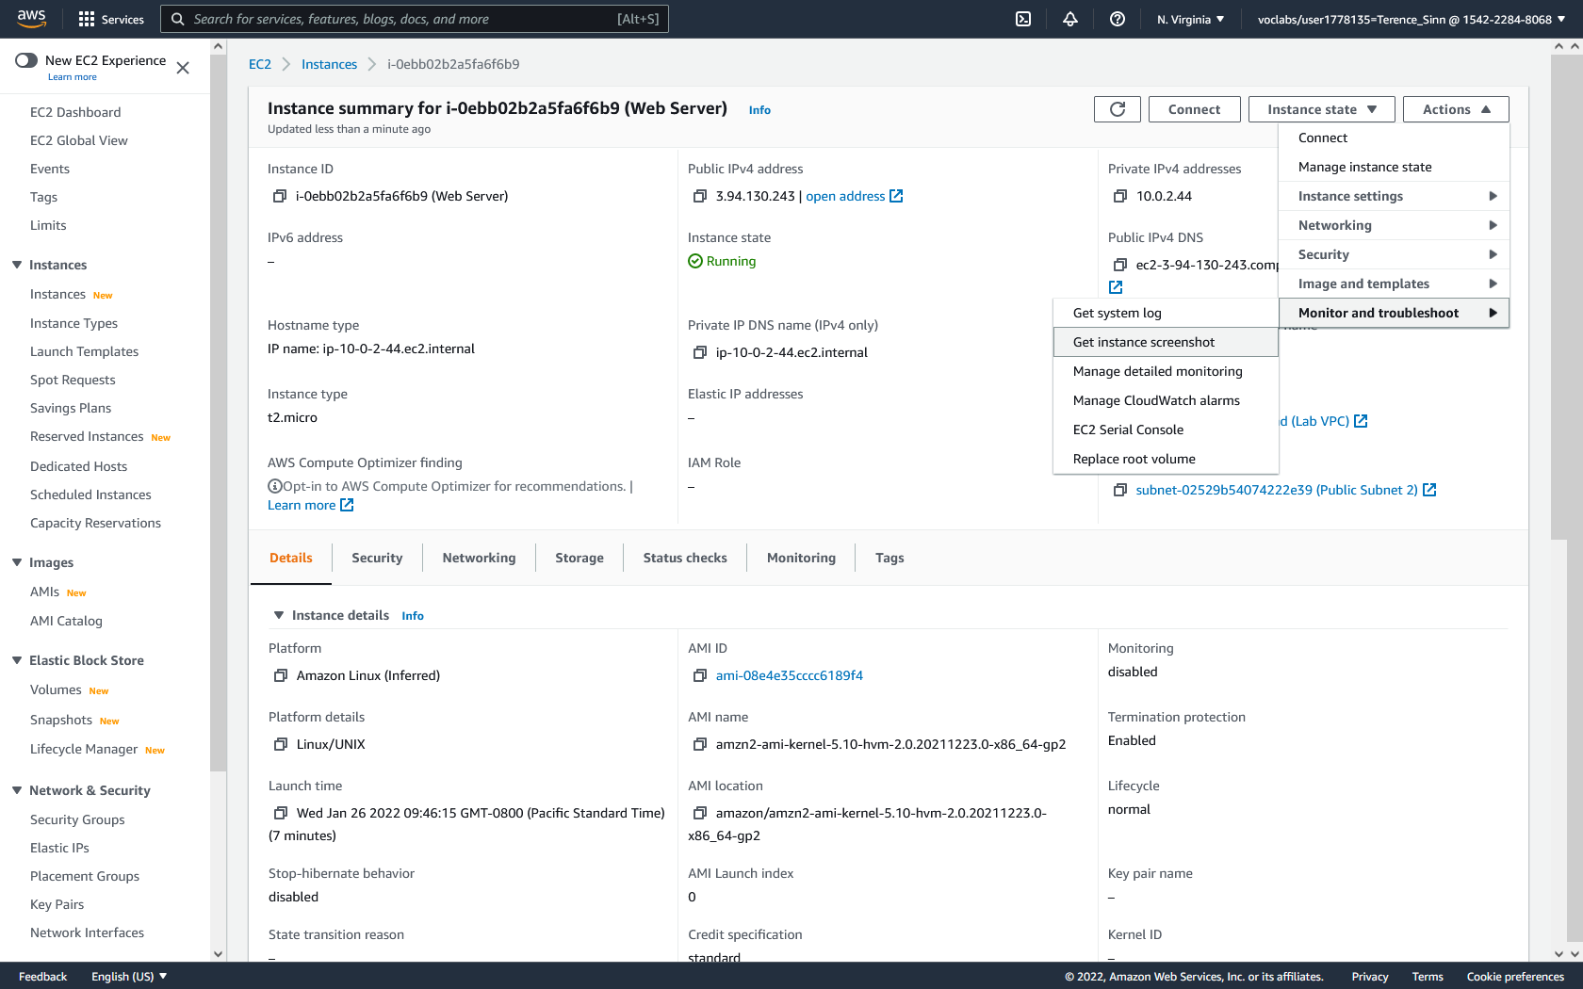

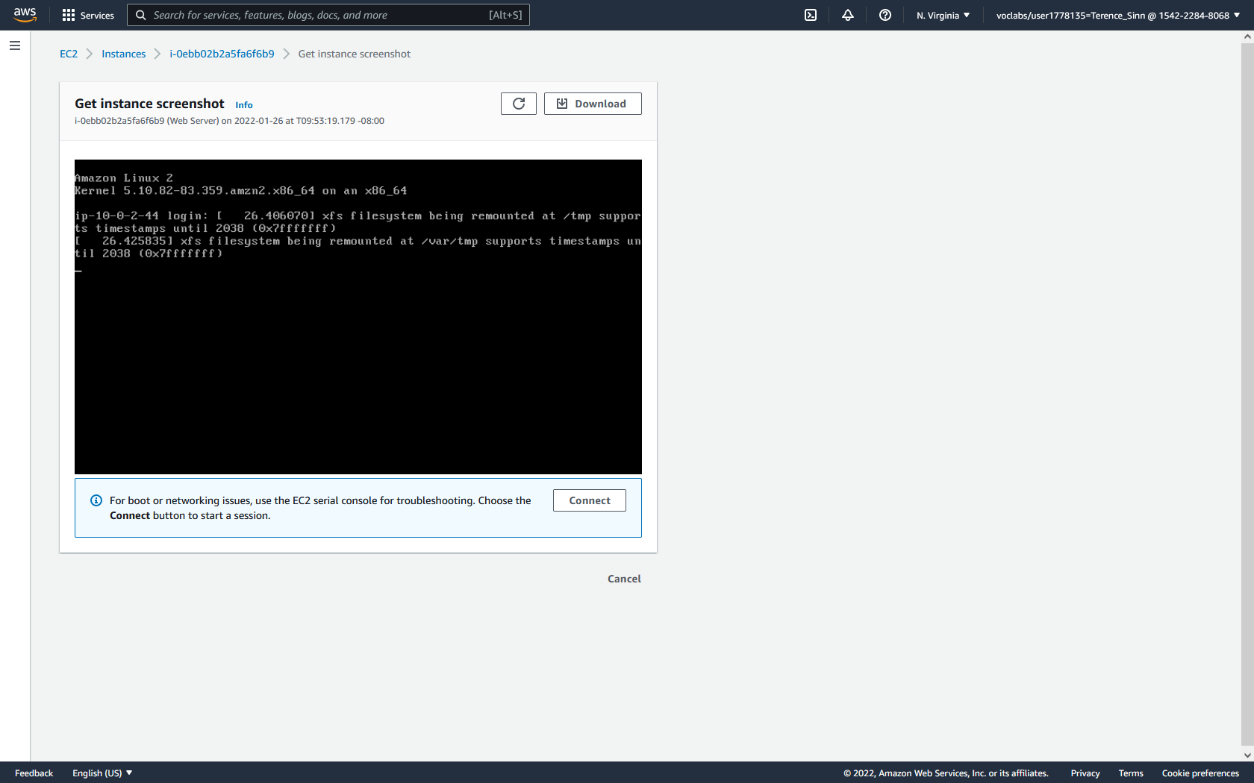

**Modifying an instance:**

1. In the instance dashboard, select the web server. Click instance state and stop. In order to modify the hardware of the virtual machine, you must first stop the virtual machine.

2. With the web server still selected, go to actions, instance settings, and change instance type.

3. Change the instance type to t2.small.

4. On the left menu, click volumes. Select the web server and click actions. Click modify volume. Change the volume of the web server from 8 GiB to 10 GiB

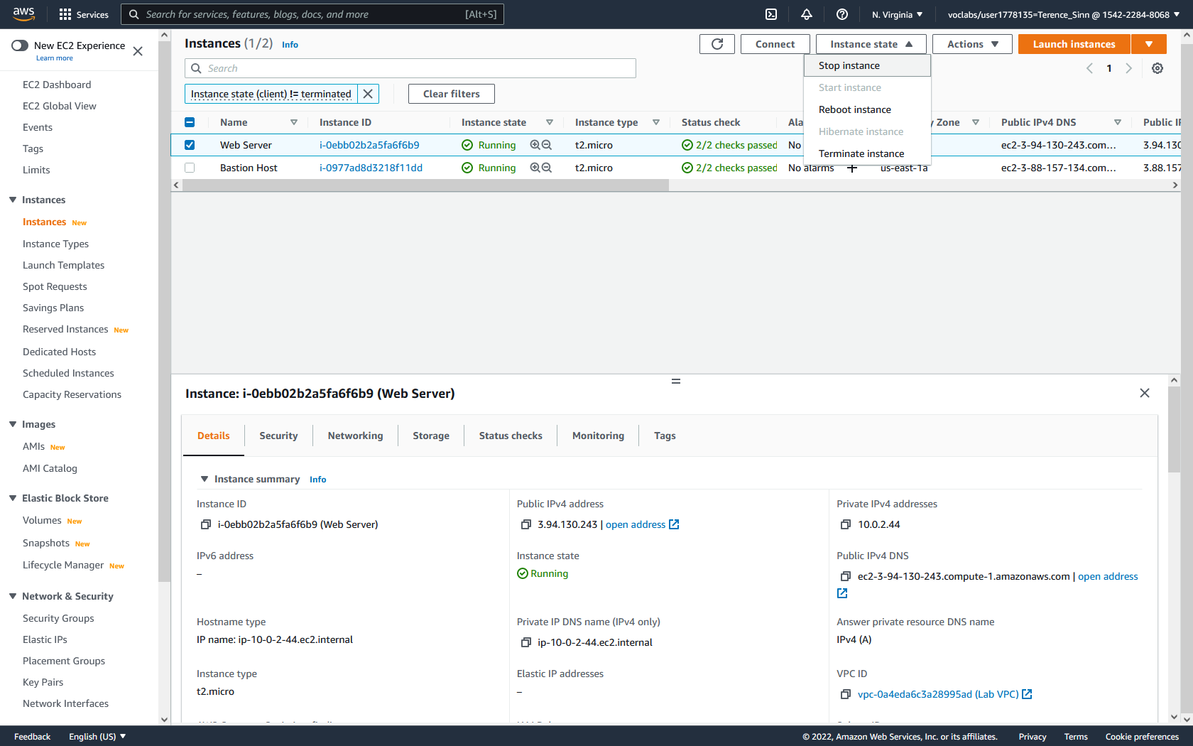

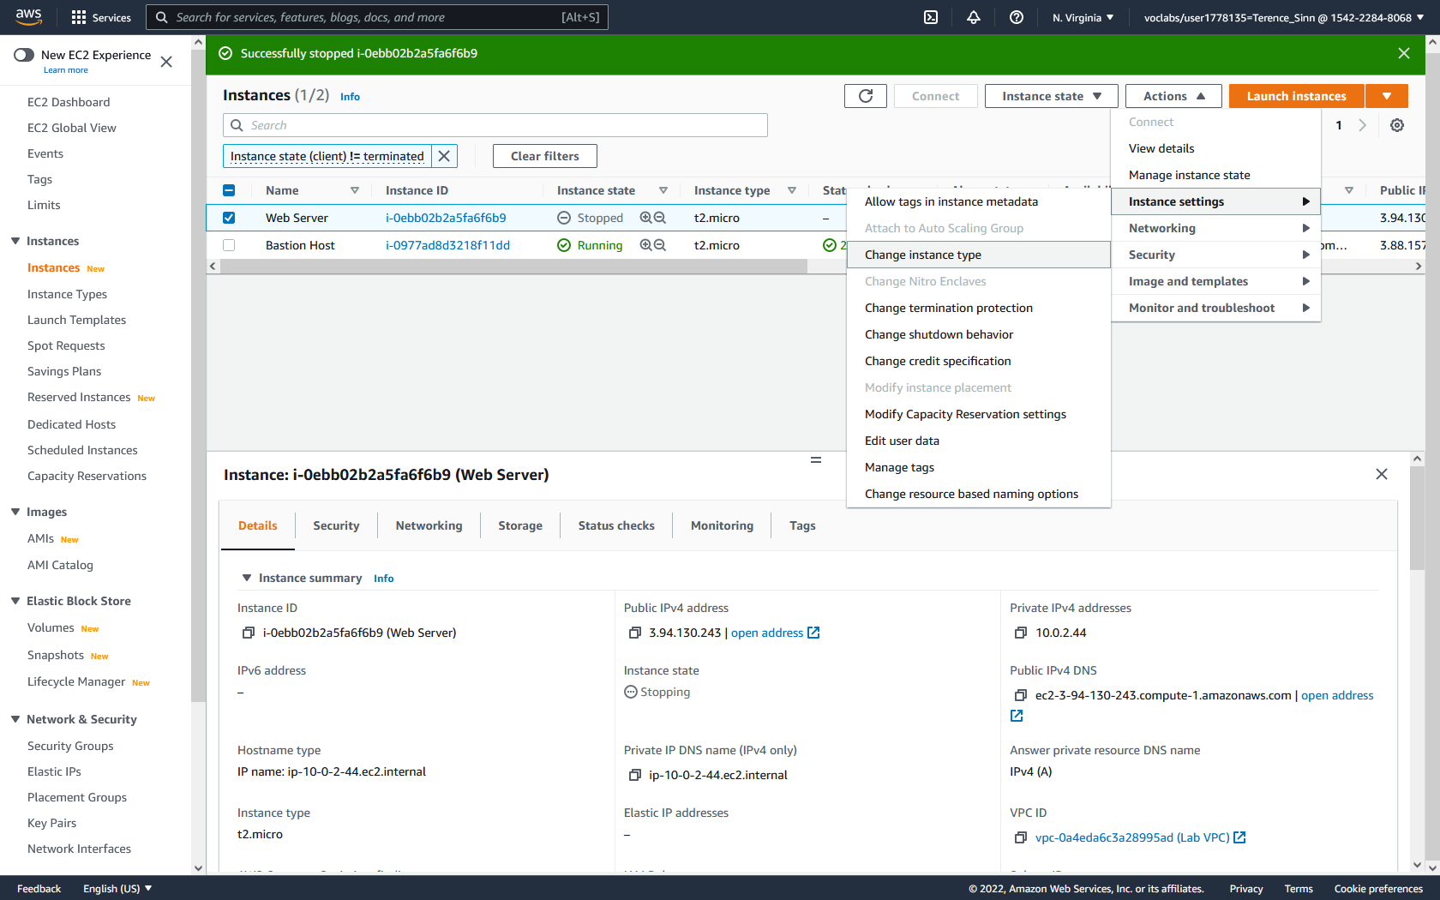

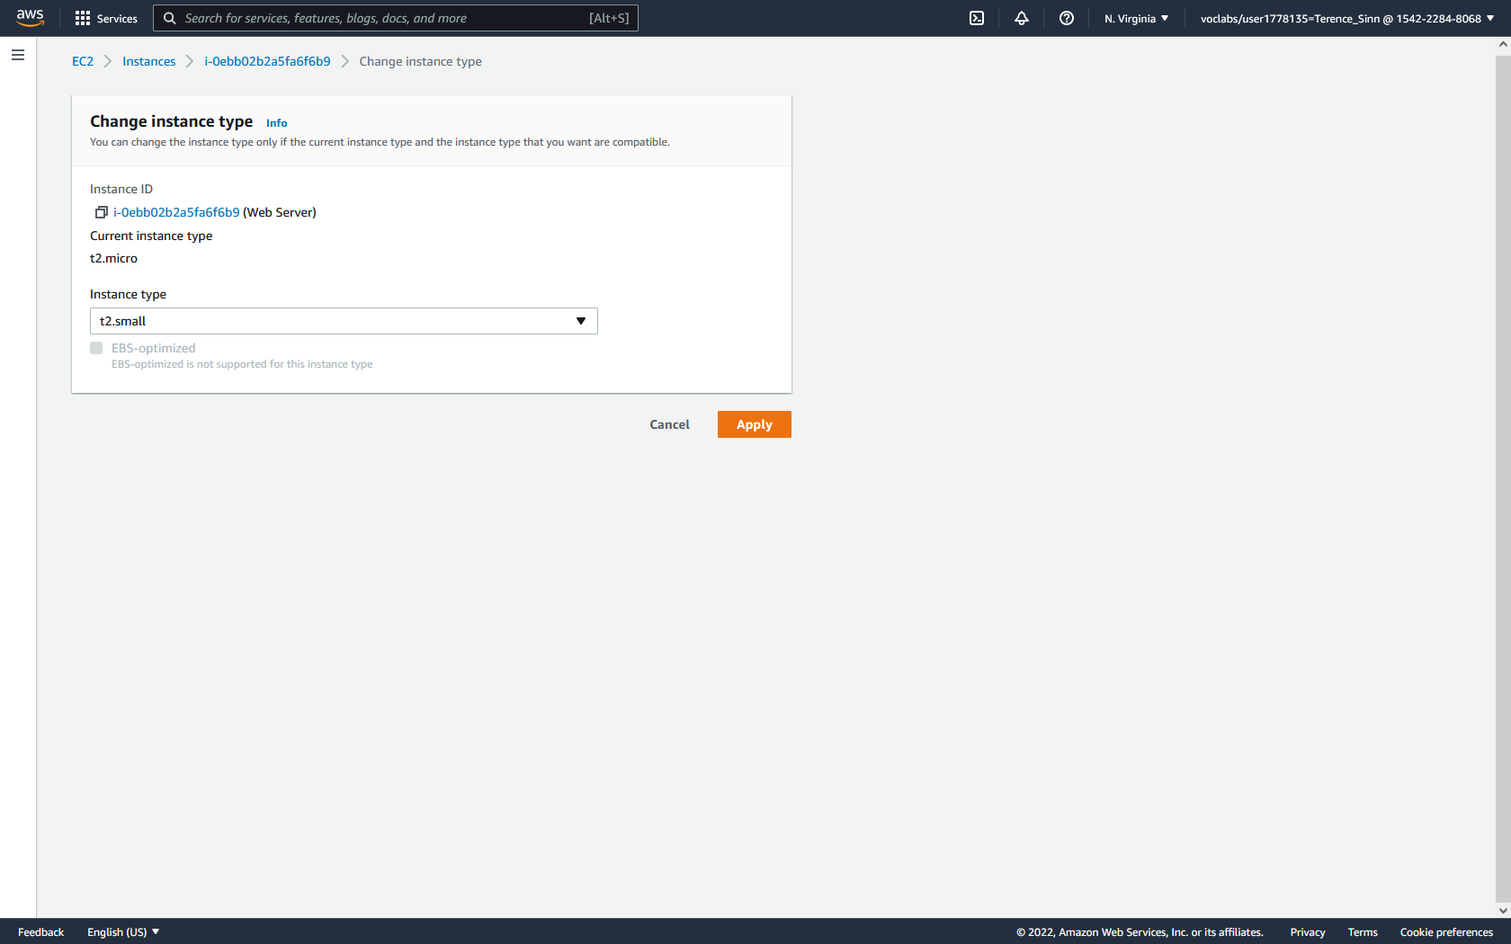

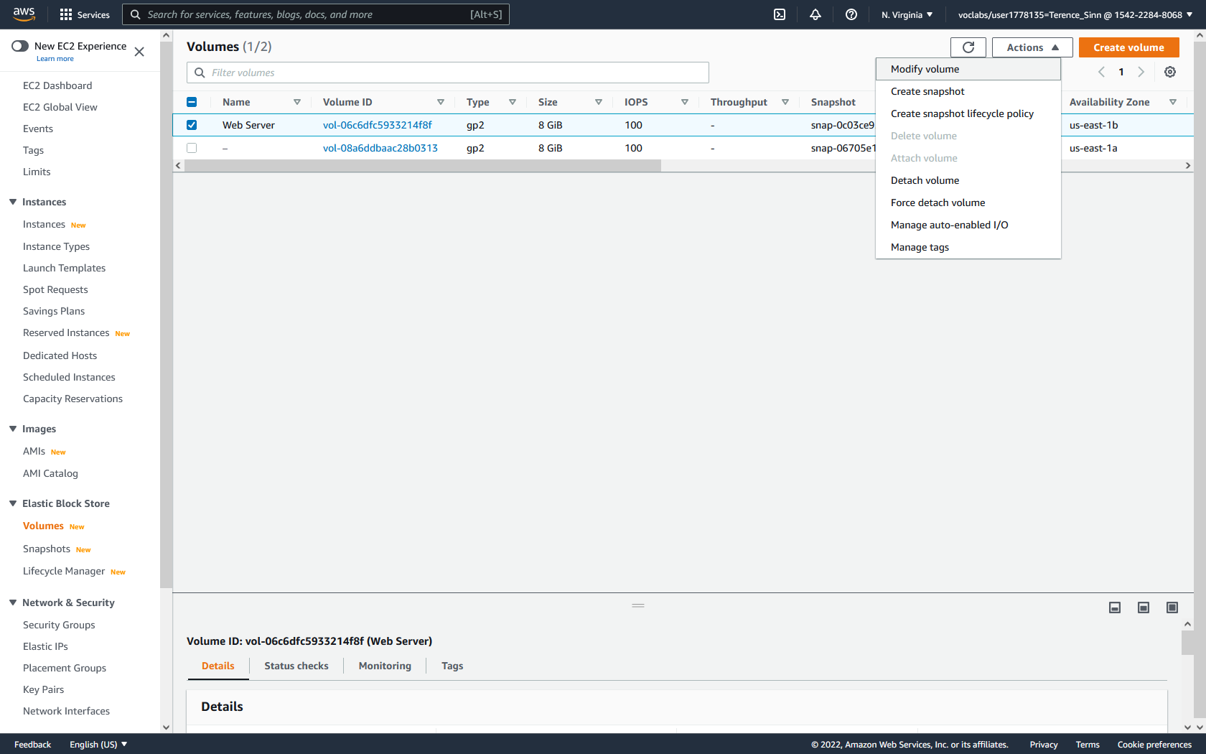

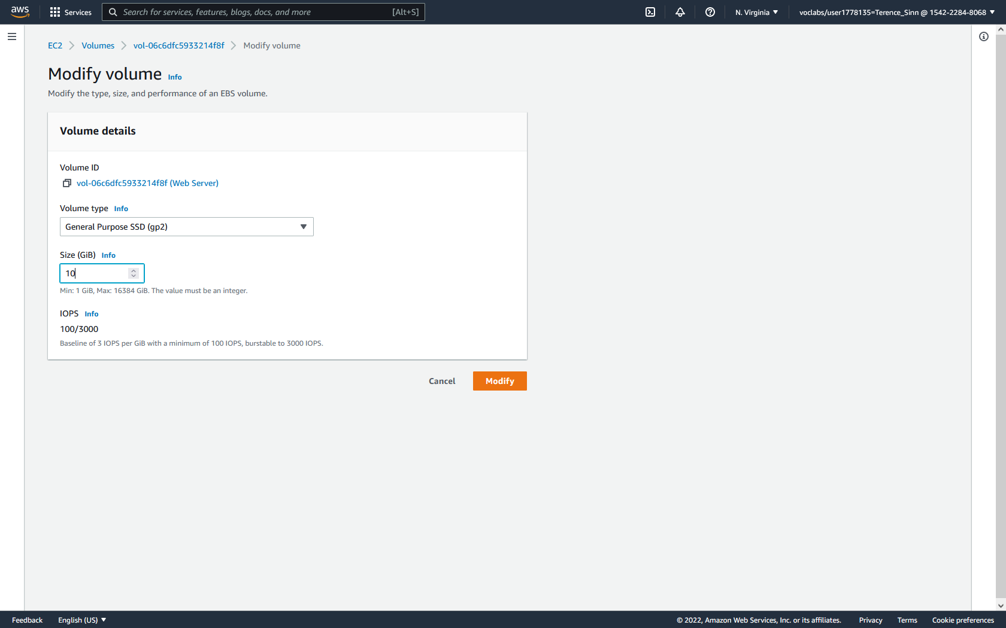

**Termination Protection:**

1. In the instances dashboard, select the web server, click instance state, and try to terminate the instance. You should receive an error message because we turned on termination protection earlier.

2. With the web server still checked, go to actions, instance settings, and change termination protection. Turn off the termination protection.

3. Repeat step 1 to terminate the web server. You should see it shutting down and terminating.

